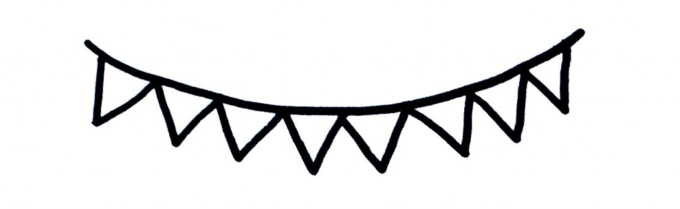

Messick’s Messages
August 22-26, 2022
Math Skills for Topic 1: Understanding
Addition & Subtraction
Lesson 6: More Compare Situations
Lesson 7: Change Unknown
Lesson 8: Practice Adding and Subtraction
Lesson 9: Problem Solving- Construct Arguments
**We will have a math test next Tuesday. A study guide will be sent home on Monday.**

Important Dates
August 26: Spirit Day- wear sunglasses
August 30: Curriculum Night @ 5:30
Sept. 5: Labor Day holiday
Sept. 28: Fall pictures

Language Arts Skills for Readiness Week 2
*Review of the letter shape and sound of Nn-Zz
*Sight word review: have, I, is, a, there, see, up, the
Science/Social Studies/Leader in Me
*All About Me
*Write Class Mission Statement
*Distinguish between author and illustrator
*Continue class alphabet book

Announcements
*Thank you to all of those who donated to the Sink-a-Palooza fundraiser! Our class came in FIRST PLACE for PPS!!!
*Remember to sign up for Class Dojo to receive important updates and see pictures of our class in action! This will be our primary source of communication.
*A newsletter and homework will be sent every Monday. I will collect homework each Friday. It is not graded but a treat will be given for completion.
*Please initial your students DOT folder each day under their pawprint. Also, please keep all papers at home that are in the back pocket.
*Tuesday folders will be sent home tomorrow. Please keep all papers in the “Keep at Home” side and return papers that are in the other pocket. Sometimes I will ask for graded papers to be returned so that I can keep a sample of student work.

