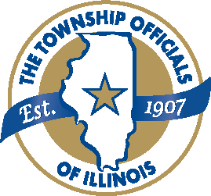
Application

Name

Mailing Address

City, State, Zip _______________________ Phone _______________ Email __________________________

Township in which you reside

County in which you reside

U.S. Citizen? • Yes • No Illinois Resident? • Yes • No

High School:

City _________________________ State _______ Zip ________________
Expected Graduation Date Cumulative GPA* College/University attending Fall 2026: (must be in Illinois)

School Name ____________________________ City in Illinois _____________________
Expected Major:

*Please provide your official transcript. Check with your school guidance department to verify that your transcript is official.

*Applications are now submittable via email in a PDF format only to the TOI office at debbie@toi.org.

TOI will award seven $2,000 scholarships in 2026
Essay of not less than 500 words on "The Role of Township Government in Today's Society and in the Future" is attached, with signature, title, township/county of township official who was interviewed. This MUST be an elected township official who serves on a township board in Illinois. Please contact our office if you have any questions.

Name Title Township County
Interviewee’s Signature

Extracurricular Activities (also include work experience)

(If additional space is needed, please attach separate sheet(s)).

Signature of Applicant: Date:
To be eligible, you must meet all the following criteria:
Must be a graduating Illinois high school senior.
Must be applying to attend a university/college located in Illinois. Awards may not be deferred. If you need to change schools after being awarded a scholarship, please contact the TOI office as soon as possible.
Must be a U.S. citizen and resident of Illinois.
Must plan to attend a university/college in Illinois as a full-time student.
Must have a history of extracurricular activities that demonstrates a willingness to accept leadership responsibilities (student government, club officer, etc.) or a commitment to civic responsibility, social consciousness and a willingness to serve the community (community service projects, volunteer activities with local service agencies or charitable institutions, etc.)
Must submit a 500-word essay on The Role of Township Government in Today’s Society and in the Future
that will include information gained from an interview with an elected township official.
Must submit two letters of recommendation from teachers, counselors, local officials or businesspeople. Must submit an official high school transcript.
Must submit a cover letter and completed application form.
This application may be submitted by email or mailed through the USPS. All submissions must be dated and post marked no later than 12:00 AM on March 2, 2026. All emailed submissions must have attachments separated and in a .pdf format.
All applicants should expect to receive written notification of a decision after April 1, 2026.
All scholarship awards are disbursed directly to the award recipient’s school and must be used for the
2026-2025 academic year, awards may not be deferred.

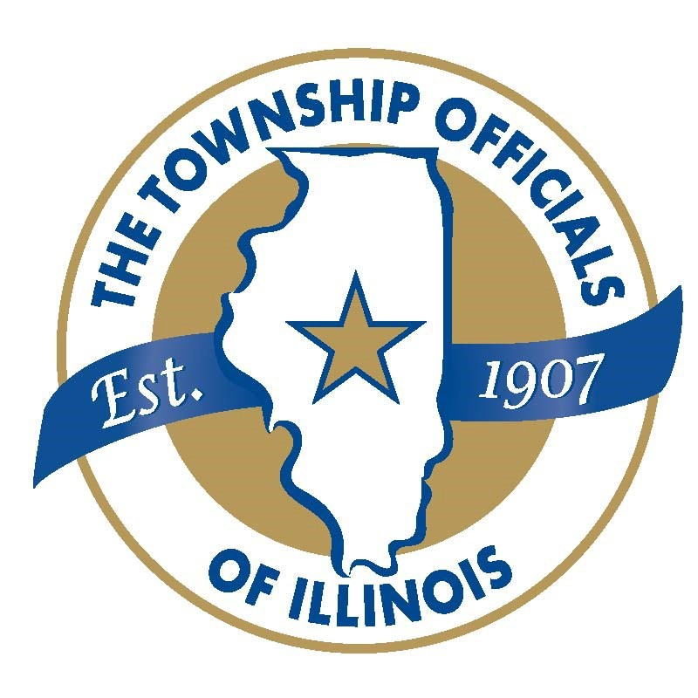
2026 Scholarship Application

Carolyn Langan Scholarship Delbert Miller Scholarship
William Ahrends Scholarship Robert Turner Scholarship
Barbara Behm Scholarship George H Miller Scholarship
Troy Kost Scholarship

Each year, since 1989, the Township Officials of Illinois Scholarship Fund awards funds to graduating high school seniors to continue their education at Illinois colleges/universities.
A total of $403,500 has been awarded to 236 students.
Any questions may be directed to TOI at 217-744-2212 or teresa@toi.org.
Please mail or email your completed application to debbie@toi.org, postmarked no later than March 2, 2026 to:

Township Officials of Illinois Attn.: Scholarship Committee 3217 Northfield Drive
Springfield, Illinois 62702

Providing scholarships for Illinois students since 1989

