Please review the study guide. A read the words grade will be given on Friday. No reading test this week.

spiders

verbs

MATH:

We will start topic 4- subtraction facts to 20

Week of Oct. 11

Red Ribbon Week

Monday- wear red

Tuesday- wear pajamas

Wednesday- wear tie dye/neon

Thursday- wear favorite team shirt

Friday- wear costumes

High Freq. Words:

To get ask of as he

Contact Information

Email: Pamela.luker@acboe.net

Website: prattvilleprimary.com/pamelaluker

LANG. ARTS:

SS/SCIENCE:

READING:

Our Learning





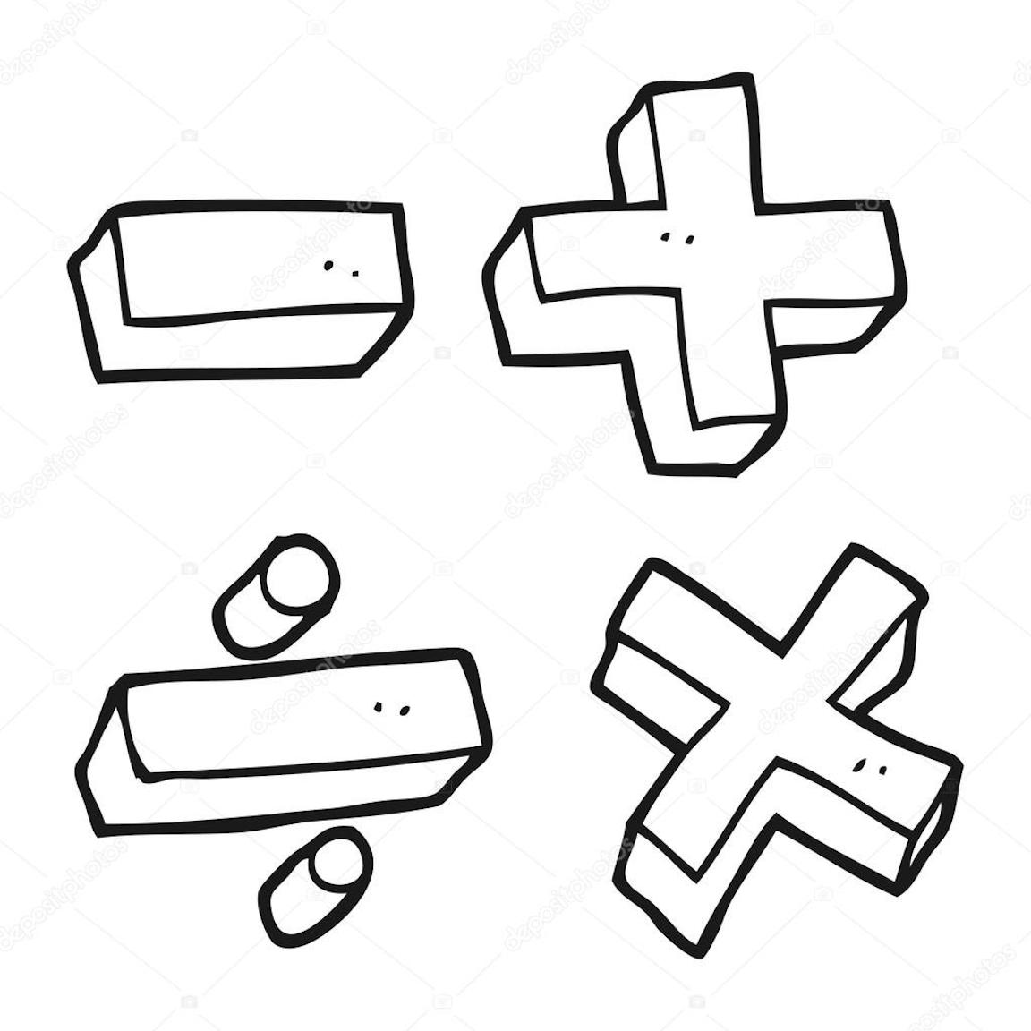



Upcoming Events

October 14 special snack- free choice

October 17 report cards issued

October 19 unity day-wear orange

October 20 penton farms field trip

October 21 spirit day- pink out

Reminders

\* A parent workshop will be held on October 18th. Two first grade teachers will present the workshop at three different times during the day. They will cover ways to help your child with reading and math. More information will be sent home

Mrs. Luker’s Class