Please review the study guide. A reading test will be on Friday.

bats

Simple sentences

MATH:

We will continue topic 4- subtraction facts to 20

Week of Oct. 17

Red Ribbon Week- Oct. 24-28

Monday- wear red

Tuesday- wear pajamas

Wednesday- wear tie dye/neon

Thursday- wear favorite team shirt

Friday- wear costumes

High Freq. Words:

Down its red help six

Contact Information

Email: Pamela.luker@acboe.net

Website: prattvilleprimary.com/pamelaluker

LANG. ARTS:

SS/SCIENCE:

READING:

Our Learning





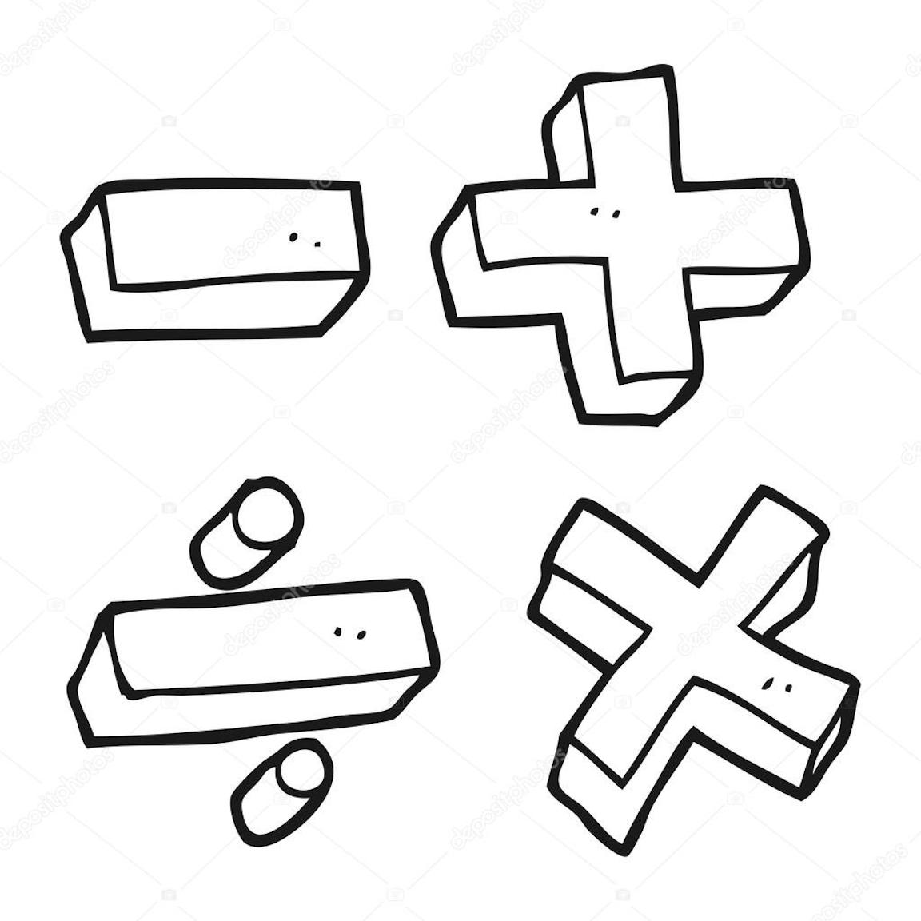



Upcoming Events

October 17 report cards issued

October 19 unity day-wear orange

October 20 penton farms field trip

October 21 spirit day- pink out

Reminders

\* A parent workshop will be held on October 18th. Two first grade teachers will present the workshop at three different times during the day. They will cover ways to help your child with reading and math.

\*our field trip is Thursday. More information will be sent home about the trip, but each child is to bring a lunch from home

\* Please remind your children to keep all toys (stuffed animals, balls, fancy pens, etc.) at home

Mrs. Luker’s Class