Off and Away to Third Grade Neverland!

Welcome to third grade! I hope you had a safe and enjoyable summer. My name is Avery Myers, and I am so excited to be your child’s teacher this year! I will be teaching Reading and ELA. My pair teacher is Kaitlyn Nickels, and she will be teaching Math, Science, and Social Studies. I look forward to challenging my students and helping them reach their full potential. I would love to see you at Open House at Prattville Elementary School on August 5th from 1:30-2:15 PM. I hope that you and your child will be able to stop by during this time. I look forward to meeting you and your child soon, and I can’t wait for a magical year! I have attached a supply list specific to our classroom, and you are more than welcome to bring these supplies to Open House.
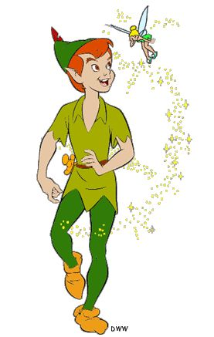
Sincerely,
Miss Myers

“All you need is faith, trust, and a little bit of pixie dust.”
Miss Myers’s Supply List
- 1 supply box
- 4 packs of 24 count Crayola crayons
- 2 packs of Crayola colored pencils
- 1 pack of Crayola markers
- 4 black, fine tip expo dry erase markers
- 1 pack of highlighters (assorted colors)
- 4 12-count boxes of pre-sharpened pencils
- 1 pair of Fiskars scissors
- 1 pack of colored copy paper
- 1 one-inch white, clear view 3 ring binder (clear sleeve on front cover)
- 1 zipper pouch for binder
- 1 three-prong poly (plastic) folder with pockets (yellow)
- 2 composition books
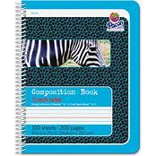
- 1 Pacon Zaner-Bloser (Grades 2-3) Primary Composition Book ½ inch ruled (see picture)
- 2 pairs of headphones
- 1 container of disinfecting wipes
- 1 roll of paper towels
- 2 boxes of tissues
- 2 glue sticks
Please only label your child’s supply box, composition books, and headphones. You are more than welcome to write their name on the inside of their binders, but I will have a sheet with their name on it on the first day of school to insert in the front clear sleeve of the binder.

