Mt. Zion Elementary

Parent and Family Engagement Plan

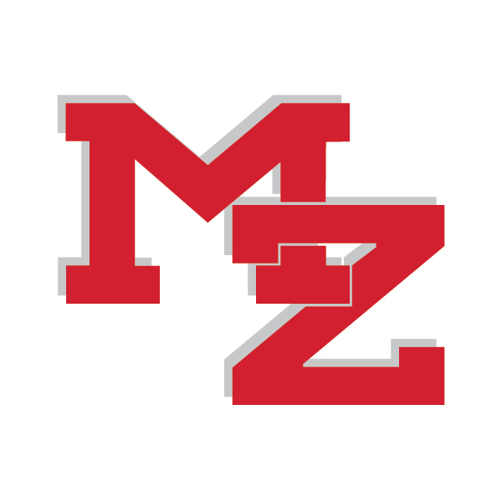

2021-22

Revision Date: June 2, 2021

Mt. Zion Elementary School
Parent and Family Engagement Policy and Plan for Shared Student Success

2021-2022 School Year

Mt. Zion Elementary School
Cindy H Parker, Principal
260 Eureka Church Road
(770) 832-8588
mze.carrollcountyschools.com

Plan Revised June 2, 2021

What is Title I?

Mt. Zion Elementary is identified as a Title I school as part of the Every Student Succeeds Act (ESSA). Title I is designed to support State and local school reform efforts tied to the challenging State academic standards to improve teaching and learning for students. Title I programs must be based on effective means of improving student achievement and include strategies to support family engagement. All Title I schools must jointly develop with parents and family members a written parent and family engagement policy.

School Plan for Shared
Student Achievement

What is it?
This is a plan that describes how Mt. Zion Elementary will provide
opportunities to improve family engagement to support student learning.
Mt. Zion Elementary values the contributions and involvement of parents and
family members to establish an equal partnership for the common goal of
improving student achievement. This plan describes the different ways that
Mt. Zion Elementary will support family engagement and how parents can help plan
and participate in activities and events to promote student learning at school and at home.

How is it revised?
Mt. Zion Elementary School provides a digital copy on the school website and a hard copy in the front office of the parent and family engagement policy, as well as the schoolwide plan, our school-parent compact, and the family engagement budget. Administration addresses Building Staff Capacity during several faculty meetings throughout the year. Additionally, parent input and comments regarding this plan are welcome during the school year by emailing the administrators or the Family Engagement Coordinator. The plan is posted on our school website for parents to view and submit feedback throughout the year. All parent feedback received during the year will be used to revise the plan for the next school year. We also distribute an annual survey online and by mail to ask parents for their suggestions on the plan and the use of funds for family engagement. Parents and family members can also give feedback during several parent meetings and activities during the school year. Parents may contact the Director of Federal Programs should they have any complaints or concerns about the Family Engagement Plan.

Who is it for?
All students participating in the Title I, Part A program, and their families are encouraged and invited to fully participate in the opportunities described in this plan. Mt. Zion Elementary will provide full opportunity for the participation of parents and family members with limited English, with disabilities, and of migratory children.

Where is it available?
At the beginning of the year, the plan is available on the school website and in our front office. The plan will also be posted social media. Parents can also retrieve a copy of the plan in the Parent Resource Center.

School-Parent Compacts
As part of this plan, Oak Elementary and our families will develop a school-parent compact, which is an agreement that parents, teachers, and students will develop that explains how parents and teachers will work together to make sure all our students reach grade-level standards. The compacts will be reviewed and updated annually based on feedback from parents, students, and teachers during the
Community Cares event and
the School Forum. The
school-parent compacts
also are shared with
parents during
parent-teacher
conferences and
kept with each child’s
teacher if parents
need another copy.

Let’s Get Together!
Mt. Zion Elementary will host the following events to build the capacity for strong family engagement to support a partnership among the school, parents, and the community to improve student academic achievement. All meetings for parents and family members will be held twice during the day in the morning before school and in the evening at 7:00 pm.

Open House Appointments - July 30 & August 2, 2021
Meet your child’s teacher and our friendly and helpful school staff for the year.

Annual Title I Meeting – September 6, 2021 & September 13, 2021
We will provide an opportunity to learn about our Title I program, including our parent
and family engagement policy, the schoolwide plan, the school-parent compacts, and parents’ requirements. Invitations will be emailed and posted in the school newsletter, social media, and local media.

A Taste of Writing Night – October 21, 2021
Parents will enjoy hearing the latest writing samples and curriculum updates.

Art Gallery Walk – November 18, 2021
Parents will enjoy refreshments and a gallery walk of student artwork and writing.

MZ Cluster Fine Arts Night-December 2, 2021
Students across the cluster, K-12, will perform and exhibit artwork.

Living History Museum – January 20, 2021
Come and enjoy walking the halls of history, as students exhibit research of their favorite historical figures through writing,video and speech.

Parent STEM Night – February 17, 2021
Engage in fun, hands-on STEM activities with your child..

Math Night – March 17, 2021
Learn how to make math fun at home.

Honor Chorus Performance – April 21, 2021
Listen to the sounds of beautiful music as our Honor Chorus students perform.

2021-2022 District Goals
All schools in the district will increase 3% in ELA and Math as measured by
the College and Career Readiness
Performance Index (CCRPI).

2021-2022 School Goals
Mt. Zion Elementary will increase in ELA and Math, specifically in 4th grade, by 3% as measured by the CCRPI.

The focus for reading is:
K–1: Beginning sounds and sight words
K–4: Vocabulary development

The focus for math is:
K–6: Place value and estimation

Mt. Zion Elementary is Branching Out!

Mt. Zion Elementary will take the following measures to promote and support parents and family members as an important foundation of the school in order to strengthen the school and reach our school goals. We will:

Ensure that all information related to school and parent programs, meetings, and other activities is published in both English and Spanish, posted on the school website, and included in the monthly school newsletter for all families.
Provide monthly trainings for staff during their planning periods on strategies to improve communication with parents and ideas to increase family engagement with reading and math activities for our students outside of the classroom. Staff will also share best practices during regularly scheduled faculty meetings.
Partner with early childhood programs, middle and high schools, college and career ready resources or organizations, parent resource centers, or other programs (as applicable) to help prepare parents and their children for successful school transitioning.
Share information in English and Spanish on the school blog and in the school newsletter for parents to understand the school’s academic standards and assessments as well as the ways parents can monitor their child’s progress and work with educators.
Communicate with all families and the community on a regular basis regarding schoolwide events and activities, through phone messages, social media, and flyers.
Work with our parents to develop relevant trainings and helpful presentations to educate our staff on the importance of parent and family engagement and how to support student learning.
Provide necessary materials and handouts for parents at conferences, meetings, and activities to help parents work with their child to improve their child’s achievement.
Use our Partners in Education and School-Community Team to improve awareness of the activities and events listed in the school parent and family engagement policy.
Offer literacy and computer classes for parents and family members to help further enhance their various educational levels.
Collect feedback from parents and family members at all events, place input card around the building and a post suggestion form on the school website in order to respond to parents’ requests for additional support for parent and family engagement activities.

Mt. Zion Elementary is committed to helping our
parents and families attend the family
activities listed in this policy. Please call
or email us if you need assistance with
child care or transportation in order to
participate in our programs.

Renea Huddleston
770-832-8588
renea.huddleston@carrollcountyschools.com

Parent Resource Center
Come visit the Parent Resource Center to check out books, study materials, and activities to use at home with your child. Computers are available for parents to explore the Parent Portal and educational resources.
Monday – Friday, 7:30 am –2:30 pm

Parent and Family Engagement
Mt. Zion Elementary believes that family engagement means the participation of parents and family members in regular two-way, and meaningful communication involving student academic learning and other school activities, including ensuring:

That parents play an integral role in assisting their child’s learning.

That parents are encouraged to be actively involved in their child’s education at school.

That parents are full partners in their child’s education and are included, as appropriate, in decision-making and on advisory committees to assist in the education of their child.

The carrying out of other activities as described in this plan.

School & Community
Council Team
Mt. Zion Elementary invites all parents to join the School Community Team to share ideas and ways to involve other parents and family members to build partnerships with school, families, and the community. The team will meet four times during the school year, but parents and family members can also submit their ideas or suggestions at any school activities and meetings, as well as through our parent surveys and website. If you would like to learn more about the School Community Team, please contact the principal at 770-832-8588 or complete the interest
form and leave it in the
Main Office.

Share Your Thoughts
We want to hear from you. If you have any suggestions or if there is any part of this policy that you feel is not satisfactory with the students’ and the school’s goals for academic achievement, please provide us with your comments in the space provided and leave this form in the Main Office:

Name: (optional)

Telephone Number: (optional)

School Community Team

Yes, I am interested and wish to join the School Community Team.
Please contact me so I can learn more in joining the School Community Team.
Please send me notifications about future meetings and updates.

Name:

Child’s Name and Grade:

Address:

Phone Number:

Email address:

Parent and Family Engagement Standards
Mt. Zion Elementary and our parents have adopted the National PTA Standards for Family-School Partnerships as the school’s model in engaging parents, students, and the community. These standards are:
Welcoming All Families
Communicating Effectively
Supporting Student Success
Speaking Up for Every Child
Sharing Power
Collaborating with Community

