Math Review Week # 1 Name__________________
Day 1

1. Color the triangle:

2. Circle the number 3: 0 1 2 3 4 5

3. What shape is this? square oval

Mental Math ______________________
_________________________________________

_________________________________________
Math Review Week # 1 Name__________________
Day 2

1. Color the square:

2. Circle the number 1: 0 1 2 3 4 5

3. What shape is this? rectangle circle

Mental Math ______________________

Math Review Week # 1 Name__________________
Day 3

1. Color the rectangle:

2. Circle the number 2: 0 1 2 3 4 5

3. What shape is this? square oval

Mental Math ______________________
_________________________________________
_________________________________________
Math Review Week # 1 Name__________________
Day 4

1. Draw a circle:

2. Circle the number 5: 0 1 2 3 4 5

3. What shape is this? rectangle circle

Mental Math ______________________

Math Review Week # 2 Name__________________
Day 1

1. Circle the number 5: 0 1 2 3 4 5

2. Color the cone:

3. Count forwards: 1, 2, 3, ___, ___, ___, 7

Mental Math ______________________
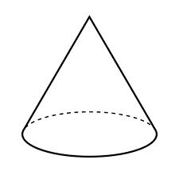
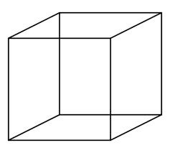
_________________________________________

_________________________________________
Math Review Week # 2 Name__________________

Day 2

1. Color the triangles:

2. Circle all the 5s: 0 5 1 2 5 3 4 5 5

3. Color the square:

Mental Math ______________________

Math Review Week # 2 Name__________________
Day 3
1. Color the squares:

- Circle all the 2s: 2 0 2 1 2 3 2 4 5

3. Color the triangle:

Mental Math ______________________
_________________________________________
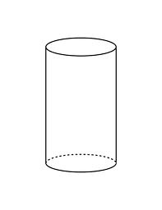
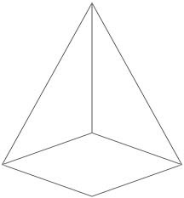
_________________________________________
Math Review Week # 2 Name__________________
Day 4

1. Draw a triangle:

2. Circle all the number 1s: 0 1 2 1 3 4 1 5

3. Color the rectangle:

Mental Math ______________________

Math Review Week # 3 Name__________________
Day 1
- How many shapes
are there?____

2. What comes next in the pattern?: O X O X ___

3. Draw an oval:

Mental Math ______________________
_________________________________________

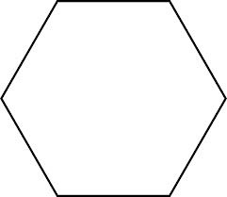
_________________________________________
Math Review Week # 3 Name__________________
Day 2

- Count forwards: 5, 6, 7, ___, ___, ___

2. Put an X on the number 4: 0 1 2 3 4 5

3. How many cubes are there?___

Mental Math ______________________
Math Review Week # 3 Name__________________
Day 3

1. Count forwards: 3, 4, 5, ___, ___, ___, 9

- How many shapes are there?____

3. Finish the AB pattern: X O X O X O ____ ____

Mental Math ______________________
_________________________________________
_________________________________________
Math Review Week # 3 Name__________________
Day 4

1. Count forwards: 4, 5, 6, ___, ___, ___, 10

2. Put an X on the number 0: 0 1 2 3 4 5

3. What shape does not belong?

Mental Math ______________________

Math Review Week # 4 Name__________________
Day 1

1. Count backwards: 10, ___, 8, 7, ___, 5, ___, 3

2. How many circles are there?____

3. Write the number that comes after 6: ____

Mental Math ______________________
_________________________________________

_________________________________________
Math Review Week # 4 Name__________________
Day 2

1. Count backwards: 8, ___, 6, 5, ___, 3, ___, 1

- How many squares are there? _____

3. Write the number that comes before 2: ____

Mental Math ______________________

Math Review Week # 4 Name__________________
Day 3

1. Count backwards: 9, ___, 7, 6, ___, 4, ___, 2

- How many triangles are there?____

3. What day comes after Monday? Sunday Tuesday

Mental Math ______________________
_________________________________________
_________________________________________
Math Review Week # 4 Name__________________
Day 4

1. Count backwards: 10, 9, ___, 7, ___, 5 ___, 3

2. Put an X on the number 4: 0 1 2 3 4 5

3. What shape does not belong?

Mental Math ______________________
Math Review Week # 5 Name__________________
Day 1
1. Draw 4 circles in the box:

- Count forwards: ___, 2, 3, ___, 5, 6, ___,8, ___, 10

3. Is this shape 2D or 3D? 2D 3D

Mental Math ______________________
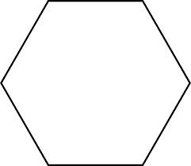
_________________________________________

_________________________________________
Math Review Week # 5 Name__________________
Day 2

1. Count forwards: 4, 5, ___, ___, 8, ____, 10

- How many cylinders are there? _____
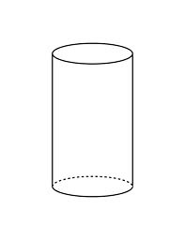
3. Write the number that comes before 8: ____

Mental Math ______________________

Math Review Week # 5 Name__________________
Day 3
1. Draw 6 triangles in the box:

- How many 2D shapes are there?____
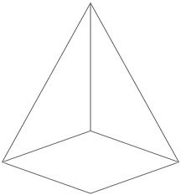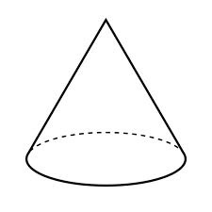

3. Write the number that comes after 9: ____

Mental Math ______________________
_________________________________________
_________________________________________
Math Review Week # 5 Name__________________
Day 4

1. Count backwards: ___, 9, ___, 7, 6, ___, ___, 3, 2

2. Put an X on the number 4: 2 1 2 3 4 5

3. Draw a rectangle:

Mental Math ______________________

Math Review Week # 6 Name__________________
Day 1
1. Color 4 circles:

- How many sides? ___ How many vertices?___

3. Count backwards: 9, ___, 7, 6, ___, ___, ___, 2

Mental Math ______________________
_________________________________________

_________________________________________
Math Review Week # 6 Name__________________
Day 2
1. Color 5 cubes: 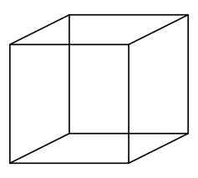

- Is this shape 2D or 3D ?____

3. Write the number that comes after 7: ____

Mental Math ______________________

Math Review Week # 6 Name__________________
Day 3
1. Color 7 squares:

- How many sides? ___ How many vertices?___

3. Write the number that comes after 9: ____

Mental Math ______________________
_________________________________________

_________________________________________
Math Review Week # 6 Name__________________
Day 4
1. Color 3 triangles:

2. Is this shape 2D or 3D? ____

3. Draw an oval:

Mental Math ______________________

Math Review Week # 7 Name__________________
Day 1
1. How many flowers are there?____

2. Count forwards: 1, 2, 3, ___, ___, ___, ___, ___

3. Draw 3 squares in the box:

Mental Math ______________________
_________________________________________
_________________________________________
Math Review Week # 7 Name__________________
Day 2

- How many sides?___ How many vertices?___

- How many bears in all?______

3. Write the number that comes after 9: ____

Mental Math ______________________

Math Review Week # 7 Name__________________
Day 3

1. Put an X on the number 1: 9, 0, 1, 2, 3, 4, 5

- Count backwards: 10, 9, 8, ___, ___, ___, ___, ___

- If today is Sunday, what will tomorrow be?
Monday Friday

Mental Math ______________________
_________________________________________
_________________________________________
Math Review Week # 7 Name__________________
Day 4
- Which domino shows 5? 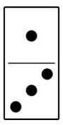 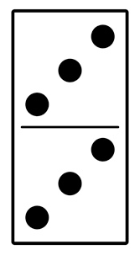 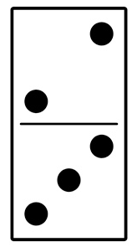

2. Which shape does not belong?

3. Is a rectangle a 2D shape or a 3D shape? _____

Mental Math ______________________

Math Review Week # 8 Name__________________
Day 1

- Circle the group that shows 5:

- If today is Sunday, what was yesterday?
Monday Saturday
3. Write 7 in the triangle:

Mental Math ______________________
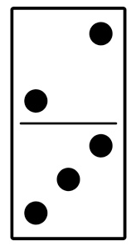
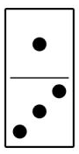
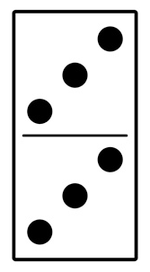
_________________________________________
_________________________________________
Math Review Week # 8 Name__________________
Day 2

1. Circle the domino that shows 6 dots:

2. Trace these numbers: 10 9 8 7 6 5 4
3. Write the number that comes after 7: ____

Mental Math ______________________

Math Review Week # 8 Name__________________
Day 3

- How many bears are there?_____

- Finish the AB pattern: 1, 2, 1, 2, 1, 2, 1, 2, ___, ___

- Draw a rectangle:

Mental Math ______________________
_________________________________________

_________________________________________
Math Review Week # 8 Name__________________
Day 4
- Which shape does not belong?

2. Is a cube a 2D shape or a 3D shape?_____

3. Write the number that comes before 6 _____

Mental Math ______________________

Math Review Week # 9 Name__________________
Day 1

- How many paintbrushes are below?____

- If today is Thursday, what was yesterday?
Wednesday Friday
3. Write 8 in the oval:

Mental Math ______________________
_________________________________________
_________________________________________
Math Review Week # 9 Name__________________
Day 2

- If this month is May, what will next month be?
June December

- Put an X on all the number 2s: 1 2 6 4 2 8 9 2

3. Write the number that comes after 5: ____

Mental Math ______________________
Math Review Week # 9 Name__________________
Day 3

- What shape is this? rectangle circle

- Count backwards: 8, 7, 6, ___, ___, ___, ___, ___

- Is this shape 2D or 3D? 2D 3D

Mental Math ______________________
_________________________________________
_________________________________________
Math Review Week # 9 Name__________________
Day 4

- Count forwards: 3, 4, ___, ___, ___, ___, ___, 10

- Put an X on the number 1: 2 1 7 3 4 5

- Color 5 squares:

Mental Math ______________________

