SCAN TO PAY DEVICE FEE ONLINE
Money due by April 22, 2022
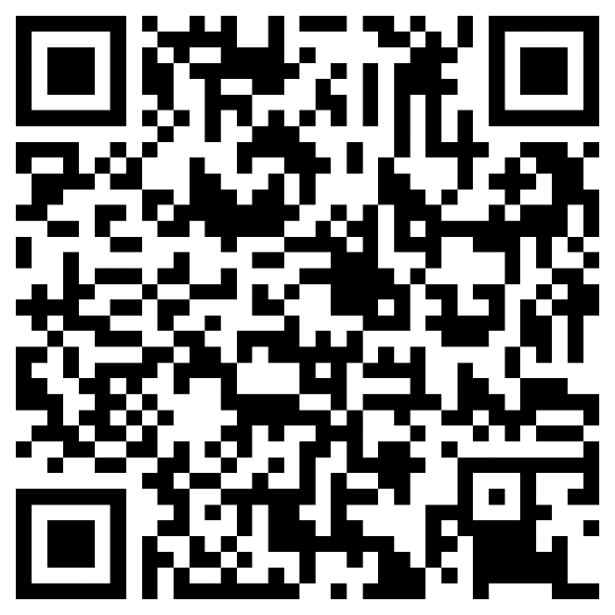

REVOPAY INSTRUCTIONS
- Scan the image
- Click “Make a Payment”
- Enter Southaven High
- Click “Make a Quick Payment”
- Enter account number (Lunch Number)
- Complete and verify info then select “Continue to Payment”
- Select “Device Support Fee”
- Select payment method
- Review and approve
- Submit Payment

After you pay you will receive an email receipt. You must show this receipt to you second block teacher.

