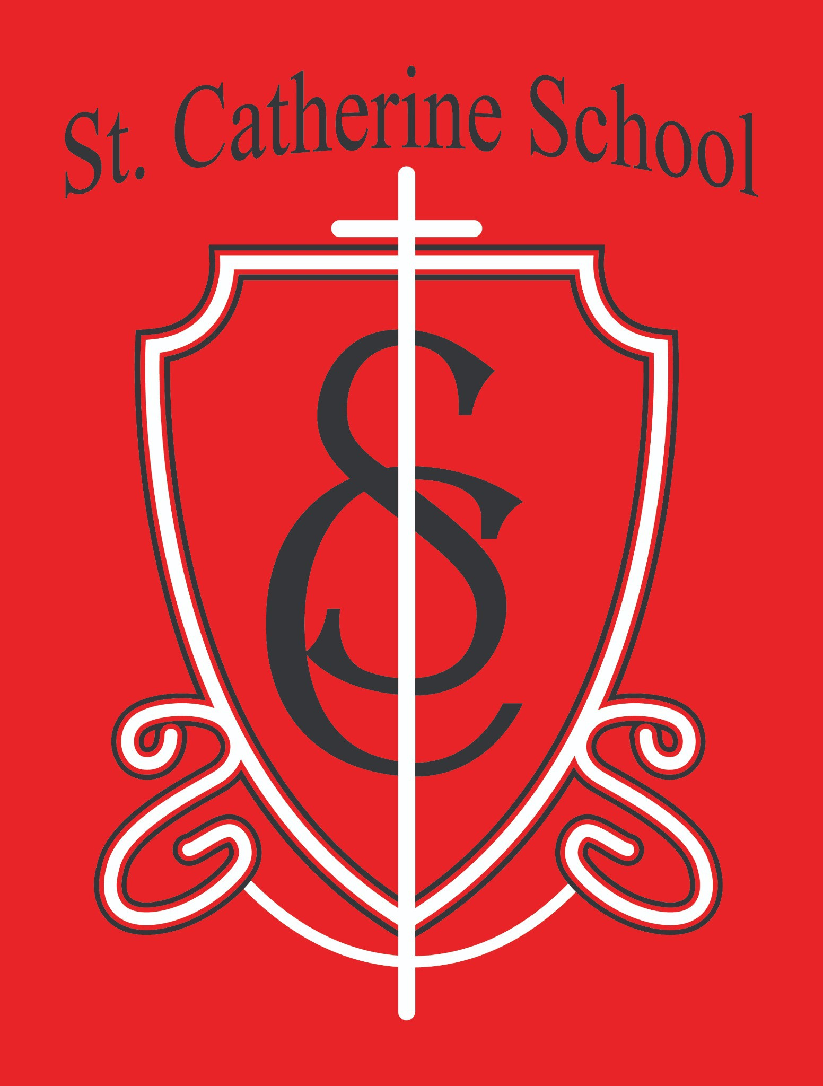

St. Catherine School Weekly Newsletter (Week of March 23- 27)
https://www.stcatherine.k12.nd.us/parents

Principal's Message
Dear St. Catherine Families,
This coming Monday, I will be out of the building as I present my graduate portfolio to a committee at the University of Mary. This portfolio represents my learning and growth over the past two years and serves as the final step before completing my second master's degree.
I am incredibly grateful for the opportunity to continue advancing my professional knowledge— especially at a Catholic institution like the University of Mary. I am also deeply thankful to be part of a school community that is supportive and understanding of the responsibilities and commitments that exist beyond the school day.
Thank you for your continued trust and support as I serve as the leader of St. Catherine School. Your partnership means more than you know.

Reminders

Kids Heart Challenge
Congratulations and thank you for your generosity! Our school raised $2,398.94. T-shirts and larger prizes will be mailed and should arrive in the coming weeks. Music Program

Our music program continues to do wonderful things.
Please help encourage practice at home, especially for recorders and ukuleles.
Upcoming Schedule (Holy Week & Easter Break) School in session: Thursday, April 2 (Holy Thursday) No School: Friday, April 3 (Good Friday)
No School: Monday, April 6 (Easter Monday)
No School: Tuesday, April 7 – Friday, April 10 (NCEA Convention / Easter Break) School resumes: Monday, April 13
We recognize this is a longer break than usual. We are very grateful for the opportunity for our staff to attend the NCEA Conference in Minneapolis and grow alongside thousands of other Catholic educators.

Report Cards
Please sign and return report cards if you have not already done so.

Winter Gear Reminder
Please continue sending winter gear daily. This time of year can shift quickly between warm weather and snow. It is always better for students to have gear and not need it than to need it and not have it.

Food Service Update
Mrs. Kennedy is currently on maternity leave and plans to return the second week of May. Please direct any food service questions to the school office (Ms. Giesen or Mr. Lee).

We want to share an important update with our school families. Ms. Busch has accepted a position closer to home and will be leaving St. Catherine School at the conclusion of this school year. While we are excited for her next chapter, we will greatly miss her in our school community. Please pray for her transition and ask the Lord to continue guiding great staff to our school.

She asked that the following message be shared:

Dear St. Catherine Families,
I want to share an important message with you all. It is with a heavy heart that I say I will be leaving St. Catherine’s Elementary at the conclusion of this school year.

This was a very difficult decision because I have truly loved working with your children and being part of this school community. Teaching music and physical education here has been incredibly meaningful, and I am very grateful for the support from families throughout my time at the school.
I have decided to pursue an opportunity that will allow me to continue growing my career and better support my long-term financial needs. While I am excited for what comes next, I will sincerely miss, and will cherish, each and every student and the connections we’ve built.
Thank you all for your support of the arts, helping grow your child’s skills, and sharing your wonderful, kind, thoughtful, and virtuous students.

Musically yours, Alexis Busch

As we look ahead, St. Catherine School will hire a part-time music teacher for the 2026–2027 school year. Applicants should have a degree in music education or elementary education or be willing to pursue licensure through an alternative pathway.
If you or someone you know may be interested in this opportunity, please contact the school office for more information.
We have a plan for the physical education (gym) position and will share more details with families once finalized.

St. Catherine Spotlight
Substitute Teachers & Staff
Thank you to our wonderful substitute teachers and staff members who step in when needed. Your flexibility and willingness to serve our students make a tremendous difference, and we are very grateful.
Little Saints Childcare – Infant Room Growth
We continue to see strong interest in our childcare program, especially in the infant room. We have been touring many expecting families, and several have already secured spots.
Thank you to Ms. Reah, Ms. Taryn, Ms. Beth, and Ms. Gracie for the incredible care and attention they provide to our youngest learners.

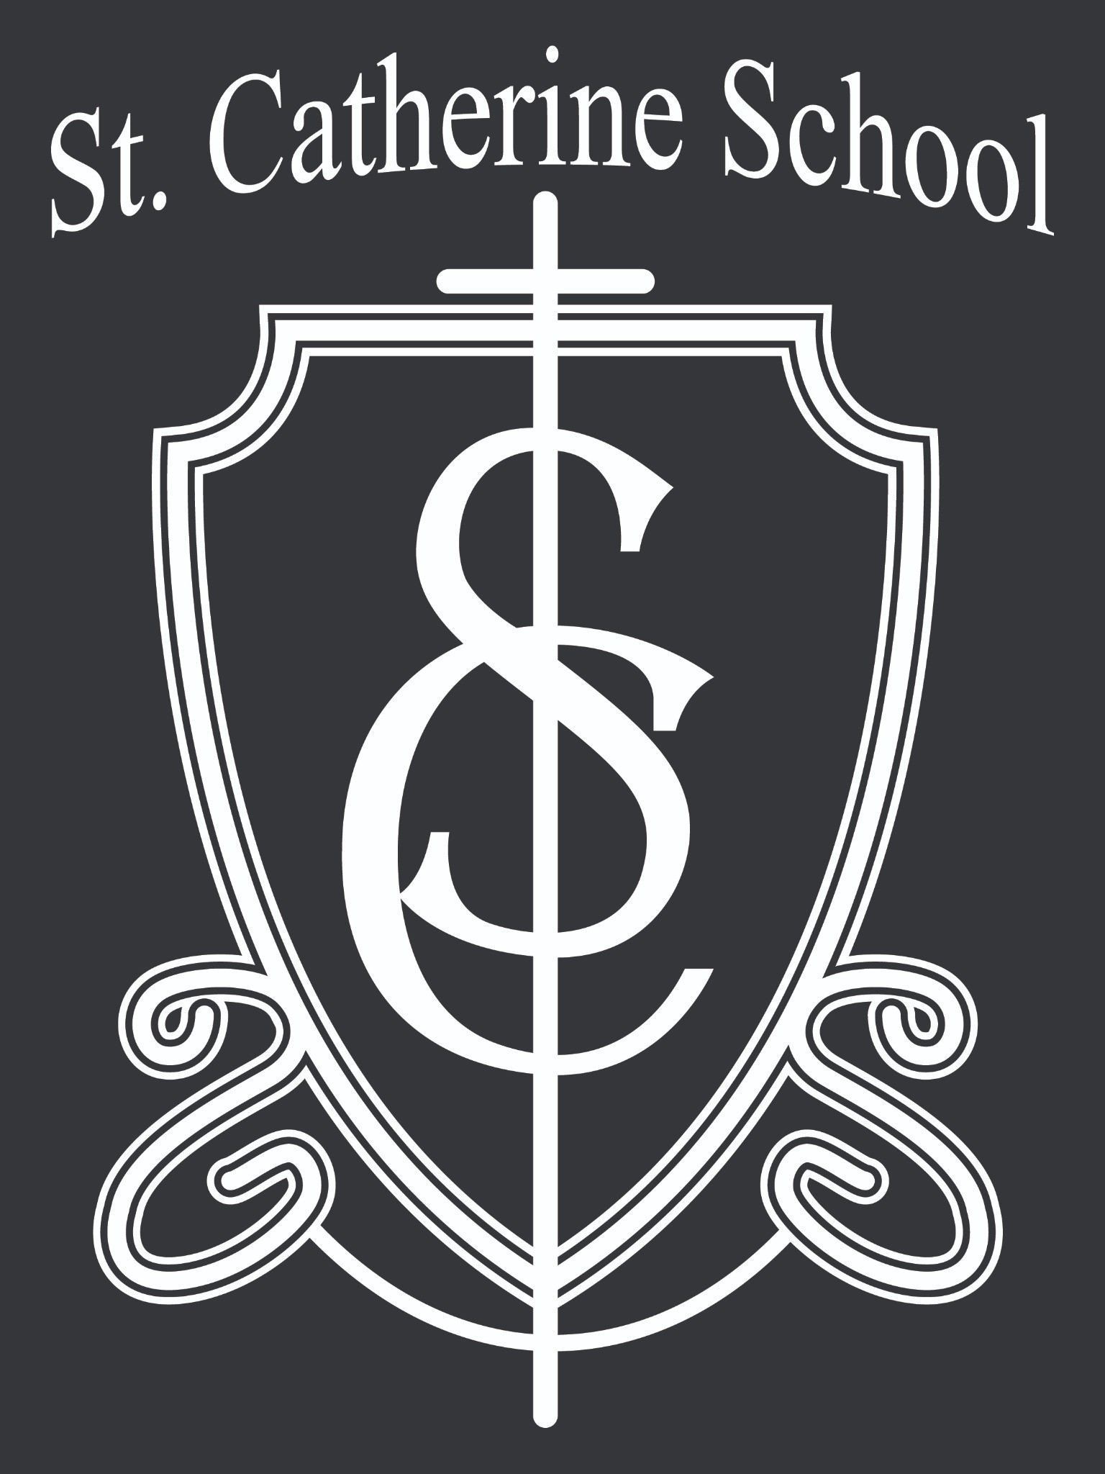

Stay Connected with St. Catherine School
📍 Address: 540 3rd Ave. NE, Valley City, ND 58072
Email: nicholas.lee1@k12.nd.us
📧
Phone: 1-701-845-1453
📞
Website: www.stcatherine.k12.nd.us
🌐
📘 Follow Us on Facebook: St. Catherine School on Facebook

“Inspiring excellence through faith, learning, and service.”

