## 

Ms. Mann’s Class News October 21-October 25, 2024

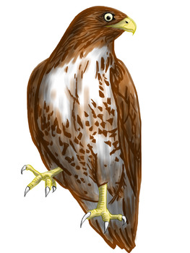

Reading with Raptors

The 2nd grade received a visit from Valerie Castanza with **Raptor Ridge**, who brought several raptor birds (Red tail Hawk, Black Buzzard, and a Barn Owl) to our school.

**What we are studying this week.**

**Congratulations to our Students of the Week for October.**

Dawson Hancock

Keaton Halstead

Piper Wooley

**Science-**Science Spin from Scholastic News

**Social Studies**- Lady Liberty Studies-monuments and symbols of the

United States of America

**Language Arts**- Irregular plural nouns

**Math-** adding to 100

**Reading-***Our Government at Work*

**Spelling**- r controlled words

**Tests this week: Wednesday,** test on arrays and repeated addition

**Other upcoming tests:**

**Phonics/Spelling test on long u words and r-controlled words October 31**

**Language test on irregular verbs October 30**

**Important**

Our students and families have several opportunities to show support for others at this time.

1: Wounded Warrior Project-any non-perishable items, monies are needed

2. Hurricane Victims-any donations to fit the needs of the people affected by the recent hurricanes are appreciated.

3. Our Booster.com fund raiser is going on now. Please help us meet our goal by donating.

**Student of the Month for October**

Gabe Milhouse

Congratulations Gabe!

**Classroom Needs**

Baby wipes

Treats for treasure box

Dry Erase Markers,

Highlighters

**Paper Towels** We need each student to bring two rolls a month to keep up with our demand.

As always, thank you so much.

**Important Dates**

October 31, candy grab

Nov 11, Veteran’s Day Holiday, no school

Nov 25-29 Thanksgiving holidays, no

school

December 20, ½ day

December 23-January 3 Christmas Holidays

Students return on Jan 7