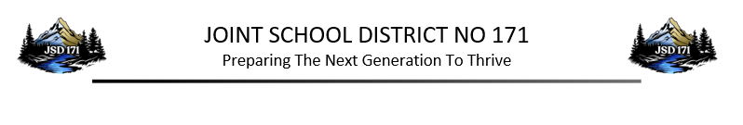
Vacancy Announcement

Date: August 13, 2026
Position: Child Nutrition Delivery Driver
Location: District-wide
Position Summary
Joint School District No. 171 is seeking a reliable and dedicated Child Nutrition Delivery Driver to join our team. In this role, you will ensure the safe, timely, and efficient delivery of food and kitchen supplies across the district.
Key Responsibilities
- Safely transport food and supplies to various school locations within the district.
- Load and unload delivery vehicles carefully to maintain food safety and inventory integrity.
- Operate district transport vehicles in strict compliance with traffic laws and school safety protocols.
- Collaborate with the Child Nutrition Director and kitchen staff to ensure delivery schedules are met.

Schedule: One day per week/ approximately 5.5 hours per day

Salary: $16.08 per hour

Benefits: This position is not eligible for benefits.
Closing Date: Open until filled
Start Date: As soon as possible
Direct Inquiries: Carmen Griffith, Child Nutrition Director (208) 476-0500 or griffithc@jsd171.org

Applications Available:
https://orofinojsd171.schoolinsites.com/employmentopportunities
(select Classified Application)
Email- HR@jsd171.org
Central Office- 1145 Riverside Ave. Orofino, ID 83544

Please return application materials to HR@jsd171.org

EOE/AA EMPLOYER
VETERANS’ PREFERENCE

