Mrs. Daniel’s Messages
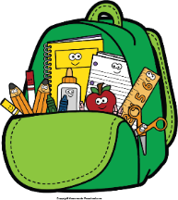
April 25-29, 2022
Grammar (prepositions and prepositional phrases) and

Reading Skills (draw conclusions) Tests: Friday
Spelling (final syllable) and Vocabulary Tests: Friday
Please check binders each night and initial behavior log.
Monday, April 25: Progress Reports Issued Friday, April 29: Spirit Day; Special Snack
Wednesday, May 4: Field Trip Money/Forms Due
by 9:00 a.m.
Monday, May 9: Field Trip to Lanark
Monday, May 16: Field Day
Friday, May 20: Awards Day
Thursday, May 26: Teacher In-Service
(NO SCHOOL)
Friday, May 27: Last Day of School

Reading Story and Skills:  Story:  A Birthday Basket for Tia  by Pat Mora  Text-Based Comprehension:  draw conclusions;  questioning  Phonics/Fluency:  final syllables  -tion, -ture  Grammar:  prepositions and  prepositional phrases |  | Vocabulary Words  (these words will be tested each week):  - aunt – your father’s sister, your mother’s  sister, or your uncle’s wife  - bank – a place where people keep their money  - basket – something to carry or store things in  - collects – brings things together  - favorite – the thing liked better than others  - present – something given
Math  Topic 12: Measuring Length  Topic 15: Graphs and Data  On Friday, we will take a weekly assessment. |  |  |  | Social Studies/Science  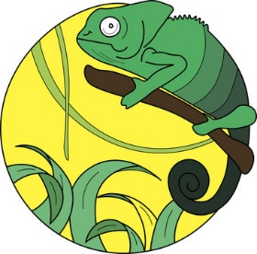  We will study  plants and  animals more  this week.
Spelling Words: Students who spell all bonus words correctly with get a small prize.
1. mixture  2. nation  3. section | 4. future  5. picture  6. action |  | 7. caution  8. station  9. fixture |  | 10. motion  11. nature  12. feature | BONUS  13. location  14. adventure  15. fraction

