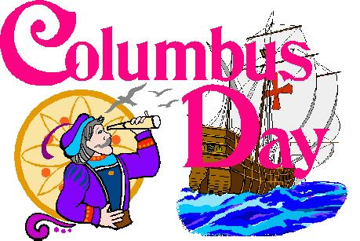

Mrs. Williams’ Class News

**Week of October 2, 2023**

**Math –** find sums of two whole numbers (regrouping)

**Social Studies –** continue magnet unit

**Upcoming Events:**

**Thursday, October 5** – Conferences

**Friday, October 6** – No School for students

**Monday, October 9** – Columbus Day – No School