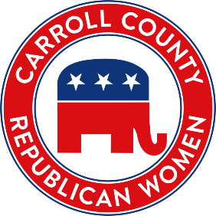
Carroll County Republican Women (CCRW)
2027 Scholarship Information and Application

CCRW is proud to provide scholarship opportunities to graduating high school students in Carroll County. Through these monetary gifts, we hope to enrich lives and encourage young men and women to become future Republican Leaders. CCRW will award one scholarship in the amount of $750.
Eligibility
The CCRW Scholarship recipient must show a high degree of motivation in pursuit of their education and have an active history of community service and/or political involvement with the Republican Party.
- Applicant must be a U.S. citizen; a resident of Carroll County; and, a registered voter of Carroll County, if 18 or older.
- Applicant must be currently a graduating High School Senior, planning to attend a 2- or 4-year accredited college or trade school in the Fall of 2026, with a GPA of at least 3.0, who has demonstrated good moral character, strong leadership skills and a concern for the local community.

Scholarship Application Packet
Each applicant must submit the following items to be fully considered for scholarship:
_____Copy of Letter of Acceptance for enrollment from an accredited college or trade school, signed by an enrollment administrator.
_____Certified high school transcript listing GPA.
_____Attach two (2) letters of recommendations.
_____Scholarship Application must be signed by the applicant’s high school counselor or college advisor.
_____Complete Page 2 of the Scholarship Application along with a 500-word essay on the topic listed.

Applicants will be judged on the submitted responses along with:
- Leadership Activities and Community Service
- Scholastic Achievement and Future Goals

Award Guidelines
The Carroll County Republican Women Awards/Scholarship Committee will make the final selection based on above criteria as well as thoroughness of the written essay, with emphasis on good grammar and clarity.
Deadline: All completed applications must be emailed by March 31, 2027.
Email to: CCRW Awards Chair at: cherylhofmann@att.net
Winner will be asked to read his/her winning essay to the CCRW membership at the June 26, 2026 meeting to be held in Carroll County. Award check ($500) will be presented at that meeting.

Our very best to you!
Congratulations to the Class of 2027!
www.carrollcountyrepublicanwomen.com

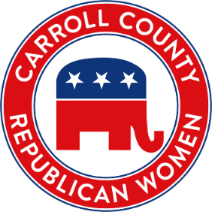
Carroll County Republican Women
2027 Scholarship Application

Name ______________________________________Date of Birth__________________________
Home address: ___________________________________________________________________
E-mail: _________________________________ Phone number: ____________________________
Parent / Guardian name and address: __________________________________________________ ________________________________________________________________________________
High School: _____________________GPA: ____________ Date of Graduation: _______________
High School Awards and accomplishments:
________________________________________________________________________________
_________________________________________________________________________________
Clubs/Organizations: (List any offices held and committees served on):
_________________________________________________________________________________
_________________________________________________________________________________
Other Activities and Honors:

Participation in any local Republican organizations/events:
_________________________________________________________________________________
500-WORD ESSAY TOPIC: All applicants must submit a personal essay 500-words or less about: How would you ensure elections are fair, secure and reliable?
Describe any special circumstances that you have experienced that would assist the scholarship committee in the selection process.
School Counselor Signature: ___________________________________________________________
Engaging, Educating, and Encouraging Republican Women since 1943.

