Math Review Week #1~Day 1 Name________________________

- Count forwards: 56, ________, ________, ________, 60, ________

- Put an X on the largest number: 51 16 29 42 73 8

- Jenny has 3 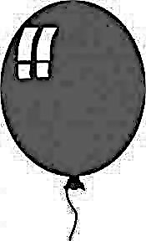s. She popped 2 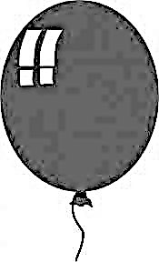s. How many 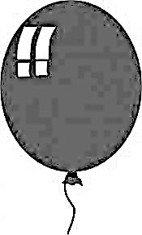s are left?

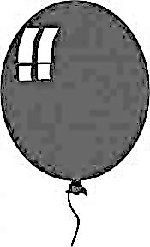 - = ________

4. What comes next in the pattern? O O X X O O X X ______ ______

5. Circle all the numbers in the SEVENTIES: 56 78 73 74 88 27

Mental Math ______________________

____________________________________________________________
____________________________________________________________
Math Review Week #1~Day 2 Name________________________

1. Add: + = ________

2. Count forwards: 45, 46, _______, ________, 49, ________, 51, ________

- Write the number that comes after 32: ________

- Circle the object that is most like a triangle:
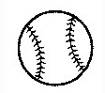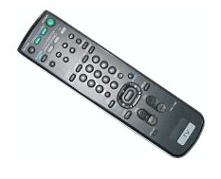

5. Circle the pennies: 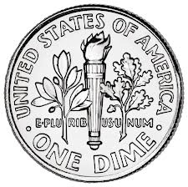 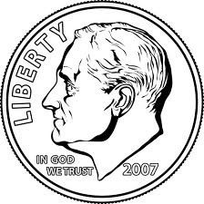 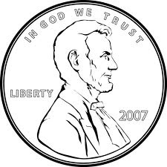 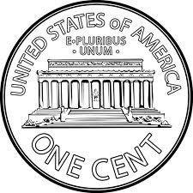

Mental Math ______________________
Math Review Week #1~Day 3 Name________________________

- Write the number sixty-two: ______________

2. What is the name of this shape? ____________

3. Put an X on the smallest number: 90 51 16 29 38 74

- How many fish are there? 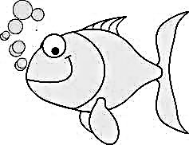 +

________ + _______ = _______

5. How many sides? _______ How many vertices? _______

Mental Math ______________________
____________________________________________________________
____________________________________________________________

Math Review Week #1~Day 4 Name________________________

- Write the number that comes right before 45: ______

- Add: + = ________

- What is the name of this shape?_____________

- Count backward: 20, ______, 18, 17, ______, ______, ______, ______

5. If tomorrow is Saturday, then what day is today? Friday or Tuesday

Mental Math ______________________
Math Review Week #1~Friday Five Name_____________________

1. Put an X on the largest number: 51 16 29 42 73 8

2. Circle the object that is most like a triangle:

3. How many fish are there? 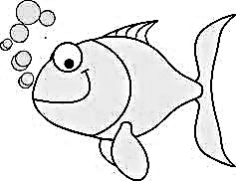 +

________ + _______ = _______

4. Write the number sixty-two: ______________

5. If tomorrow is Saturday, then what day is today? Friday or Tuesday

Mental Math ______________________

Math Review Week #2~Day 1 Name________________________
- Circle the tallest boy:

- Count forwards: 24, ________, ________, ________, 28, ________

- Tim has 7 s. He ate 3 s. How many s are left?

_______

4. If today is Saturday, what was yesterday? Friday or Tuesday

5. Circle all the numbers in the TWENTIES: 26 28 32 20 41 27

Mental Math ______________________
____________________________________________________________
____________________________________________________________
Math Review Week #2~Day 2 Name________________________

1. Subtract: 6 - 2 = _______

2. Circle the object that is the lightest: 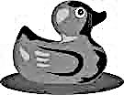

3. Color the shape that has 4 sides and 4 vertices.

- Count forwards: 87, ________, ________, ________, 91, ________

5. Add: + = ________

Mental Math ______________________
Math Review Week #2~Day 3 Name________________________

- How many vertices total?_______ How many sides total?_______

2. Count backwards: 10, 9, 8, ______, ______, ______, ______, ______

3. Circle the penny: 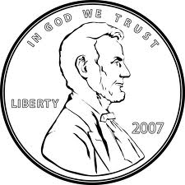 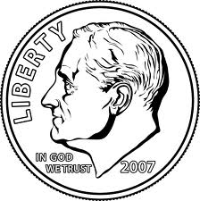

4. Write the number thirty-four: ______________

- Circle the group that has MORE sides total:

Mental Math ______________________
____________________________________________________________
____________________________________________________________
Math Review Week #2~Day 4 Name________________________

1. Circle the pennies: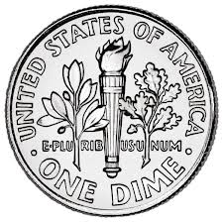 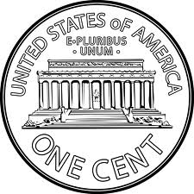

- Subtract: 7 - 3 = ______

- What is the name of this shape?_______________

4. Write the number that comes right before 67:______

5. Circle all numbers that are in the FORTIES: 44 57 33 40 41 49

Mental Math ______________________
Math Review Week #2~Friday Five Name_____________________

1. Circle all the numbers in the TWENTIES: 26 28 32 20 41 27

2. Circle the object that is the lightest: 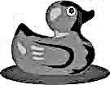

3. Add: + = ________

4. Circle the group that has MORE sides total:

5. Circle the pennies:

Mental Math ______________________

Math Review Week #3~Day 1 Name________________________

- Finish the ABB pattern: X O O X O O _____, _____, _____, _____

2. Count forwards: 16, ________, ________, ________, 20, ________

3. Fred has 4 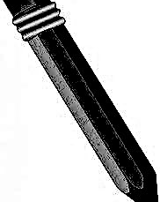s. He got 2 mores. How many s does he have in all?

+ = _______

4. Circle the smallest number: 84 19 41

5. Circle all the numbers in the NINETIES: 89 91 94 23 79 99 96 80

Mental Math ______________________
____________________________________________________________
____________________________________________________________

Math Review Week #3~Day 2 Name________________________

1. Circle all the rectangles:

2. Subtract: 4 - 2 = ________

3. Circle the largest number: 94 19 71 28 65 30

- Fill in the place value for 87: ______ tens ______ ones

- Finish the AAB pattern: X X O ______ ______ ______ ______ ______

Mental Math ______________________

Math Review Week #3~Day 3 Name________________________

- Circle the shapes with 4 vertices:

2. Write the next 2 numbers in the pattern: 6 7 9 6 7 9 6 7 9 _____ _____
3. Circle the penny:

4. Draw two shapes that have no sides and no vertices: _________ _________
- Cross out any shape that does not have 3 sides: 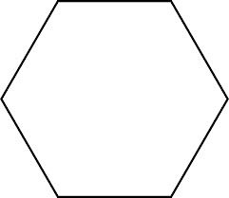

Mental Math ______________________
____________________________________________________________
____________________________________________________________

Math Review Week #3~Day 4 Name________________________
- Circle the pennies: 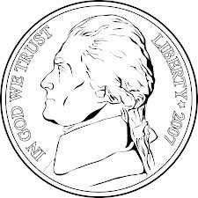 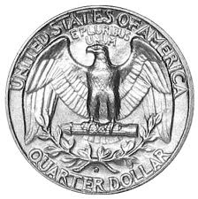

- Add: + = ________
- Circle the object that is the heaviest: 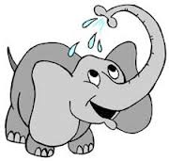

4. What type of pattern is this? 
AB ABB

5. Cross out the number that is in the wrong place: 20, 19, 18, 17, 18, 15, 14
Mental Math ______________________

Math Review Week #3~Friday Five Name_____________________

- Fred has 4 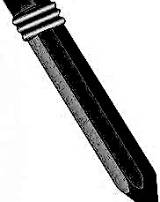s. He got 2 mores. How many s does he have in all?

+ = _______

2. Fill in the place value for 87: ______ tens ______ ones

3. Circle the penny:

4. Cross out any shape that does not have 3 sides:

5. Cross out the number that is in the wrong place: 20, 19, 18, 17, 18, 15, 14

Mental Math ______________________

Math Review Week #4~Day 1 Name________________________
1. Subtract the dominos: 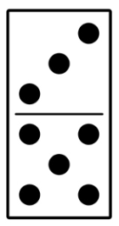 - 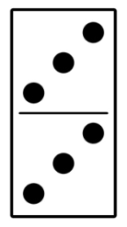 = ______

2. Count forwards: 52, ________, ________, ________, 56, ________

3. Pam ate 1 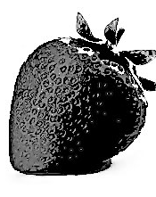. She ate 6 mores. How many s did she eat in all?

+ = _______

4. Write the next 3 numbers in the pattern: 8 8 7 8 8 7 8 8 7 ____ ____ ____
5. Circle the value of a penny: 1¢ 5¢ 10¢

Mental Math ______________________
____________________________________________________________
____________________________________________________________
Math Review Week #4~Day 2 Name________________________

1. Add: + = ________

2. Circle the coin name: nickel dime penny

3. Count backwards: 20, ________, 18, 17, ________, 15, ________, 13

- Circle the shape that is missing from the pattern ?

- Finish the ABC pattern: 9 7 3 ______ ______ ______ ______

Mental Math ______________________
Math Review Week #4~Day 3 Name________________________

- Circle the object that is the lightest:

- What shape is this?___________
3. Circle the nickels: 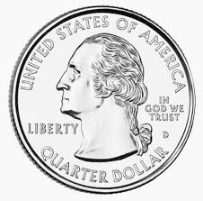

4. Count backwards: 20, ________, 18, 17, ________, ________, ________

5. Cross out any shape that does not have 4 sides

Mental Math ______________________
____________________________________________________________
____________________________________________________________

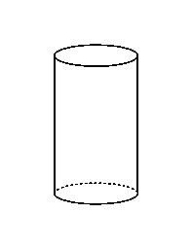
Math Review Week #4~Day 4 Name________________________
- Show 5:00 on the clock: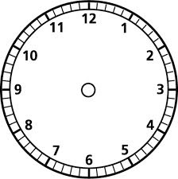
- Circle the shapes with 0 sides:

- Is this shape 2D or 3D? 2D 3D

4. Write the number sixty-eight: ______________

- Counting back, cross out the number that is in the wrong place and correct it:

59, 58, 57, 52, 55, 54, 53
Mental Math ______________________
Math Review Week #4~Friday Five Name_____________________

1. Count forwards: 52, ________, ________, ________, 56, ________

2. Circle the shape that is missing from the pattern ?

3. Circle the nickels:

4. Circle the object that is the lightest:

5. Counting back, cross out the number that is in the wrong place and correct it:

59, 58, 57, 52, 55, 54, 53

Mental Math ______________________

Math Review Week #5~Day 1 Name______________________

- Show 5 o’clock on the clock:

2. Which shape does not belong?

3. Bob had 4 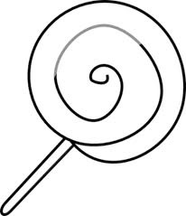s. He ate 2 s. How many s does he have left?

- = ____

4. Draw the next 2 shapes in the pattern: _____ _____

5. Circle all the numbers in the FORTIES: 44 40 14 24 47 46 43

Mental Math ______________________
____________________________________________________________
____________________________________________________________
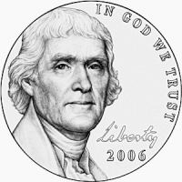
Math Review Week #5~Day 2 Name________________________

1. Circle the coin name: nickel dime penny

2. Count by 10s: 30, 40, ______, ______, 70, ______, ______, 100

3. Circle the largest group of circles:

4. Complete the pattern: ☺ 😐 😐 ☺ 😐 😐 ___

5. Circle any two shapes whose sides equal 8 total:

Mental Math _____________________
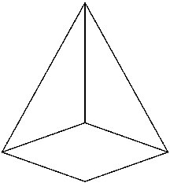
Math Review Week #5~Day 3 Name________________________

- Is this shape 2D or 3D? 2D 3D

- Circle in ANY 2 shapes that have a TOTAL of 8 vertices:

3. Subtract using the picture to show: 6 - 3 =______

4. What type of pattern is this? ___________ 

- How many sides?______ How many vertices?______

Mental Math ______________________
____________________________________________________________
____________________________________________________________

Math Review Week #5~Day 4 Name________________________

- Is this shape 2D or 3D? 2D 3D
- Circle the coin value: 5¢ 25¢ 10¢ 1¢

- Write the name: _____________

4. Circle the AAB pattern:        

- If this month is May, what will next month be? June or December

Mental Math ______________________
Math Review Week #5~Friday Five Name______________________

1. Draw the next 2 shapes in the pattern: _____ _____

2. Count by 10s: 30, 40, ______, ______, 70, ______, ______, 100

3. Subtract using the picture to show: 6-3 =______

4. How many sides?______ How many vertices?______

5. Write the name for this coin: _____________

Mental Math ______________________

Math Review Week #6~Day 1 Name________________________
- 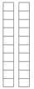 Circle the number: 18 20 10

2. Subtract using the picture to show: 4-3 =______

3. Circle the smallest group of fish:
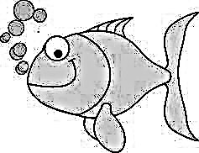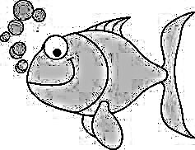

4. Draw the missing pattern pieces:     ___ ___    
5. Circle the coin name: nickel dime

Mental Math ______________________
____________________________________________________________
____________________________________________________________
Math Review Week #6~Day 2 Name________________________

1. Circle all the 2D shapes: 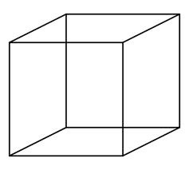 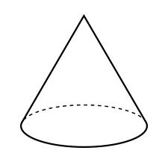

2. Put an X on all the largest number: 91 86 99 84

3. There were 5 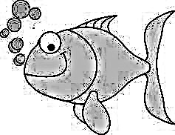 in the pond. 3 more were born. How many are there now?
+ = ____

4. Draw a shape with 4 SIDES.

- Write the next 3 letters in the pattern: G H H G H H _____ _____ ____
Mental Math ______________________

Math Review Week #6~Day 3 Name________________________

- How many hundreds, tens, and ones are in the number 137:

_____hundreds ______tens ______ones
- Circle the dimes:

3. Color in ANY 2 shapes that have a TOTAL of 8 vertices between them:

4. Circle the growing pattern:           
5. Color all shapes that have greater than 3 vertices.

Mental Math ______________________
____________________________________________________________
____________________________________________________________

Math Review Week #6~Day 4 Name________________________
- What is the name of this shape?_______________
- Circle the number: 18 20 40

3. Use the pictures to solve 5-2=___

4. Count backward. Find the mistake & correct it. 87, 86, 85, 84, 80, 82, 81
 
- Count backwards: 18, 17, 16, ______, ______, ______, ______

Mental Math ______________________
Math Review Week #6~Friday Five Name______________________
1. Circle the number: 18 20 10

2. Circle all the 2D shapes:

3. Circle the dimes:

4. Circle the growing pattern:      

5. Count backward. Find the mistake & correct it. 87, 86, 85, 84, 80, 82, 81

Mental Math ______________________

Math Review Week #7~Day 1 Name________________________

- Circle all the numbers in the NINETIES: 99 29 39 98 91 23 29

- Circle all shapes that have less than 4 vertices.

3. Add: 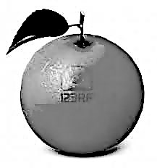 + = _________

- Count forward: 118, 119, 120, ________, ________, ________, ________

5. Subtract: 2-1=_____

Mental Math ______________________
____________________________________________________________
____________________________________________________________
Math Review Week #7~Day 2 Name________________________

1. Circle all the 3D shapes:

2. What number has 3 TENS and 1 ONE? Thirty-One Thirteen Thirty

- Draw the missing shapes: __ __

4. Subtract: 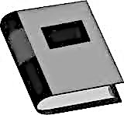 6- 2 = ______

5.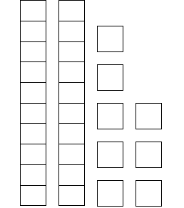 Circle the number: 18 37 28

Mental Math ______________________
Math Review Week #7~Day 3 Name________________________

- Draw a model to show 160:

- Add: 5+5=______

3. Fill in the place value for 180: _____ hundreds _____ tens _____ ones

4. Circle any number with a 6 in the ones place: 46 76 36 89 16 6

5. Draw a shape that has 4 vertices and 4 sides:

Mental Math ______________________
____________________________________________________________
____________________________________________________________

Math Review Week #7~Day 4 Name________________________

- Circle all shapes that have less than 3 vertices.

- Which number has 1 HUNDREDS, 6 TENS and 3 ONES? 163 316

- Add: 8+2=_______ 

4. Fill in the place value for 199: _______ hundreds ______ tens ______ ones
  
- Begin by drawing a shape with 3 vertices.
Inside that shape, draw a shape with 4 sides.

Mental Math ______________________

Math Review Week #7~Friday Five Name_____________________

1. Count forward: 118, 119, 120, ________, ________, ________, ________

2. Draw the missing shapes: __ __

3. Fill in the place value for 180: _____ hundreds _____ tens _____ ones

4. Circle all shapes that have less than 3 vertices.

5. Add: 8+2=_______

Mental Math ______________________

Math Review Week #8~Day 1 Name________________________

1. Fill in the place value for 62: ______ tens ______ ones

2. What number has 6 TENS and 7 ONES? Seventy-Six Sixteen Sixty-Seven

3. What coin is this? penny dime nickel quarter

- 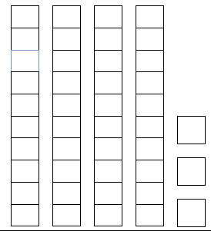 Circle the number: 43 34 70

5. What is the value of a quarter? 5¢ 25¢ 10¢

Mental Math ______________________
____________________________________________________________
____________________________________________________________
Math Review Week #8~Day 2 Name________________________

- Add: 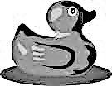 + = ____
- What is the name and value of this coin? ____________ ______¢

- Count forward: 97, 98, ______, ______, ______, ______, 103, ______, 105

- Which number has 2 HUNDREDS, 8 TENS and 3 ONES? 238 283

- In the box draw a model using
tens and ones for the number 74.

Mental Math ______________________
Math Review Week #8~Day 3 Name________________________

1. Fill in the place value for 132: _____ hundreds _____ tens _____ ones

2. Circle the growing pattern:       

 

3. Count forwards: 189, 190, 191, ______, ______, ______, ______, ______

4. I have no sides and no vertices. Draw me:

5. Circle any number with a 3 in the tens place: 34 36 67 38 13 29

Mental Math ______________________
____________________________________________________________
____________________________________________________________

Math Review Week #8~Day 4 Name________________________
- Circle all shapes that have less than 3 sides.

2. Circle the value of this money: one-dollar five cents one cent

3. Which piece of the pattern fell out? _ _ _ 

       or      

4. Subtract. Seven fish were in the pond. Two jumped out! How many are left?
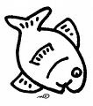 ______ - ______ = _______

5. Count back. ‘X’ the error and correct it. 98, 97, 96, 92, 94, 93, 92, 91

Mental Math ______________________
Math Review Week #8~Friday Five Name_____________________

1. What is the value of a quarter? 5¢ 25¢ 10¢

2. Add: 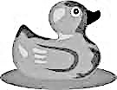 + = ____

3. Which number has 2 HUNDREDS, 8 TENS and 3 ONES? 238 283

4. Circle the growing pattern:        

    

5. Count back. ‘X’ the error and correct it. 98, 97, 96, 92, 94, 93, 92, 91

Mental Math ______________________

Math Review Week #9~Day 1 Name________________________

- Use < > or = to compare the following numbers: 113 ___ 115 150 ___ 50

2. What number has 4 TENS and 0 ONES? Fourteen Forty Forty-One

3. What coin is this? penny dime nickel quarter

- Order these #s from LEAST to GREATEST: 34 64 24 94

_______ _______ _______ ________
5. What is the value of a penny? 1¢ 5¢ 25¢ 10¢

Mental Math ______________________
____________________________________________________________
____________________________________________________________
Math Review Week #9~Day 2 Name________________________

1. Subtract: 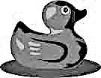 4-3 = ____
- What is the name and value of this coin? 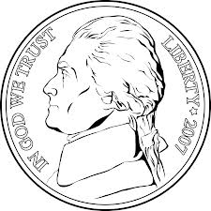____________ ______¢

3. Circle any number with a 4 in the ones place: 34 54 57 84 94

- Fill in the place value for 156: ______ hundreds, ______ tens, ______ ones

5. Circle the number: 143 118 134

Mental Math ______________________
Math Review Week #9~Day 3 Name________________________

- Order the following numbers from LEAST to GREATEST: 98 89 54 100

__________ ___________ ___________ ___________

- Add: 5+ 2 =____

3. Fill in any number that makes this equation true: 23 < __________
4. How many vertices are there total? ____

5. Draw a model in the box to show the number 23.

Mental Math ______________________
____________________________________________________________
____________________________________________________________

Math Review Week #9~Day 4 Name________________________
- Circle all shapes that have more than 3 sides:
2. Circle the value of this money: one-dollar five cents one cent

3. Circle the number: 143 151 134

4. Count forwards: 167, 168, 169, ______, ______, ______, ______, ______
  
- Add: + = _______

Mental Math ______________________
Math Review Week #9~Friday Five Name_____________________

1. Order these #s from LEAST to GREATEST: 34 64 24 94

_______ _______ _______ ________

2. Use < > or = to compare the following numbers: 113 ___ 115 150 ___ 50

3. What is the name and value of this coin? ____________ ______¢

4. How many vertices are there total?____

5. Circle the number: 143 151 134

Mental Math ______________________

