Portage School District Therapy Dog Handbook

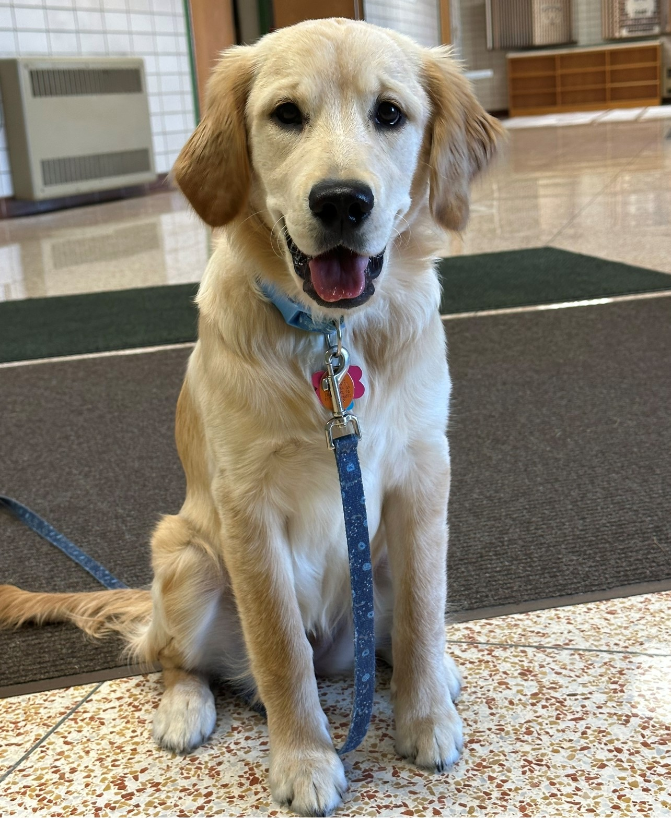

What is a therapy dog?
Portage Area School District supports the use of a therapy dog for the benefit of its students’ subject to the conditions of the school board policy. A therapy dog is a dog that has been trained and registered to work with its handler to provide emotional support, comfort, therapeutic benefits, emotional well-being or companionship to school district students. Therapy dogs are not “service animals” as that term is used in the Americans with Disabilities Act (ADA), and therefore approval of the use of a therapy dog on district property is entirely within the discretion of the Superintendent and Portage Area School Board and not considered a reasonable accommodation under the ADA. This therapy dog is personal property of the school social worker employed by Portage Area School District. According to the Alliance of Therapy Dogs: “Their responsibilities are to provide psychological or physiological therapy to individuals other than handlers.”
Some traits of therapy dogs are:
- Stable temperaments, friendly, easy going personalities
- They are encouraged to interact and be pet by a variety of people while they are on duty
- Give children with learning disabilities confidence
- Owners of therapy dogs do not have the same rights as service dogs to be accompanied by the dog in establishments where they are not permitted.
A handler is an individual school district staff member who owns the therapy dog and who has been individually trained, evaluated, and registered with her therapy dog to provide animal assisted activities, animal assisted therapy, and animal assisted interactions within a school.
Purpose
Therapy dogs improve the culture and general mood of the school for all students and staff. Therapy dogs provide many healing effects including:
- Reduced stress and anxiety for students and staff
- Decreased feelings of depression, loneliness, and feelings of isolation
- Decrease in aggressive behaviors
- Increase in socialization resulting in a sense of happiness and well being
- Increase in mental stimulation
- Give children with learning disabilities confidence
Improve the general mood of the school.
Therapy dogs make a connection with at-risk students, and give them a reason to come to school. The emotional well-being of students is a large factor in their success. The presence of a therapy dog can give student a sense of happiness that allows them to perform better academically. Animals have been incorporated into schools in order to allow children to discuss issues of grief (Mockler, 2010).
Make connections with at risk students, and give them a reason to come to school.
There are many children who struggle to open up to a teacher or counselor about issues that they are facing. Interaction with animals can relieve their anxiety and improve mood (Siegel, 2004). The therapy dog will give our social worker opportunities to talk with children that otherwise wouldn’t open up about their situation. Children may find comfort talking to the dog, and in turn, be willing to share with a school staff. Many children who experience emotional troubles often lack trust, and using the intervention for a dog may help the children to develop trust. Interacting with animals helps to decrease anxiety, manipulative/ abusive behaviors, depression, increase self-esteem, self-worth, expression of feelings, and ability to trust (Chandler, 2001).
Improve literacy skills.
Reading to dogs can eliminate the fear of judgement for many children. Many studies have shown that students are able to improve their reading ability because of the increased motivation and interest they have in reading with a dog. A study of the All Ears Program was conducted at the Veterinary School at the University of California-Davis, and is showed that school children that read aloud with a handler and dog team improved their reading skills by 12 percent compared to children who read with an adult only (Paddock, 2010).
Therapy dog standards and procedures
Registration: The therapy dog shall have registration from an organization that requires an evaluation of the therapy dog and the handler and shall remain current and in good standing at all time.
Health and Vaccinations: The handler shall submit proof from a licensed veterinarian that the therapy dog is in good health and has been immunized against diseases common to dogs. Such vaccinations shall be kept current and up to date at all times. The handler will also ensure the therapy dog is given flea and tick treatments monthly.
Licensing: The dog shall wear appropriate identification issued by the county. Nala is also microchipped and registered.
Health and safety: The Board of School Directors shall ensure that the therapy dog does not pose a health and safety risk to any student, employee, or other person at school and that the therapy dog is brought to the school district only when properly groomed, free of illness or injury, and the temperament appropriate for working with children and others in the schools.
Control: The handler shall ensure that the therapy dog wears a non-corrective collar or harness and a leash no longer than 4 feet and shall remain in control of the therapy dog by holding the leash at all times that the therapy dog is on school district property, including during breaks, unless such leash would interfere with the therapy dogs safe, effective performance of his work or tasks. The handler shall maintain control of the therapy dog at all times. Students and staff will not be permitted to give the dog any people food or treats.
Supervision and care of the therapy dog: The handler shall be solely responsible for the supervision, and humane care of the therapy dog, including any feeding, exercising, and cleaning up after the dog while the dog is in the school buildings or on school property. The handler shall not leave the therapy dog unsupervised or alone on school property at any time.
Authorized Area(s): The handler shall ensure that the therapy dog has access to only such areas of the school building or properties that have been authorized by school district administrators.
Allergies and Aversions: The handler shall remove the therapy dog to a separate area, as designated by the school Superintendent. In such instances where any student or school employee who suffers dog allergies or aversions is present in an office, hallway, or classroom. In order to minimize allergic reaction, the handler shall provide a clean blanket for the therapy dog to lay on.
Damages and Injuries: The handler shall assume full responsibility and liability for any damage to school property or injury to district staff, students, or others in the school caused by a therapy dog. The handler will carry a 1-million-dollar liability insurance on the therapy dog.
Notification: The handler shall seek approval from the building principals prior to bringing the therapy dog into the school. The request for administrative approval should include the date, times, and the area which the therapy dog will interact with students and any other limitation or conditions to be established.
Additionally, an annual notification shall be included in the parent/student handbook to allow parents the opportunity to present any concerns to having their student interact with the therapy dog and for the district to plan for an implement any necessary accommodations.
Exclusion or removal from school- A therapy dog may be excluded from school district property for any reason, with or without cause. Reason for exclusion can include, but are not limited to the following:
- The handler does not have control of the therapy dog
- The therapy dog is not housebroken
- The therapy dog presents a direct and immediate threat to others in the school or
- The therapy dog’s presence otherwise interferes with the educational program.
Procedure and School Board Discretion- Before a therapy dog is permitted on school district property pursuant to this policy, the therapy dog and the handler must be approved by the duty passed resolution of the board of school directors. The school district shall retain full discretion to permit or exclude therapy dogs from its schools and no part of this policy shall be constructed to confer a right upon anyone to bring a therapy dog into school district property.
References

Alliance of Therapy Dogs. What is the difference between a therapy dog and a service dog?. March 12th, 2017. Retrieved from https://www.therapydogs.com/service-dog-vstherapy-dog/
Animals & Society Institute. Effects of reading with adult/tutor therapy dog teams on elementary students’ reading achievement and attitudes. http://www.therapyanimals.org/Research_&_Results_files/SOAN_025_01_38-56-Levinson%20et%20al.pdf
Mockler,K.(2010).Pet Therapy: A New Way of Reaching Students with Additional Disabilities. Odyssey: New Directions in Deaf Education, 11 (1). 23-24.
Paddock, C. (2010, April 27). Dogs helped kids improve reading fluency. Medical News Today. Retrieved from http://medicalnewstoday.com/articles/186708.php.
Siegel, W.L. (2004). The Role of Animals in E

