Weight Training
Course Syllabus

Instructors: Josh Ingram, Jacob Lautenbach, Patrick Hunter, Jason Respert, Sam Zanders, Jr.

Email: joshua.ingram@hcbe.net; jacob.lautenbach@hcbe.net; patrick.hunter@hcbe.net; jason.respert@hcbe.net; sam.zanders@hcbe.net

Room: Weight Rm

Course Description:
This course aims to introduce students to the fundamental principles of strength and conditioning. The goal is to enhance the muscular strength/endurance, flexibility/mobility, and overall fitness of student-athletes. Our focus is on developing the student’s strength, power, flexibility/mobility, and core through effective programming. Our strength and conditioning program follows the physiological principles of overload, progression, and specificity. Students will gain an understanding of the essential role that strength, conditioning, and proper nutrition play in athletic performance and injury prevention. The course will cover important topics such as the contributions of strength and conditioning to athletic excellence, safety, diet, and weight management.

*Weight training follows the six GPS performance standards listed on the following link:
https://www.georgiastandards.org/Georgia-Standards/Pages/Physical-Education.aspx

Class Structure:
Our strength and conditioning program is designed to take an integrative approach by combining movement-specific training with core and flexibility exercises. Every muscle group will be worked through its full range of motion, with an emphasis on proper technique to ensure adequate muscular response and reduce the risk of injury. The training programs will include cardiovascular conditioning, strength training, power training, and speed training.

Class Objectives:
Students will be able to:
-Perform various strength training exercises with proper form.
-Demonstrate correct biomechanical technique while performing all exercises to enhance muscular response and injury reduction.
-Apply correct safety/spotting techniques in the weight room.
-Demonstrate and apply overload, progression, and specificity principles in strength training.

Class Expectations:
*STUDENTS WILL MAINTAIN AND USE ALL EQUIPMENT APPROPRIATELY WHILE PARTICIPATING. ANY STUDENT WHO DAMAGES OR BREAKS WILL BE RESPONSIBLE FOR PAYING FOR THE DAMAGES OR REPLACING THE EQUIPMENT!

Chrome book statement: “All students are issued a district-provided chrome book for instructional purposes, student engagement, and student learning.” Chromebook use is at the direction and discretion of the classroom teacher.”

NON-NEGOTIABLES

- NO CELL PHONES. Cell phones will be taken immediately, and students will be able to pick up their devices from the front office at the end of the school day.
- RESPECT OTHERS. Pay attention, do not talk while someone else is talking, and encourage your classmates/teammates to reach their full potential.
- Follow all normal accepted behavior policies outlined in your student handbook.
- BE ON TIME FOR CLASS. The school tardy policy in the student handbook will be followed.
- Be dressed out in clothing appropriate for weight training. (No jewelry on arms/hands or dangling earrings).
- NO FOOD OR DRINKS IN THE WEIGHT ROOM. ONLY WATER IS ALLOWED.
- No Horseplay. Students that can’t be serious enough to train will be removed from class, and conduct will be reported to their respective coaches.
- ATHLETIC SHOES MUST BE WORN AT ALL TIMES, providing support, stability, and proper covering over toes that are safe and suitable for weight room workouts. NO CROCS, FOAMS, FLIP FLOPS, BOOTS, SANDALS. You will not be considered dressed out unless you are wearing proper shoes.
- STUDENTS ARE EXPECTED TO TRAIN DAILY; EVEN ON GAME DAY. Only a note from a PHYSICIAN may excuse a student from participating.
- Students will be given time to dress out, and safely secure their belongings in a locker room. The locker rooms will be locked at the start of weight training class and will be reopened at conclusion of class. The teacher will not be held responsible for lost or stolen items. Students must remove all their items at the end of each period.
- This class is designed to make YOU better...come with the right attitude/no complaining.
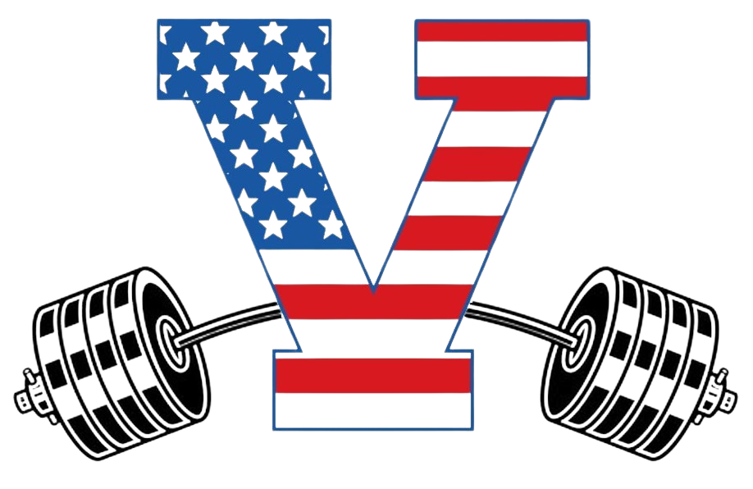

WARHAWK WEIGHT ROOM CULTURE
Be on time
Be detailed
Transition efficiently
Tempo always pushed
Do every rep every set no matter what
Great technique on everything
Attitude positive
Energy produced and demanded
Effort maximal
Coachable always

Class Schedule:
-Dress out/report weight room

Grading/Course Requirements:
Major Assessments (School Min = 5) 45%
*Participation Grade
-determined by the daily participation of all activities. Weekly grade is calculated by dividing 100 by the number of days in the week to determine the value for each day a student does not participate in daily workouts. Students must bring a doctor’s note to be excused from a workout.

Minor Assessments (School Min = 8) 20%
*Performance/Progress/Fitnessgram
-student performance and progress will be measured throughout the course by various means including the timed mile and half mile, strength max out, vertical jump increases, etc.

Daily Work (School Min=15) 15%
*Participation Grade
-Determined by having the proper shoes/clothing and participating in the workout/activity of the day. Daily grades are 20 points, PASS/FAIL. Participation grades will be assessed weekly.

Final Exam (School Min=1) 20%

-This course includes a cumulative exam at the end of the semester. The final exam during the first and second semester is worth 20% of the semester grade.

Virtual Classroom materials will be provided via Canvas

**I have read and understand all of the objectives, requirements, and expectations set forth by the Strength and Conditioning Staff for the 2024-25 Weight Training Class.

Student’s Name:___________________________________________
Parent Signature:__________________________________________

**Must be signed by Parent/Guardian and returned no later than Thursday, August 5, 2024.

Medical Information

Parents/Guardians,
If there are any medical concerns that your son or daughter has that I need to be made aware of, please explain on the following lines. Please return alongside the signed syllabus. Remember, students must have a doctor’s note to be excused from any fitness activity. If your student does not have any medical concerns, please write “None”, sign, and return. Thank you.

Student’s Name: ________________________________________
Parent’s Name: _________________________________________

Medical Concerns:

