Unit 3: Chemical Bonding, Reaction, and Energy
Student Notes

BIG IDEA: In chemical reactions, atoms are rearranged and regrouped via chemical bonding to form a new product.

ENDURING UNDERSTANDING: Students can apply their understanding of bonding to explain that mass and energy are conserved during chemical reactions as new products with new properties are made, citing evidence by using models to describe changes in atomic composition.

- Chemical Bonds and Nomenclature
(How to find valence electrons)

- Periodic Table Reactivity
  - Valence electrons- are the electrons present in the outermost shell of an atom.
  - Valence Shell- the outermost shell of an atom
  - Atoms want to have a stable or full valence shell. For the first energy level, a full shell would be 2 electrons. For the second and third energy level, a full shell would be 8 electrons.
  - Atoms that do not have a valence shell that is full of electrons are reactive meaning that they want to combine with other atoms to try to make their shells full. Atoms will transfer or “share” electrons in order for each atom to have a full outer shell.
  - Atoms bond when the valence electrons of one atom interact with the valence electrons of another atom.
  - A molecule forms when two or more atoms bond together chemically.
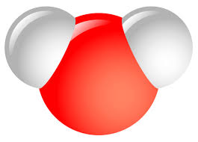

Water is an example of a
molecule that is created
when two or more atoms
bond together chemically.

G. Lewis Dot Structures- It is a way to display the number of valence electrons for elements. This chart will show the correlation between group number and the number of valence electrons.

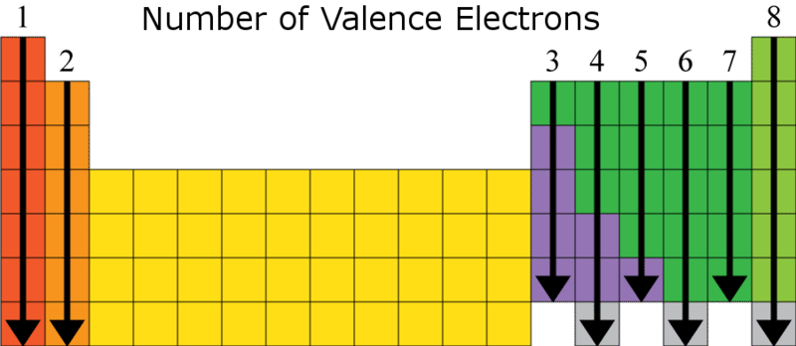

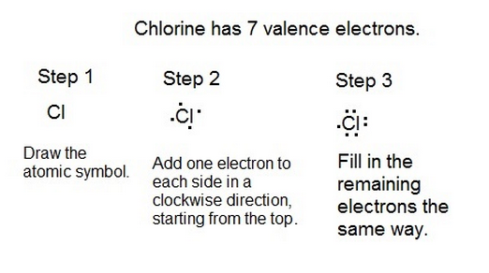

NOTE INTERACTION: Lewis-dot structure review.
Draw the lewis-dot structures for the following elements.

Ca O F H Al P

- Types of Chemical Bonds (Video) or https://www.youtube.com/watch?v=PKA4CZwbZWU
  - Ionic Bonds
    - Ionic bonds are the result of an attraction between two ions that have opposite charges.
      - What is an ion?
        - Remember that atoms are electrically neutral because they have the same number of protons and electrons. (The positive and negative charges cancel each other out). When two atoms come close enough that one of the atoms “steals” an electron from another atom, two ions are created.
        - Cation- If an atom LOSES one or more electrons, it becomes a POSITIVE ION because it now has more positive charges than negative charges.
        - Anion- If an atoms GAINS one or more electrons, it becomes a NEGATIVE ION because it now has more negative charges than positive charges.
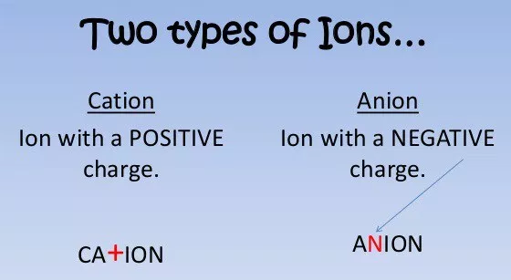

    - Ionic bonds usually occur between metals and nonmetals.
    - An example of an ionic bond is Sodium chloride (NaCl) which is table salt.
https://www.youtube.com/watch?v=Qf07-8Jhhpc
https://www.youtube.com/results?search_query=ionic+bonding+part+2
https://www.youtube.com/watch?v=RkZNYuSho0M
    - Ionic Bond & Nomenclature (Ionic Bonds)
    - Ionic- always written with empirical formula. Name the metal and then name the nonmetal with an “ide”(name the cation first, then the anion)
      - All ionic compounds, since they have a metal and nonmetal are salts.
      - When there is more than one oxidation number, use the stock system.

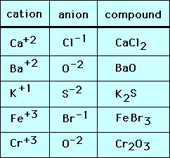

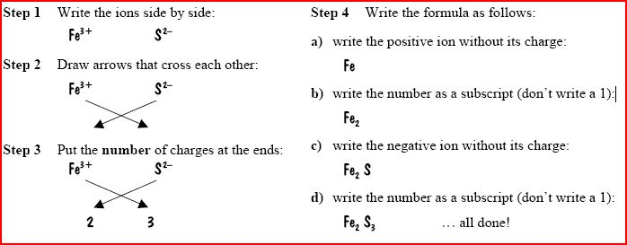

  - Covalent Bonds
    - Covalent bonds form when electrons are shared between atoms.
    - Covalent bonds often occur between nonmetals.
    - An example of a covalent bond is Carbon dioxide (CO₂)
https://www.youtube.com/watch?v=LkAykOv1foc&t=9s
    - Covalent Bonds & Nomenclature (Covalent Bonds)
      - Covalent- uses prefixes (mono, di, tri, tetra, pent, hexa, hepta…), but do not use mono on the first element.
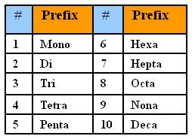
      - The second element ends in “ide”
      - If there are two conflicting vowels right next to each other, one of them is dropped
      - Ex.
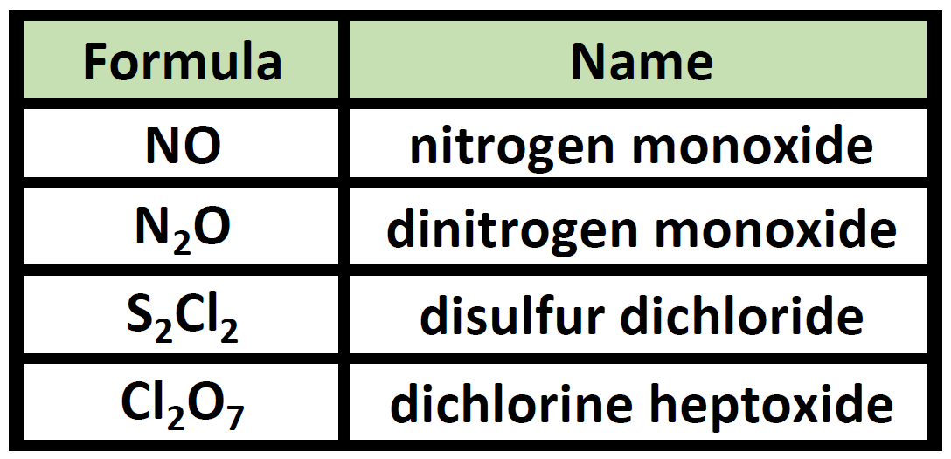

  - Metallic Bonds
    - Metallic bonds exist only in metals, like silver and gold.
    - Electrons are free to move throughout the metal atoms. This is why metals are good conductors of heat and electricity.
  - Hydrogen Bonds
    - A force of attraction between a Hydrogen atom in one molecule and a small atom of high negativity in another molecule.
    - When Hydrogen atoms have their electron unequally shared with the other attached atom, the partial positive charge on the hydrogen is highly concentrated because of its small size. The other atom will carry a negative charge. Positive charges are attracted to negative charges, but no actual physical connection occurs between adjacent molecules.
    - Hydrogen bonding also have a very important effect on the properties of water, proteins, and nucleic acids.
- Which elements want to react?
  - Elements want to find another element that will complement their outer valence electrons to give the atom a full outer shell. For example, Group 1 elements only have one valence electron and they like to bond with Group 17 elements which have seven valence electrons. Group 2 atoms have 2 valence electrons and they like to bond with Group 16, which have 6 valence electrons.

- Polyatomic ions
  - These are molecules that collectively behave as a “single” molecule with a single collective charge.
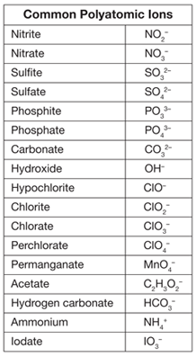
NOTE INTERACTION:

Part 1: For each of the following ionic bonds:
- Write the symbols for each element.
- Draw a Lewis Dot structure for the valence shell of each element.
- Draw an arrow (or more if needed) to show the transfer of electrons to the new element.
- Write the charges on the ions.
- Write the resulting chemical formula.

a) Sodium + Chlorine

b) Magnesium + Iodine

Part 2: For each of the following covalent bonds:
- Write the symbols for each element.
- Draw a Lewis Dot structure for the valence shell of each element.
- Rearrange the electrons to pair up electrons from each atom.
- Draw circles to show the sharing of electrons between each pair of atoms
- Draw the bond structure using chemical symbols and lines. Use one line for each pair of electrons that is shared.
- Write the chemical formula for each molecule.

a) Hydrogen + Hydrogen

b) Chlorine + Chlorine

II. Physical and Chemical Changes
Chemical and Physical Changes Video
- Physical change- A change that results in a change in appearance or form, but not the identity of the matter.

- Chemical Change- A change that results in a change in the identity of the matter (a NEW substance with different properties is formed.)
  - Evidence of a chemical change-
    - Color change
    - Gas (bubbles) produced
    - Temperature change
    - Light is produced
    - An odor is produced
    - A solid (precipitate) forms

Physical Changes | Chemical Changes (also known as chemical reactions)
Phase changes (melting, freezing, vaporization, condensation) | Cooking food (baking, grilling, etc.)
Materials being crushed, torn, bent | Digesting food
Materials being mixed or dissolved | Combustion of materials (burning, lighting a candle, gasoline in a car engine)

  - A chemical change is also known as a chemical reaction. A chemical reaction is a change in matter that produces one or more new substances.
  - Chemical reactions occur when chemical Bonds (attractions that holds compounds together) break, atoms rearrange, and new bonds form.
  - Evidence of Chemical Reactions (formation of a new substance and a change in energy).
    - Formation of a precipitate (A precipitate is a solid formed from two solutions.)
    - Change in color.
    - Production of a gas, bubbles, or odor.
    - Light produced.
    - Change in temperature.

NOTE INTERACTION:
Label the following examples PC(for physical change) and CC(for chemical change), Provide evidence for your answer.

Example | Type of change and evidence if chemical change.
Aluminum foil is cut in half
Milk goes sour
Rubbing alcohol evaporates in your hand
Butter melts
Gasoline is ignited
Bread is toasted
Hydrogen Peroxide bubbles in a cut

III. Chemical Formulas and Equations

- Compounds
  - When atoms of elements are joined together, a compound is formed. These compounds are either ionic or covalent in nature and represented by chemical formulas.
- Chemical formulas
  - A chemical formula of a compound shows the relative number of atoms of each of the elements in the compound.
    - Ex. (H₂0, CH₄, C₆H₁₂O₆)
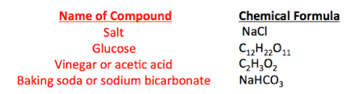
  - Empirical formula- simplest whole number ratio of atoms. (Always used with ionic compounds.)
  - Molecular Formula- Tells how many atoms are actually present.
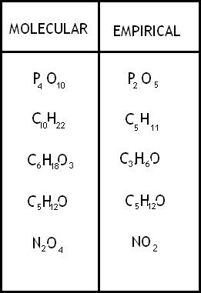
  - Structural Formula- shows how the elements are bonded together.
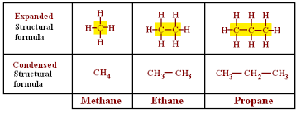

- Chemical Equations
  - A chemical equation is a “sentence” that describes what happens during a chemical reaction. It consists of symbols and/or formulas, a yield sign and coefficients and state of the compound.
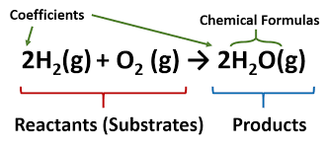

  - Parts of a chemical equation
    - Reactants
      - A Reactant is the substance(s) present at the start of the reaction
      - Reactants are written to the left of the “yield” arrow in a chemical equation
    - Products
      - A Product is the substance(s) present at the end of the reaction
      - Products are written to the right of the “yield” arrow in a chemical equation.
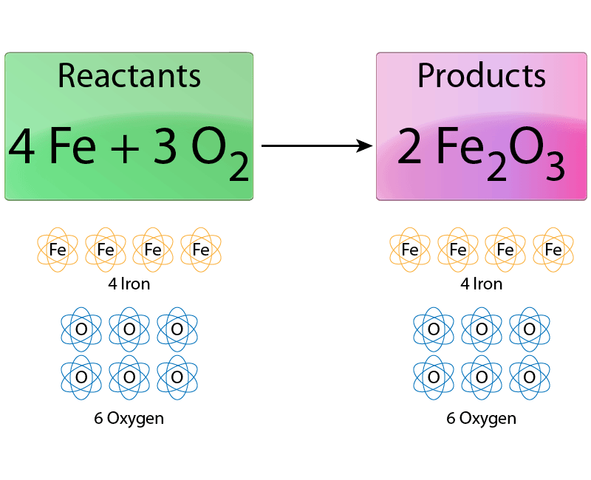
Notice how many individual atoms are on each side of the equation. The number of Fe and O atoms on the reactant side, MUST equal the number of Fe and O atoms on the product side.

  - Coefficients are put in front of the formula to show the ratio of amount of reactant to amount of product.

IV. The Law of Conservation of Mass states that during a chemical reaction matter cannot be created or destroyed, but only transferred or transformed. Therefore, chemical equations must be balanced.
- A balanced chemical equation shows that there are the same number of atoms of each element on both sides of the equation.
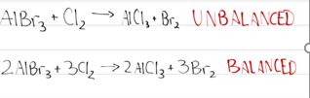

- To balance a chemical equation, coefficients must be put IN FRONT of the chemical formula.

- Do NOT add or change the subscripts. They indicate the number of atoms that are in the compound.
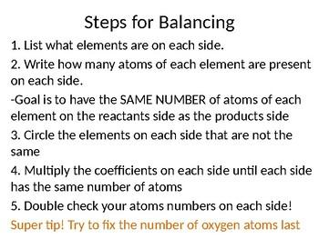

NOTE INTERACTION:
A molecular model of a balanced chemical equation is shown below.

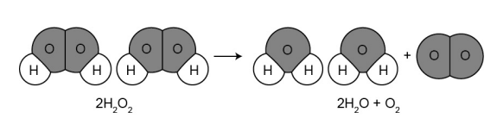
Draw the molecular model of the following balanced chemical equation.

2CO + O₂ -----> 2CO₂

Review how to balance an equation
https://www.youtube.com/watch?v=yA3TZJ2em6g

Practice balancing equations
https://phet.colorado.edu/en/simulation/balancing-chemical-equations

https://education.jlab.org/elementbalancing/index.html There is a beginner, intermediate, and advanced level.

V. Types of Reactions (Types of Reactions)

- Synthesis Reaction
  - Two or more reactants form one product.
- Single Displacement Reaction
  - A more active element displaces another less active element from a compound.
- Double Displacement Reaction
  - Two elements will be displaced in a chemical reaction
- Decomposition Reaction
  - A single compound will break down into two or more simpler substances.

- Combustion Reaction
  - Occurs when a compound (usually a hydrocarbon) reacts with oxygen gas. The products are carbon dioxide and water.
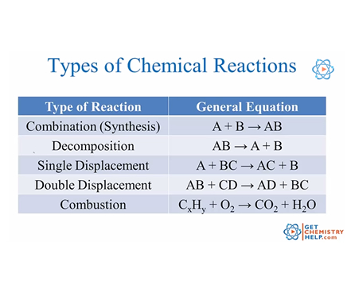
NOTE INTERACTION: Complete the following table with the type of reaction.

Reactions | Type of reaction
N₂ + 3H₂ -----> 2NH₃
2NaI + F₂ ---> 2NaF + I₂
C₂H₆ + 5O₂ ---> 3H₂O +2CO₂
2H₂O ---->2H₂ + O₂
N₂ + 3H₂ ----> 2NH₃
Pb(NO₃​)₂​+2KI→2KNO_{3​}+PbI₂​

VI. Rates of Reactions
The rate of a chemical reaction describes the speed at which a reaction happens.
The collision theory states that as more collisions in a system occur, there will be more molecules bouncing into each other and a higher chance that the molecules will complete the reaction.
The following factors increase the rate of a reaction
    - Temperature- increasing the temperature of a system increases particle motion
    - Concentration- if there is more of a substance in a system, there is a greater chance that the molecules will collide
    - Pressure- increasing pressure packs the molecules into a smaller space which increases the chance that the molecules will collide
    - Catalyst- adding a catalyst lowers the activation energy (amount of energy needed to start the chemical reaction)
    - Surface area- breaking substances into smaller pieces, or increasing surface area, exposes more the substance to the other reactant

VII. Energy Changes in Chemical Reactions
- Endothermic reaction- Energy is removed from the surrounding and enters the system. That’s why it feels colder to touch. (“Endo”=”in to”).

- Exothermic Reaction- Energy is RELEASED from the system and enters the surrounding. Feels hotter to touch. (“Exo”= “out of”).

