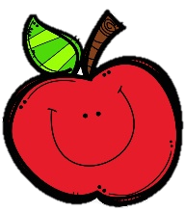
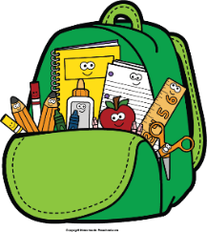
Mr. Marks’ Messages
January 13th-17th, 2025
Assessments
All ELA assessments will be pushed back until Thursday, January 23rd.
Friday Assessments: Weekly math quiz
Reminders
- Tuesday, January 14th- Report Cards
- Friday, January 17th- Class Pictures
- Monday, January 20th- MLK Jr. Day (No School)
- Friday, January 24th- Second Grade Musical (1:30 in the Lunchroom)
- Friday, January 31st- Bulldog Spirit Day/Special Snack
- Please check your child’s binder daily for important information, homework, and their behavior chart.
Reading Story and Skills:  Story: The Langston Times  Phonics/Fluency:  /s/ spelled ce, ci, cy, and /j/ spelled ge, gi  Writing:  Personal Narratives  Text-Based Comprehension:  Compare/Contrast  Grammar/Language:  Commas (items in a series) |  | Vocabulary Words  - blared: loud, harsh sound  - revealing: showing or displaying  - result: an outcome that happens because of something else  - seams: a line where pieces of material are joined together  - features: notice able parts of a flat thing  - solar panel: flat objects that convert light energy into electricity  - sources: places or things that other things came from  - progress: movement toward a goal  - officials: people who hold a certain office or position  10.value: the worth of things in money
Math  Topic 13  Shapes  Students will explore 2-D and 3-D shapes and their attributes. Students will also partition shapes into halves, thirds, and fouths. |  |  |  | Social Studies/Science  Science:  We will continue our unit on map skills. The students will learn to use maps to answer a variety of questions.
Spelling Words:
- age  - peace | - circus  - pencil |  | - magic  - ice |  | - spicy  - face | - gem  10. large

