|  |  |  |  |  |  |
| --- | --- | --- | --- | --- | --- |
|  | Monday | Tuesday | Wednesday | Thursday | Friday |
| W  E  E  K  1 | 1.Pop tart / Toast  2.Cereal Bowl  3.SAUSAGE BISCUIT | 1.Pop Tart / Toast  2.Cereal Bowl  3.CINNI MINI / YOGURT | 1.Pop Tart / Toast  2.Cereal Bowl  3.SAUSAGE BISCUIT | 1.Pop Tart / Toast  2.Cereal Bowl  3.HAM CHEESE  CROISSANT | 1.Pop Tart / Toast  2.Cereal Bowl  3.PANCAKE & SAUSAGE |
| W  E  E  K  2 | 1.Pop Tart / Toast  2.Cereal Bowl  3.SAUSAGE BISCUIT | 1.Pop Tart / Toast  2.Cereal Bowl  3. FRENCH TOAST STICKS & CHICKEN BITES | 1.Pop Tart / Toast  2.Cereal Bowl  3.SAUSAGE BISCUIT | 1.Pop Tart / Toast  2.Cereal Bowl  3.GRITS/EGGS/  SAUSAGE | 1.Pop Tart / Toast  2.Cereal Bowl  3.BREAKFAST PIZZA OR CHICKEN BISCUIT |

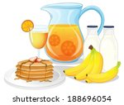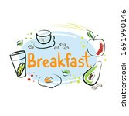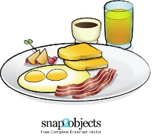

MILK, JUICE AND FRUIT ARE OFFERED WITH ALL BREAKFAST

Menu is subject to change

CNP is an equal opportunity employer