**PRATTVILLE KINDERGARTEN SCHOOL**

**2023-2024 SUPPLY LIST**

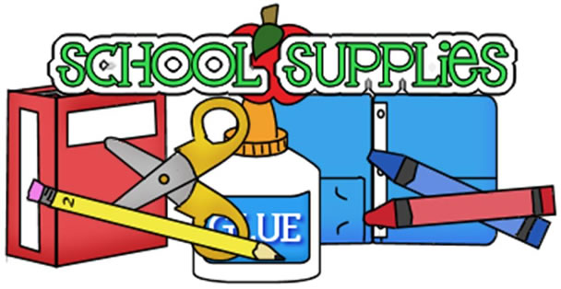

1. One 12 count pack of pre-sharpened #2 pencils
2. One pair of “Fiskars” brand children’s safety scissors
3. One 6 count pack of “Elmer’s” glue sticks
4. Two 24 count boxes of “Crayola” crayons
5. One pack of washable “Crayola” markers
6. Two rolls of paper towels
7. Two boxes of Kleenex
8. One package of baby wipes
9. Two packages of Clorox wipes
10. Boys: One box of sandwich size Ziploc bags

Girls: One box of gallon size Ziploc bags

PKS FIELD TRIP/SPIRIT DAY T-SHIRT: $15.00 from PKS Front Office

PKS Tote Bag: $15.00 from PKS Front Office

(Checks made payable to Prattville Kindergarten School)

**WISH LIST (Optional):** ream of card stock paper

**INFORMATION ABOUT SUPPLIES:**

1. We do not allow backpacks at PKS. Students will need an over the shoulder tote bag. (This can be purchased through at PKS.)
2. We do not allow “Kinder Nappers” or other type of nap rolls/mats at PKS.
3. Lunch, snack and juice can be purchased from school daily or brought from home. Depending on your choice, your child may need a lunchbox/water bottle.

**WE LOOK FORWARD TO AN EXCITING YEAR OF LEARNING WITH YOUR CHILD!**