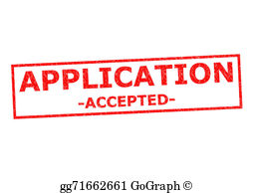

**Alabama Colleges Participating include…**

* **Alabama A & M University**
* 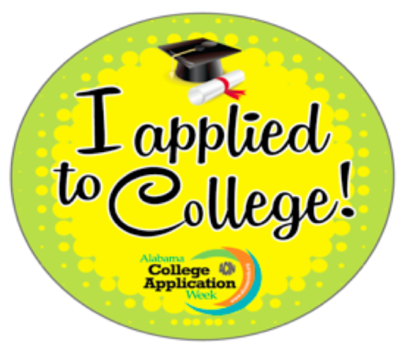**Alabama State University**
* **Auburn University at Montgomery**
* **Concordia College**
* **Jacksonville State University**
* **Judson College**
* **Marion Military Institute**
* **Miles College**
* **Selma University**
* **Spring Hill College**
* **Stillman College**
* **Talladega College**
* **Troy University**-Use code ALCAC2017 for Main Campus
* **Tuskegee University**
* **University of Montevallo**
* **University of North Alabama (UNA)**
* **University of West Alabama**

Alabama Possible**NOTE: List will be updated weekly prior to October 30, 2018**