

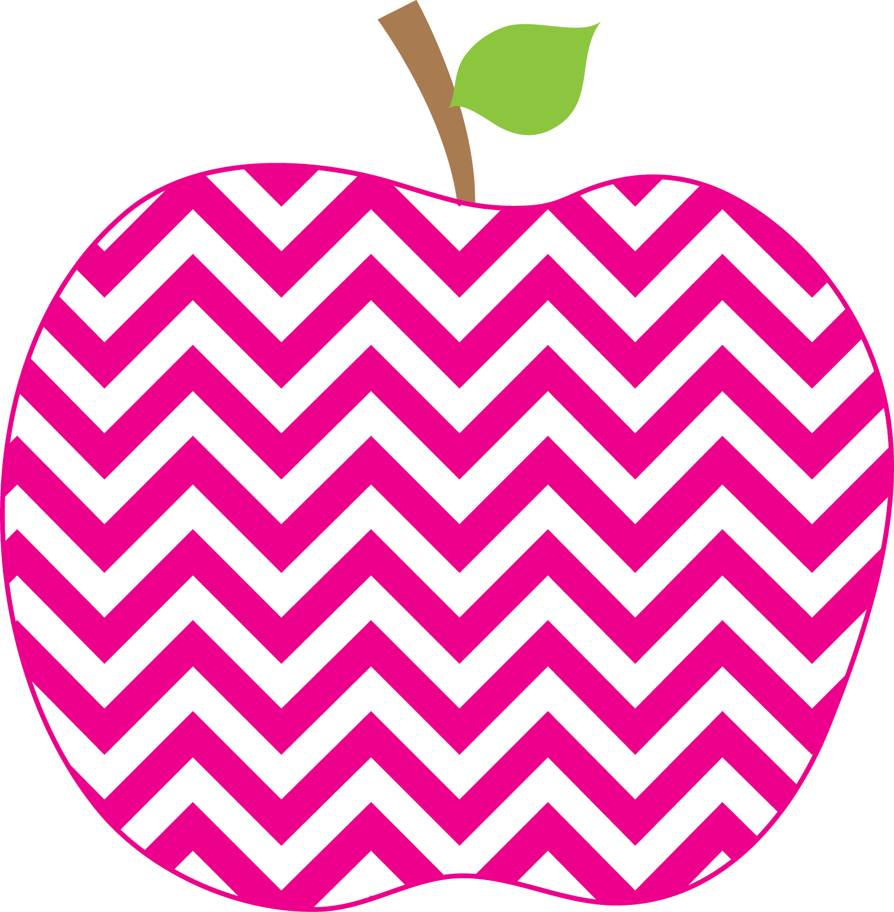



E. Robinson Weekly
Ms. E

November 4, 2024

Reading:
Phonics Skills: (REVIEW)
*Final Blend -ng spelled ng
(-ang, -ing, -ong, -ung)

High-Frequency Words: (Review)
girl, her, with, any, from, where
like, water, but, do, long, my, no

RED Words:
where with

Grammar Skill: Exclamatory Sentences

Math:
*Counting Back to Subtract

Social Studies/Science- Present Timeline Projects

**Please remember to send your child’s library book and binder to school each day.

This Week’s Focus:

Star Apple of the Week:
Athyna Hubbard
* * Please make sure to check the APPLE Binder each day for homework and sign the daily behavior sheet located in the back.

Monday, November 11th Veteran’s Day
(No School)

Wednesday, November 13th Progress Reports

Friday, November 15th Santa Pictures

Reminders:
Important Dates:

