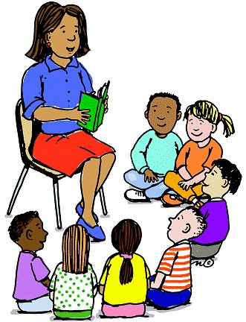

**Counselor’s Newsletter**

***Ms. Cunningham***

***November 2022***

**Dear Parents/Guardians,**

This month’s lesson will be about being Grateful. Students will learn to be grateful, thankful, and appreciative for what they have. In November, we celebrate Thanksgiving, where we gather around with our family and friends and appreciate each other. During this time, we feel thankful and grateful to be able to celebrate with the ones we love.

**News**

We will be out for a week to celebrate Thanksgiving break.

**Important Dates/Events**

**Club Day-10th**

**Holiday Break 21st-25th**

**Monthly Character Word**

**Gratitude**

We tend to take things for granted when we have access to them, or they are in abundance to us. Many of us are fortunate to have our basic needs met, but what about those of us who do not? Many people do not have access to running water, shelter, clothing or even food. It’s very important to be thankful and appreciative for what you have and not covet what others possess. Be grateful every day, be grateful that your basic needs are being met, because remember, it can be taken away.