** **

**The University of Kentucky Center of Excellence in Rural Health**

**2024-25 Healthy WAY Program**

*Healthy WAY (Wellness in All Youth) is a leadership development and research training program designed to empower rural Kentucky high school students with skills to identify and develop solutions to health and social issues at the school level. Student-led teams have the opportunity to work with school personnel to address real world concerns youth are facing today that impact their health and well-being. Project funding, hands-on research experience, technical support and research mentoring are available to student teams selected for this competitive program. Healthy WAY was established in 2019 as a signature program of the UK Center of Excellence in Rural Health (UK CERH).*

**RESULTS**

Before Healthy Way Activities

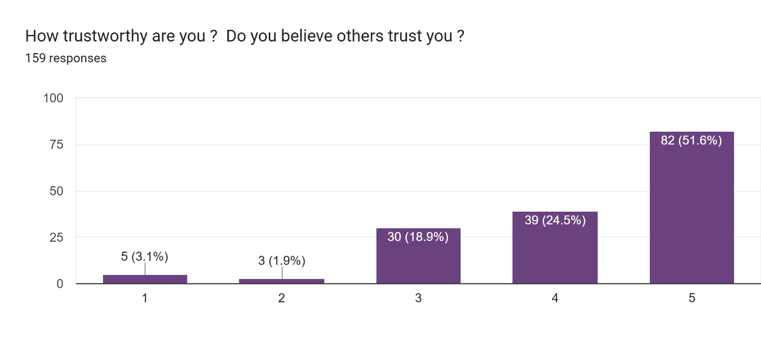

After Healthy Way Activities

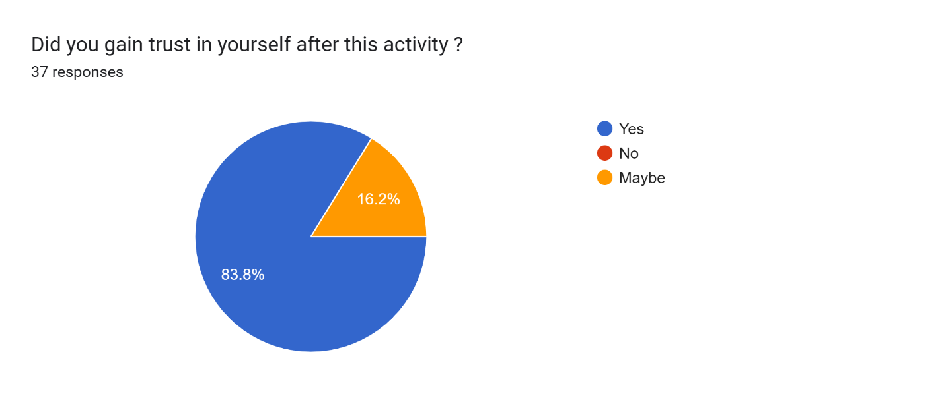

Before Healthy Way Activities

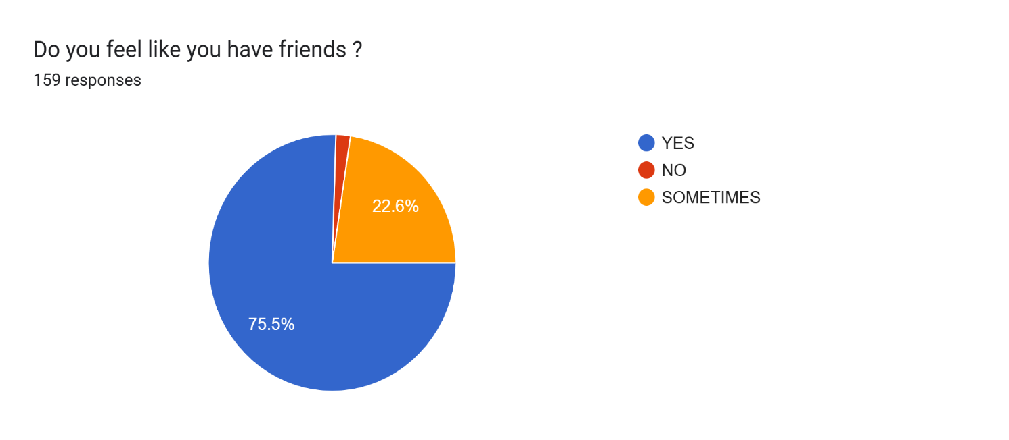

After Healthy Way Activities

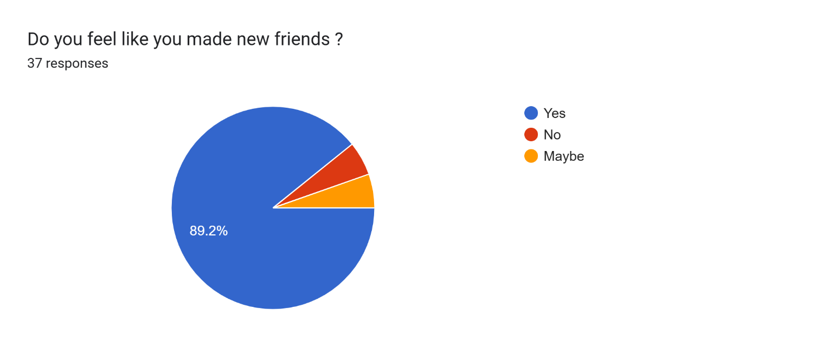

Before Healthy Way Activities

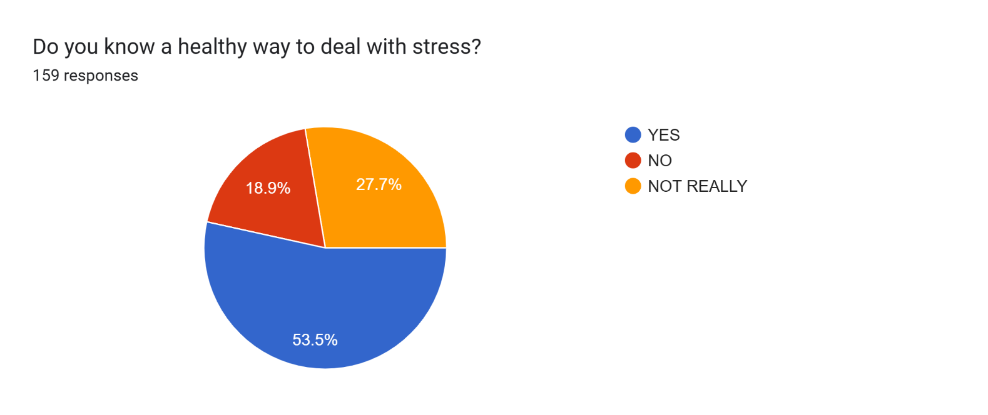

After Healthy Way Activities

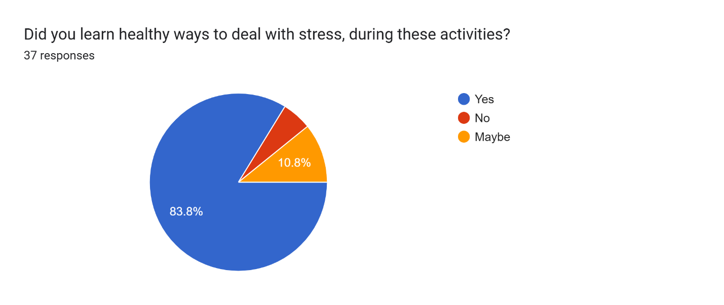

Before Healthy Way Activities

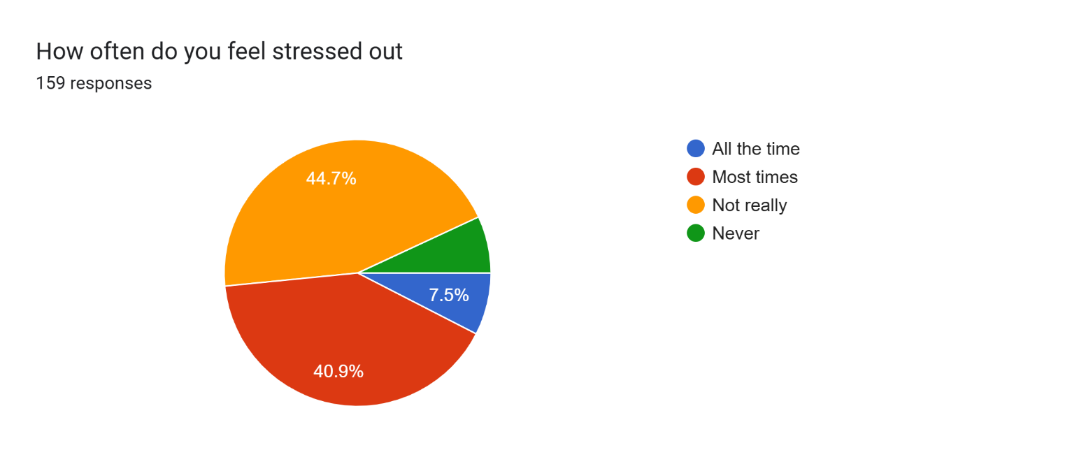

After Healthy Way Activities

