EXAMPLE FRANKLIN COUNTY HIGH SCHOOL
COLLEGE, CAREER & TECHNICAL EDUCATION FOUR-YEAR PLAN
FOR THE CLASSES OF 2023, 2024, & 2025

NAME: _____________________________________________________ DATE: ________________________________
Tennessee Graduation Requirements:

English: 4 credits
Math: 4 credits
Science: 3 credits
Social Studies: 3 credits
Personal Finance: 0.5 credit
Wellness: 1 credit
PE: 0.5 credit
Elective Focus: 3 credits
*Fine Arts: Not required for Tech School
*Foreign Lang: Not required for Tech School

Additional Requirements/Information:
In addition to the above requirements, Franklin County High School requires 6 additional credits for a total of 28 credits needed in order to graduate. All students must take the ACT to graduate. In addition to in-person AP math and science classes, FCHS now offers online AP classes at no cost for juniors and seniors with at least a 3.0 GPA. Classes offered are listed on the back of this sheet. Each student’s course of study in high school is based on individual interests and needs. Students on this path may take Career & Technical Education courses, honors courses, dual credit courses, and/or AP courses if he/she meets prerequisites. Please visit our website at https://fchs.fcstn.net/ and click on “Guidance” for more information.
More Information:
*If a student on this path plans to attend college, they should take Fine Arts and Foreign Language I and II as listed on this four-year plan to complete college entrance requirements. Career & Technical Education classes and Work Based Learning are the focus of this path.
FCHS REQUIRES 28 CREDITS FOR GRADUATION
9th Grade 10th Grade
1. English I 1. English II
2. Algebra I 2. Geometry
3. World History and Geography 3. Biology I
4. Physical Science 4. US Gov’t & Civics/PE
5. Wellness 5. Career & Technical Elective (Focus)
6. Career Exploration 6. Career & Technical Elective (Focus)
7. Career & Technical Elective (Focus) 7. Fine Arts* or Elective
8. Elective 8. Elective

11th Grade 12th Grade
1. English III 1. English IV
2. Algebra II 2. Pre-Calculus/Statistics or SAILS or Applied Math
3. Chemistry 3. Personal Finance/Economics
4. U. S. History and Geography 4. Career Technical Elective or *Foreign Lang III
5. Foreign Language I* or Career Technical Elective 5. Career Technical Elective
6. Foreign Language II* or Career Technical Elective 6. Career Technical Elective
7. Career & Technical Elective 7. Elective or Work Based Learning
8. Elective or Work Based Learning (2nd Sem) 8. Elective or Work Based Learning

POST SECONDARY PLANS
2 Year College: _____ 4 Year College: _____ Tech School: _____ Military: _____ Job: _____
The above is a general plan based upon state guidelines. Plans may change from year to year.
Student Signature__________________________________________________________________________

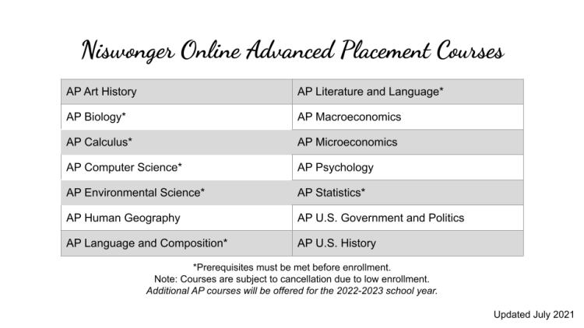
Prerequisites:
AP Art History: No prerequisite - Great introductory AP course!
AP Biology: In person Niswonger prerequisites are Biology I and Chemistry I. Algebra I is
recommended. FCHS prerequisite is honors Biology.
AP Calculus AB: In person Niswonger prerequisites are Algebra I, Geometry, Algebra II, Pre-Calculus or Trigonometry/Analytical Geometry. FCHS prerequisite is honors Calculus.
AP Calculus BC: Prerequisites are Algebra I, Geometry, Algebra II, Pre-Calculus or Trigonometry
AP Computer Science A: Prerequisite is Algebra I. Algebra II is recommended.
AP Environmental Science: Prerequisite is Algebra I. Two years of high school science with labs is recommended.
AP Human Geography: No prerequisite - Great introductory AP course!
AP Language & Composition: Prerequisites are English I and English II.
AP Macroeconomics: No prerequisites. Algebra I is recommended.
AP Microeconomics: No prerequisites. Algebra I is recommended.
AP Psychology: No prerequisite - Great introductory AP course!
AP Statistics: Prerequisite is Algebra II.
AP US Government & Politics: No prerequisite
AP US History: No prerequisite
AP Literature & Composition: Prerequisites are English I, English II, and English III or AP Language & Composition.

