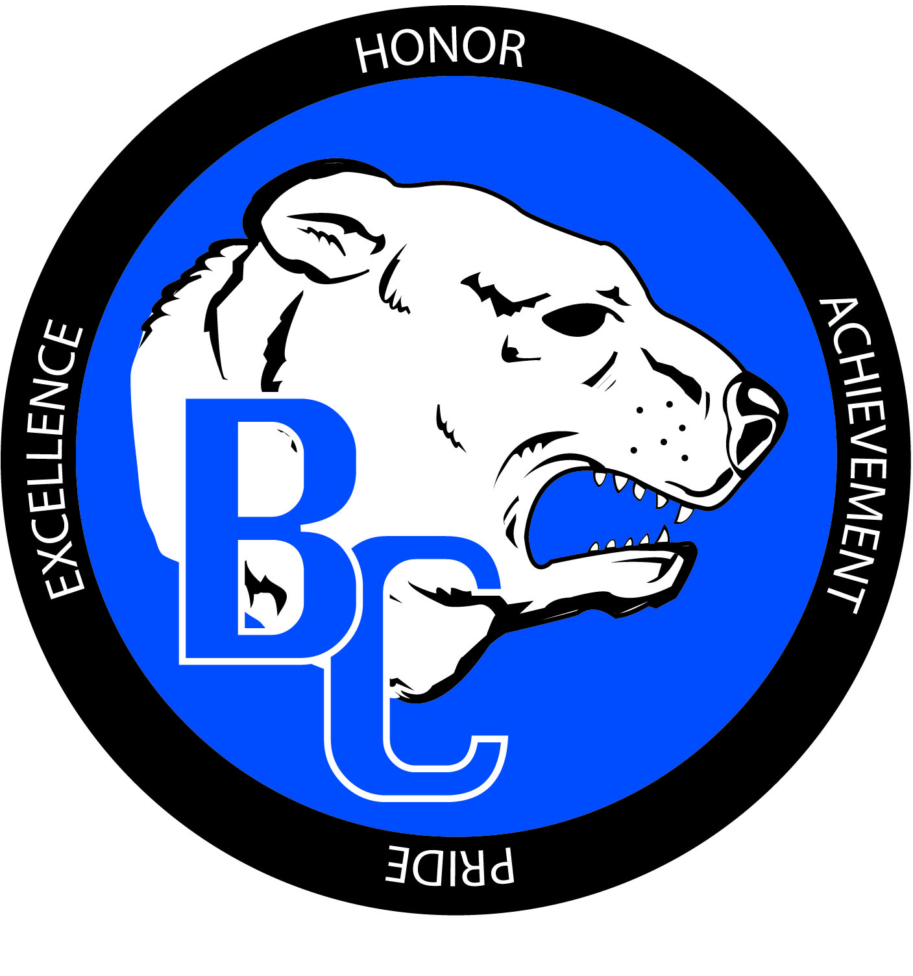
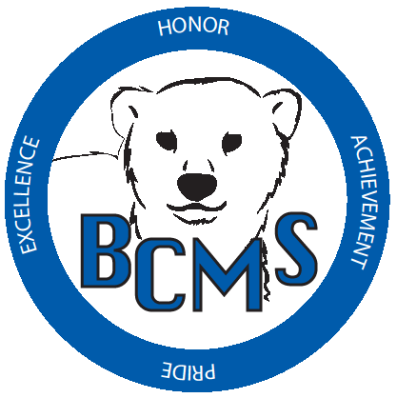
Bracken County Schools
348 West Miami Street

Brooksville, KY 41004
606-735-2523- phone 606-735-3640- fax
“Changing the world, one student at a time.”
Bracken County Schools Gifted and Talented Parent Checklist

Student Name: ______________________________ Teacher Name: _____________________
School: __________________________________ Grade: ___________ Date: _____________
Name of parent/guardian completing checklist: _______________________________________
Signature: ______________________________________

VISUAL AND PERFORMING ARTS: MUSIC
A. Indications (check all that apply):
- Observed strengths in the area of music
Explain: _________________________________________________________________
- Has won an award in music (in or out of school)
Award: _________________________________________________________________
B. Anecdotal (Please Attach)
C. Additional information that you believe is relevant. (Please Attach)
C. Music Checklist (Please complete below)

(MUST BE COMPLETED FOR RECOMMENDED STUDENTS)
Please check the characteristics which accurately describe the TYPICAL behavior of this student.

☐ Perceives fine differences in sound
☐ Easily remembers melodies and can reproduce them accurately
☐ Sensitive to rhythm – may tap fingers or feet while working
☐ Sustained interest in musical activities
☐ Expresses feelings or emotions through music or sound
☐ Makes up original tunes
☐ May hum or sing to break the silence
☐ Interested in musical symbols
☐ Can identify short rhythmic patterns as same or different
☐ Likes to perform musically
☐ Sings on pitch
☐ Able to perform musically with a high degree of technical difficulty
☐ Interested in musical instruments
☐ Enjoys musical performances
☐ Can play or would like to play a musical instrument
☐ Is interested in and learns musical symbols quickly
Additional Comments: (Use back)

