Superintendent’s
Report

November 2022

“As long as autumn lasts, I shall not have hands, canvas and colors enough to paint the beautiful things I see.”
- Vincent Van Gogh

SAU 7 Board Meeting

The SAU 7 Board meeting will be held on Thursday, November 10, 2022 at 6:00 pm at the Columbia Town Hall. The Columbia School Board has promised a dinner of homemade soup and fresh bread! At this meeting we will address the following items: SAU 7 Department Updates, Superintendent Report on Strategic Plan, SAU 7 Budget for 22-23. See you then!

Teacher Negotiations

Two of our school districts are engaging in Board-Teacher negotiations this fall. Colebrook negotiations are underway. Recently, the Pittsburg School Board and Pittsburg Education Association reached a tentative agreement for the 23-26 school years. Recall that the agreements are subject to successful vote of the town at their Annual School Meeting in the spring.

School District Public Hearings and Annual School District Meetings 2023

Meeting | SAU 7 | Clarksville * | Columbia * | Colebrook | Pittsburg | Stewartstown
Public Hearing | December 8, 2022 | February 9, 2023 | February 8, 2023 | February 7, 2023 | February 13, 2023 | February 6, 2023
Annual  School  Meeting |  | March 14, 2023 | March 14, 2023 | March 7, 2023 | March 9, 2023 | March 6, 2023
* Subject to Board approval.

Phase II: Colebrook Academy and North Point Career Center Building Project Update

We are now in the communication phase of the project! We are attending meetings and events in the community, preparing flyers for mailing and electronic communications. Public forums will also be held to inform members of the Colebrook Community about this exciting project. Recently the Board approved exterior renderings of the school addition which include the North Point CTE Center, the Academy High School and a new gym. Here are some examples of the work.

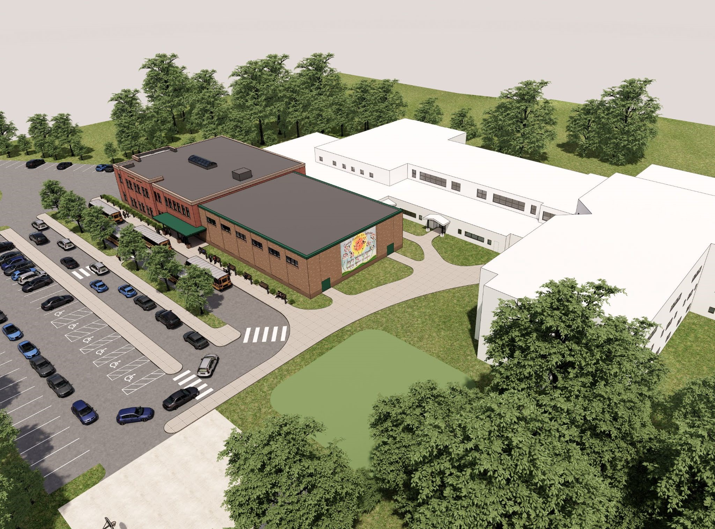
Aerial view with the new addition featured.

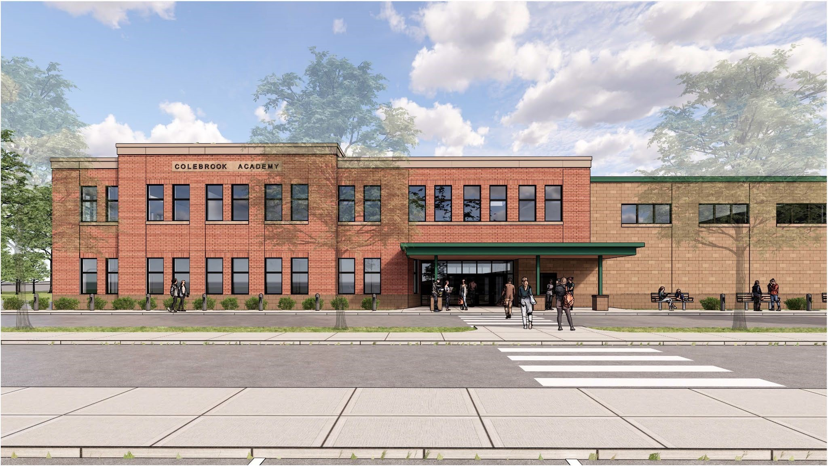
Main entrance to the Colebrook Academy and gymnasium.

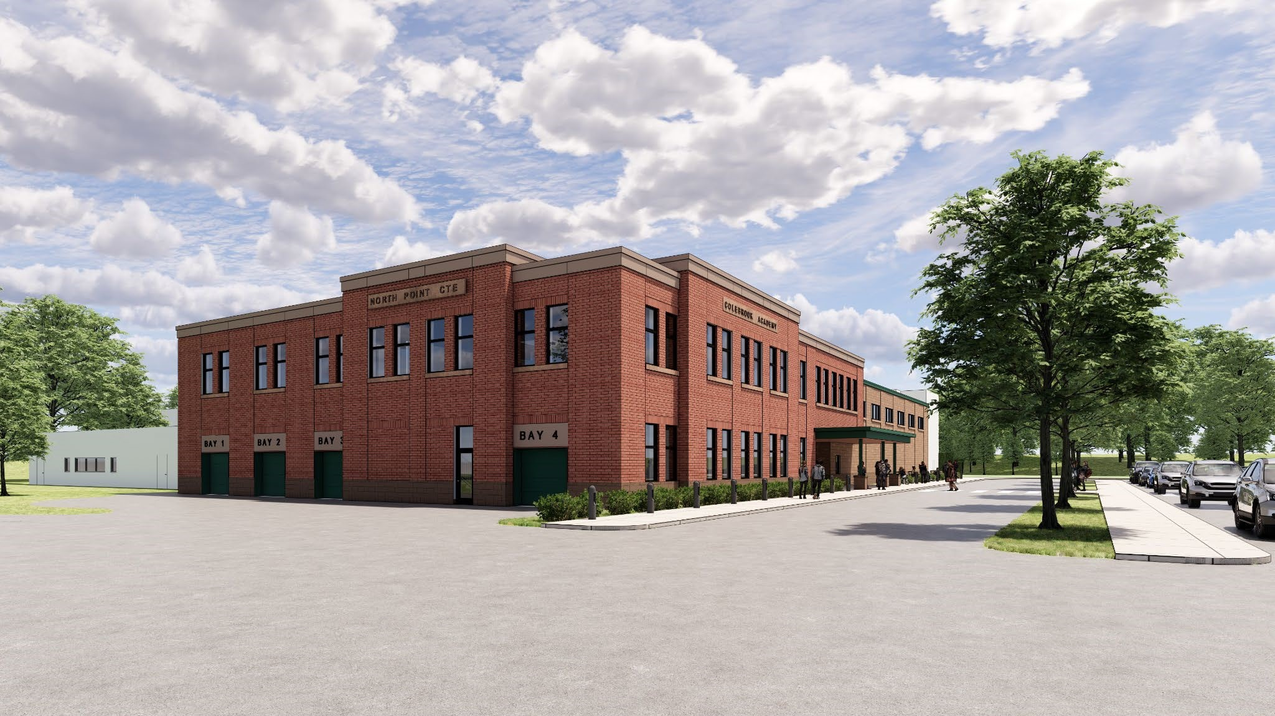
North Point CTE Center is integrated into the Academy.

More information concerning the community engagement plan will follow. We plan to actively work with the community from now through election day in March. If you have any questions or would like further information, please contact me. Curriculum Instruction and Assessment
SAU #7 Schools are continuing our focus on collaboration and innovation to scale and deepen their implementation of personalized learning, using integrated technology tools and a competency-based learning approach.
Teachers met on October 14, an administrative day, to continue work on our competency-based education system. Our teachers met in school system wide professional learning communities. Our curriculum committee, which was instituted in the fall of 2020, continues to meet monthly after school. Their task is to build our professional development plan, communicate with teachers and PLC teams, communicate progress, and seek feedback from their school colleagues. Our teams are focused on improving student outcomes and addressing learning gaps. More information will be forthcoming at our upcoming SAU 7 School Board Meeting on November 10 along with an update on progress toward our SAU 7 Strategic Plan and Superintendent Goals.
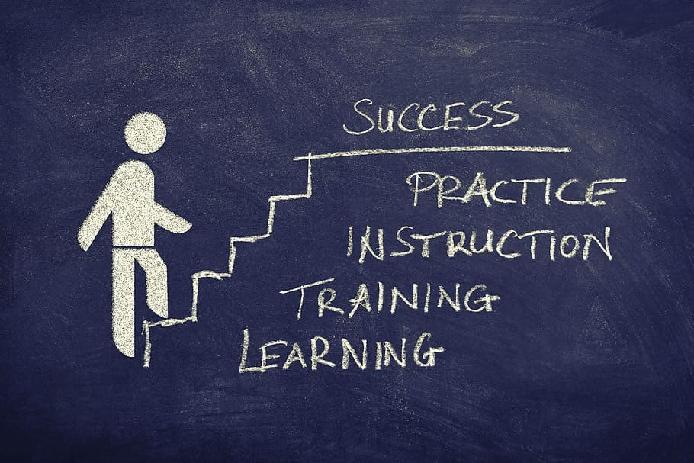

COVID Update

We continue to follow our safe and healthy protocols which are being observed by staff and students. Thanks to all for the hard work and dedication and dedication to keeping our students safe. Due to rising cases this fall, the question of additional COVID leave for school staff has arisen. At our SAU 7 meeting I will provide you with up to date attendance information and a recommendation concerning COVID leave for the remainder of the 22-23 school year.

School Principal Update

November is Principal Appreciation Month. I would like to personally thank all SAU 7 principals and assistant principals for a job well done. Take a moment to thank your school principal!

Fall Message of Gratitude to School Staff and Families

This year, I continue to be proud of our students, staff and families. When the world came to a near grinding halt due to the COVID-19 health crisis, our community made the choice to continue moving forward to support our students, progress and innovate during this unprecedented time that was marked by a genuine commitment to serve students and meet their needs with care and compassion.

Thanksgiving affords us the opportunity to slow down, to reconnect with family and friends and to reflect upon those things in our lives for which we are grateful.

I am grateful for the opportunity to serve the SAU 7 School community alongside so many dedicated educators and hardworking staff. None of us were trained to navigate teaching and learning during a pandemic. It has required all of us to come together, to address the challenges of today, to model resilience and to learn.

While the world at times can feel a bit upside down, I am grateful to be able to engage in learning with children. For it is their joy, curiosity, and imagination that helps me make sense of the world and drives me to co-create a better tomorrow. I cannot overstate my gratitude to our students, our families, and our school community for their ongoing support and adaptability. I strongly believe what we have endured will make us stronger in the years ahead.

It is my hope that this Thanksgiving will provide you the opportunity to pause and reflect upon those things for which you are grateful.

Respectfully submitted, Debra Taylor, PhD.
Superintendent

