Online Activities

Grades PreK-10 |  | IXL is personalized learning

Grades 1-6
Grades 2-6 | 
Grades 2-9 |  | 
Math Grades K-6  Reading Grades K-4 |  | parccgames.com
Grades K-5 |  | 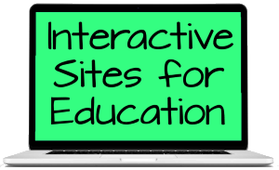
Grades 5-6 & 6-7 |  | 
Grades K-12 |  | 
Grades K-12 |  | 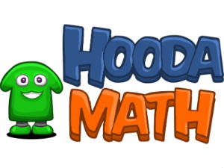
Note: Fees may be associated with online activities

