Russellville Elementary Schools
October 2024

Monday | Tuesday | Wednesday | Thursday | Friday
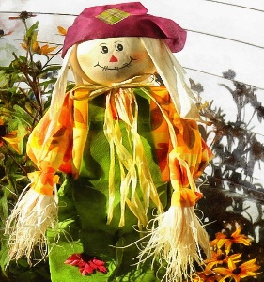 | 1  BREAKFAST  French Toast Sticks or Cereal, Fruit, Juice & Milk  LUNCH  Beef Dippers or  Popcorn chicken  Mashed potatoes, Peas, Roll, Fresh Veggies, Fruit, Juice & Milk | 2  BREAKFAST  Warm Breakfast Bread or Cereal, Fruit, Juice & Milk  LUNCH  Quesadilla or Beef Taco  Corn, Fiesta Black Beans Taco Trimmings, Fruit, Juice & Milk | 3  BREAKFAST  Toast & Jelly W/Bacon or Cereal, Fruit, Juice & Milk  LUNCH  Pizza or  Sloppy Joe Sandwich,  Green Beans, Tater Tots, Fresh Veggies, Fruit, Juice & Milk | 4  BREAKFAST  Sausage Biscuit  or Cereal, Fruit, Juice & Milk  LUNCH  Manager Choice  Fresh Veggies, Fruit, Juice & Milk
7  FALL BREAK | 8  FALL BREAK | 9  FALL BREAK | 10  FALL BREAK | 11  FALL BREAK
14  NO SCHOOL  PD DAY | 15  BREAKFAST  Pancakes or Cereal, Fruit, Juice & Milk  Baked Ham or Chicken Tenders, Seasoned Diced Potatoes, California Blend, Roll, Fresh Veggies, Fruit, Juice & Milk | 16  BREAKFAST  Egg &Cheese Biscuit or Cereal, Fruit, Juice & Milk  LUNCH  Grilled Cheese Sand. Or Cheese Bites, Homemade Chili, Waffle Fries, Fresh Veggies, Fruit, Juice & Milk | 17  BREAKFAST  French Toast Sticks or Cereal, Fruit, Juice & Milk  LUNCH  Cheeseburger or Hot Dog w/ chili, Baked Beans, Chips, Fresh Veggies, Fruit, Juice & Milk | 18  BREAKFAST  Sausage Biscuit  or Cereal, Fruit, Juice & Milk  LUNCH  Pizza or Chicken Sandwich, Green Beans, Corn, Fresh Veggies, Fruit, Juice & Milk
21  BREAKFAST  Egg & Cheese Biscuit or Cereal, Fruit, Juice & Milk  LUNCH  Lasagna Rollup or Popcorn Chicken, Garlic Toast,  Steamed Broccoli, Sweet Carrots, Fresh Veggies, Fruit, Juice & Milk | 22  BREAKFAST  Warm Muffin, Pop tart or Cereal, Fruit, Juice & Milk  LUNCH  Cheese Quesadilla or Bean & Cheese Burrito covered in Queso Cheese, Corn, Fiesta Black Beans, Fresh Veggies, Fruit, Juice &Milk | 23  BREAKFAST  Warm Cinnamon Roll or Cereal, Fruit, Juice & Milk  LUNCH  Hot Ham & Cheese Croissant or Pizza, Green Beans, Fries, Cookie, Fresh Veggies, Fruit, Juice & Milk | 24  BREAKFAST  Pancakes or Cereal, Fruit, Juice & Milk  LUNCH  Fried Bologna Sandwich or Mozzarella Cheese Sticks, Queso Tomato Soup, Goldfish Crackers, Fresh Veggies, Fruit, Juice & Milk | 25  BREAKFAST  Sausage Biscuit or Cereal, Fruit, Juice & Milk  LUNCH  Fish Sticks or Corn Dog Nuggets, Pinto Beans, Mac & Cheese, Hushpuppies, Fresh Veggies, Fruit, Juice & Milk
28  BREAKFAST  Dutch Waffle or Cereal, Fruit, Juice & Milk  LUNCH  Grilled Cheese Sand. Or Hot Ham & Cheese Sub, Chicken Noodle Soup, Smiley Fries, Fresh Veggies, Fruit, Juice & Milk | 29  BREAKFAST  Warm Muffin, Pop tart or Cereal, Fruit, Juice & Milk  LUNCH  Chicken Fettucine Alfredo or Chicken Tenders, Garlic Toast, Steamed Broccoli, Sweet Carrots, Fresh Veggies, Fruit, Juice & Milk | 30  BREAKFAST  Bacon Biscuit or Cereal, Fruit, Juice & Milk  LUNCH  Cheese Quesadilla or Beef Taco, Corn, Refried Beans, Taco Trimmings, Fruit, Juice & Milk | 31  BREAKFAST  Pancakes or Cereal, Fruit, Juice & Milk  LUNCH  Hamburger or Chicken Sandwich  Baked Beans, Chips, Fresh Veggies, Fruit, Juice  Halloween Treat | 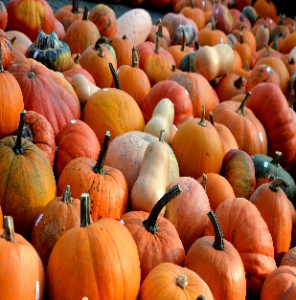
NEWS:
CHOOSE ONE ENTRÉE FOR LUNCH. EACH TRAY MUST HAVE A FRUIT OR VEG AND AT LEAST TWO OTHER ITEMS TO BE CONSIDERED A MEAL. MENU IS SUBJECT TO CHANGE WITHOUT NOTICE.
In accordance with Federal civil rights law and U.S. Department of Agriculture (USDA) civil rights regulations and policies, the USDA, its Agencies,
offices, and employees, and institutions participating in or administering USDA programs are prohibited from discriminating based on race, color,
national origin, sex, disability, age, or reprisal or retaliation for prior civil rights activity in any program or activity conducted or funded by USDA.

