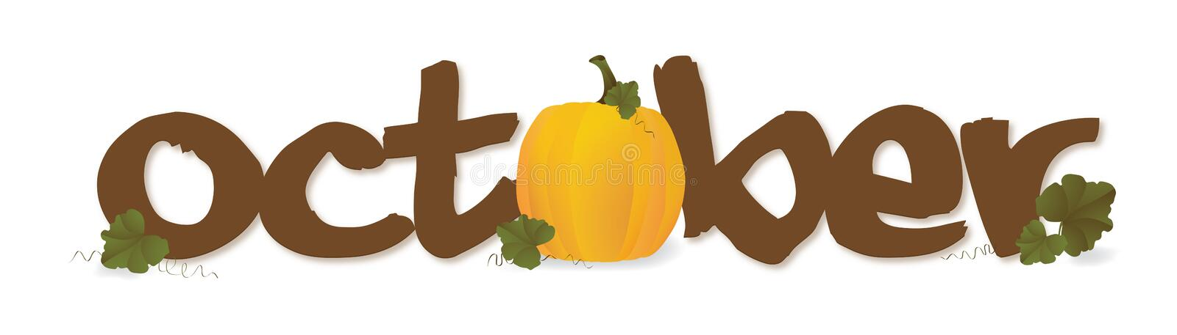

**It is fall! We are so thrilled for fall to be here! We are excited for some fall weather. What an exciting and fun time of the year. Your kids are doing great and we are learning a lot.**

**During October, we will be learning about healthy habits, pumpkins, community helpers, and having some fun with Halloween! Every day, we are counting, reviewing the calendar and having fun with letters and sounds. Each week we go over a letter, say the sound, and practice writing it. Towards the end of October, we will be scheduling conferences with you to talk about what your child is learning. Please make note the conference day will be sometime in November. We hope your children are sharing their experiences with you. We certainly are loving seeing each of them grow. We are very blessed.**

**Please work on the following items with your child.**

**Recognizing Uppercase /lowercase letters (Hh, Qq, Yy, Gg & Uu)**

**Recognize letters in our name**

**Write your name**

**Mark Your Calendar**

**Oct. 2nd – Custodian Day**

**Oct. 4th – Make Up Pictures/ Glow Party/ Special Snack $1.50**

**Oct. 7th – Fundraiser Begins**

**Oct. 9th – Grandparent Picnic**

**Oct. 10th – Pumpkin Patch Field Trip**

**Oct. 11th – ½ day for all students Pre-K dismisses at 11:00**

**Oct. 14th – No school**

**Oct. 18th – Fundraiser Ends**

**Oct. 28th Red Ribbon Week(details to come)**

**Nov. 1st Fall Fun Day (details to come)**

It’s Fall Y’all

