**Back Pack Safety** 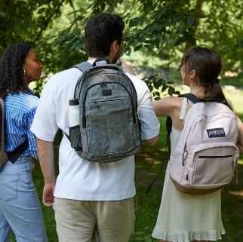

**From the National Safety Council –**When you move your child's backpack after he or she drops it at the door, does it feel like it contains 40 pounds of rocks? Maybe you've noticed your child struggling to put it on, bending forward while carrying it, or complaining of tingling or numbness.

If you've been concerned about the effects that extra weight might have on your child's still-growing body, your instincts are correct.

Backpacks that are too heavy can cause a lot of problems for kids, like back and shoulder pain, and poor posture. The problem has grabbed the attention of lawmakers in some states, who have pushed for legislation requiring school districts to lighten the load.  
Read more on the National Safety Council Website:

<https://www.nsc.org/home-safety/safety-topics/child-safety/backpacks>  
   
  
**Additional resources:**

* <https://www.acatoday.org/Patients/Health-Wellness-Information/Backpack-Safety>
* <https://orthoinfo.aaos.org/en/staying-healthy/backpack-safety/>
* <http://orthokids.org/Health-Fitness/Backpack-Safety>