Interview with Dori Benton
by Izzie Long

Q: Where do you see yourself in 4 years?
A: “Graduating College and going to get my certificate to train dogs.”

Q: Tell us something interesting about you.
A: “I love to read and listen to music and I am always ready to hang out with friends.”

Q: Who is your biggest role model?
A: “My grandma Gibbons.”

Q: What is your favorite high school memory?
A: “One day when half the high school was gone for a basketball tournament, the rest of the kids still at school got a deck and played cards all day.”

Q: What was your dream job as a kid? What is your dream job now?
A: “When I was little I wanted to work with animals but now I want to train service dogs.”

Q: Who is your favorite teacher? Why?
A: “Mrs. Toelle because she never puts a student down and easily admits when she’s done something wrong or made a mistake.”

Q: What is the best advice you have received from a teacher or staff member at Kremlin-Hillsdale?
A: “At least give it a try, and you might end up liking it. This has motivated me to try things that I actually ended up enjoying.”

Q: What would your message be to your fellow graduates?
A: “I’m going to miss you a lot. Please stay in touch and I can’t wait to see you again.”

Q: What would your advice be to the underclassmen here at Kremlin-Hillsdale?
A: “Senior year can be a lot of fun, so just don’t take yourself too seriously or it won’t be.”

Q: If you could be granted one wish, what would it be?
A: “I would wish for my dream car.”

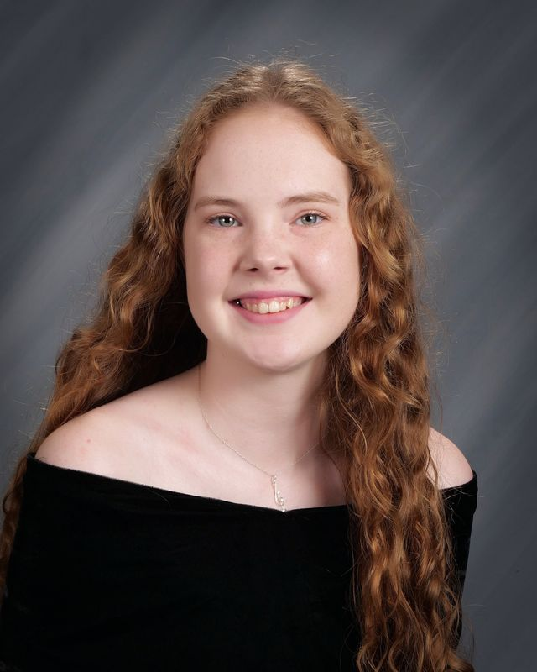

Interview with Gabriella Brandenburg
by Izzie Long

Q: Where do you see yourself in 4 years?
A: Attending College at Weber State

Q: Tell us something interesting about yourself.
A: I’m boring.

Q: Who is your biggest role model?
A: My mom.

Q: What is your favorite high school memory?
A: I hated high school.

Q: What was your dream job as a kid? What is your dream job now?
A: A vet. An architect.

Q: Who is your favorite teacher? Why?
A: Mrs. Edington because she doesn’t make me read out loud.

Q: What is the best advice you have received from a teacher or staff member here at Kremlin-Hillsdale?
A: High school doesn’t matter.

Q: What would your message be to your fellow graduates?
A: It was good knowing you.

Q: What would your advice be to the underclassmen here at Kremlin-Hillsdale?
A: Don’t get into drama.

Q: If you could be granted one wish, what would it be?
A: To open my own business.

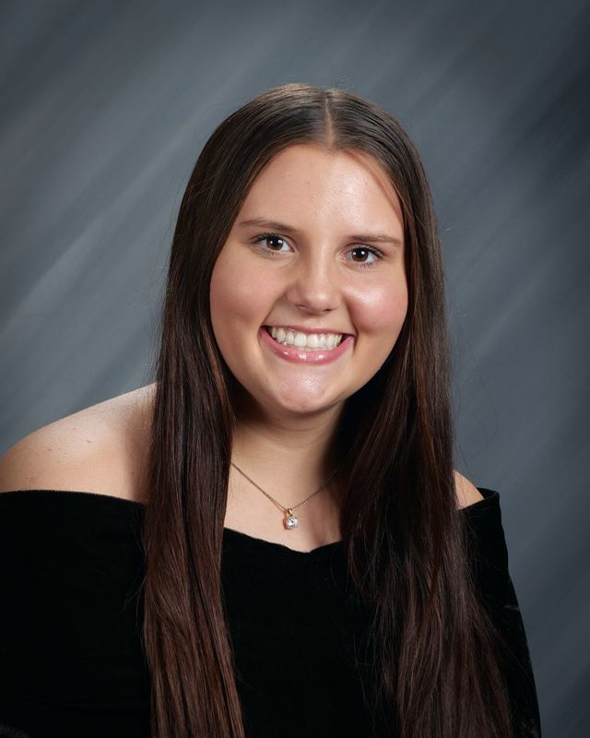

Interview with Taryn Rhodes
by Zac Snodgrass

Q: Where do you see yourself in 4 years?
A: Working in a dentist office.

Q: Tell us something interesting about you.
A: My fingers are crooked.

Q: Who is your biggest role model?
A: My mom, she is a hard working lady, and whatever needs to be done she gets done.

Q: What is your favorite high school memory?
A: When Karoline hit her first homerun over the fence.

Q: What was your dream job as a kid? What is your dream job now?
A: I never thought about working as a kid, becoming a dental hygienist.

Q: Who is your favorite teacher? Why?
A: Mrs. Edington. She is one of the chillest teachers, and has helped me a lot through my high school career.

Q: What is the best advice you have received from a teacher or staff member here at Kremlin-Hillsdale?
A: Practice like a champion -Coach Hawkins.

Q: What would your message be to your fellow graduates?
A: I wish you guys the best, and hope to see you around here and there.

Q: What would our advice be to the underclassman here at Kremlin-Hillsdale?
A: Ignore all the drama that goes on; Get along with everyone, life is too short to be fighting with one another.

Q: If you could be granted one wish, what would that be?
A: To wear leggings to school.

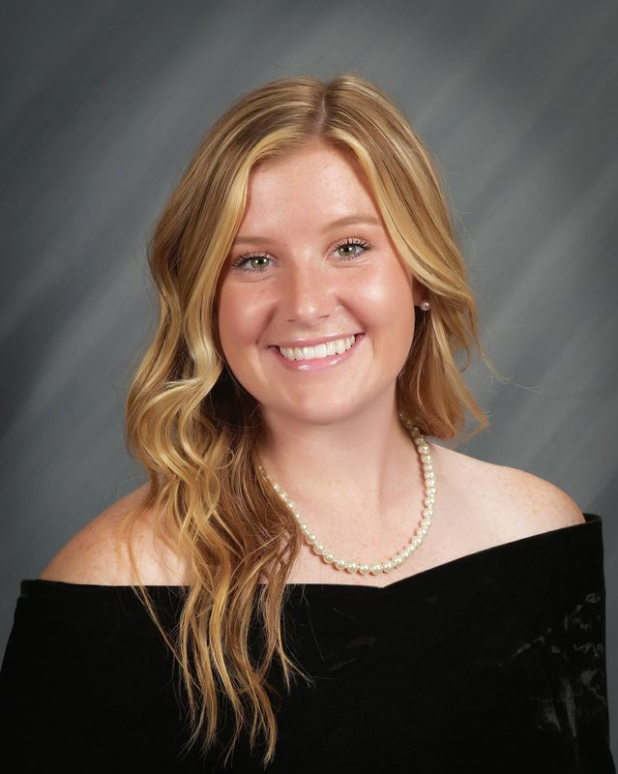

Interview with Kadence Stewart
by Hannah Baugh

Q: Where do you see yourself in 4 years?
A: I see myself in 4 years beginning my life, having a family and going on adventures.

Q: Tell us something interesting about yourself.
A: Something interesting about me is that I’m an athlete.

Q: Who is your biggest role model?
A: My biggest role model would have to be my parents; they lead to where I am today.

Q: What is your favorite high school memory?
A: My favorite high school memory was just being here and experiencing just the whole high school experience.

Q: What was your dream job as a kid? What is your dream job now?
A: My dream job as a kid I always wanted to be a professional baseball player and make it to the MLB. My dream job now is I would love to run a business in the future.

Q: Who is your favorite teacher? Why?
A: My favorite teacher ever would have to be Mrs. Chesser. She was always so nice to me. She was also very helpful and understanding.

Q: What is the best advice you've received from a teacher or staff member here at Kremlin-Hillsdale?
A: The best advice I have ever received from a teacher at Kremlin-Hillsdale was to always keep pushing and go after what I wanted to in life.

Q: What would your message be to your fellow graduates?
A: I will see y’all on the other side. It was a great time while it lasted…

Q. What would your advice be to the underclassmen here at Kremlin-Hillsdale?
A: No matter the circumstances of the situation just keep taking a step forward every day and have a great headspace while doing it.

Q: If you could grant one wish, what would that be?
A: I would wish that I could’ve gone to a division II school or a JUCO so I could play football just for a few more years.

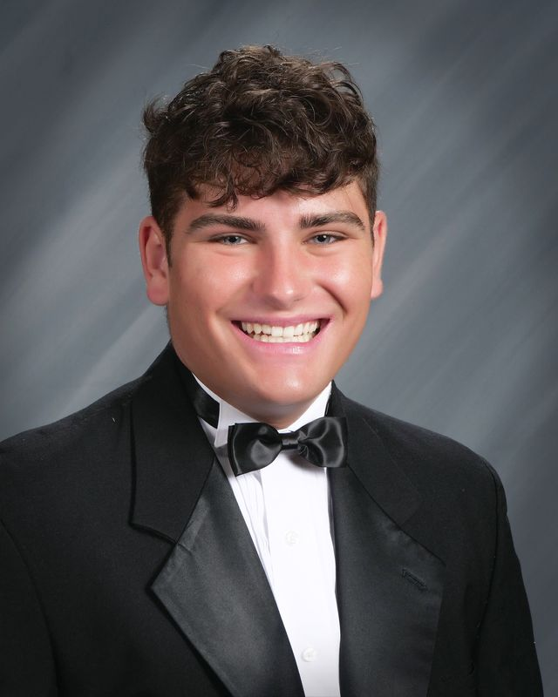

Interview with Hannah Baugh
by Kadence Stewart

Q: Where do you see yourself in 4 years?
A: Having a good job with good income, starting a family, living in a nice home being happy.

Q: Tell us something interesting about yourself.
A: I lived in England

Q: Who is your biggest role model?
A: My parents for sure

Q: What is your favorite high school memory?
A: My senior year spending it with my family, my boyfriend, and friends.

Q: What was your dream job as a kid? What is your dream job now?
A: Dentist, now I want to be in the medical field

Q: Who is your favorite teacher? Why?
A: Mrs. Edington because she is a really good teacher.

Q: What is the best advice you have received from a teacher or staff member here at Kremlin-Hillsdale?
A: I haven't received any.

Q: What would your message be to your fellow graduates?
A: Good luck in the real world

Q: What would your advice be to the underclassmen here at Kremlin-Hillside?
A: Use deodorant, focus in school, have fun because time flies so live in the moment.

Q: If you could be granted one wish, what would it be?
A: Endless amount of money and happiness.

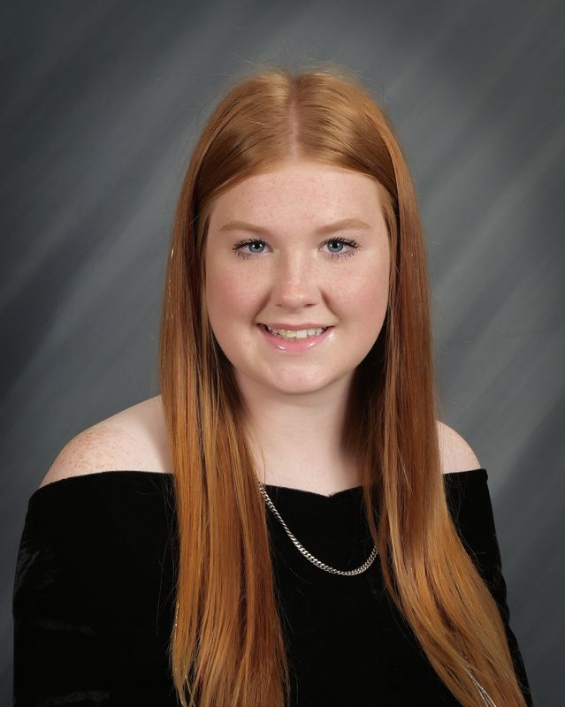

Interview with Ethan Haggard
by Hannah Baugh

Q: Where do you see yourself in 4 years?
A: Graduating from SWOSU and going to Texas to be a game warden.

Q: Tell us something interesting about yourself.
A: I've been at Kremlin longer than over half the teachers.

Q: Who is your biggest role model?
A: My grandma

Q: What is your favorite high school memory?
A: 2021 state FFA convention

Q: What was your dream job as a kid? What is your dream job now?
A: Professional bull rider, federal game warden

Q: Who is your favorite teacher? Why?
A: Mr. Goyen, all the fun memories on Ag trips

Q: What is the best advice you have received from a teacher or staff member here at Kremlin-Hillsdale?
A: If you work hard for whatever you want, and don't give up. You will eventually get it!

Q: What would your message be to your fellow graduates?
A: Don’t do anything stupid so that way we can all come back to our reunion.

Q: What would your advice be to the underclassman here at Kremlin-Hillsdale?
A: Try something new each year because you never know what you think about something unless you try it.

Q: If you could be granted on wish, what would it be?
A: To be able to relive all the great memories with my class.

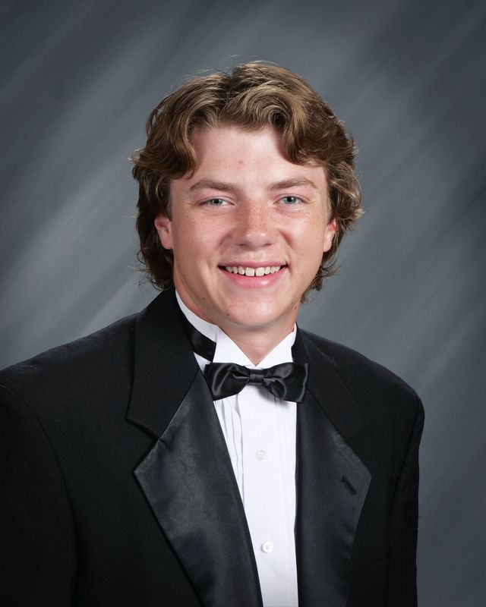

Interview with Jayden Gerhard
by Zac Snodgrass

Q: Where do you see yourself in 4 years?
A: Working as an RN making money and starting a family with my best friend.

Q: Tell us something interesting about yourself.
A: I love to eat at Chick-Fil-A.

Q: Who is your biggest role model?
A: My Mom.

Q: What is your favorite high school memory?
A: Going on all the team camps with the softball girls.

Q: What was your dream job as a kid? What is your dream job now?
A: Nurse. Now it’s a teacher but leaning back towards a nurse.

Q: Who is your favorite teacher? Why?
A: Coach Voth. He has taught me how to be a better person and always encourages me.

Q: What is the best advice you have received from a teacher or staff member here at Kremlin-Hillsdale?
A: Don’t be sorry be better -Coach Voth

Q: What would your message be to your fellow graduates?
A: I’m glad I got to know all of you and I wish you all the best!

Q: What would our advice be to the underclassman here at Kremlin-Hillsdale?
A: Do you! Work hard and have big goals! Don’t let people tear you down.

Q: If you could be granted one wish, what would that be?
A: To be rich!!

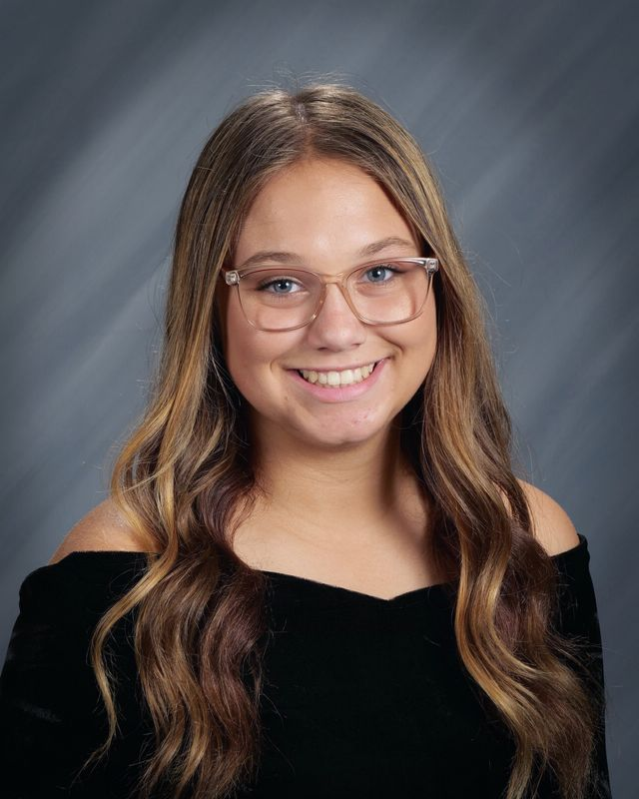

Interview with Abby Vandiver
by Izzie Long

Q: Where do you see yourself in 4 years?
A: Working at a good restaurant, gaining experience to open my own restaurant.

Q: Tell us something interesting about yourself
A: My favorite food is Ramen.

Q: Who is your biggest role model?
A: My parents. They both work really hard and always support me in everything I do.

Q: What is your favorite high school memory?
A: The senior trip.

Q: What was your dream job as a kid? What is your dream job now?
A: A vet as a kid, and now I want to be a chef.

Q: Who is your favorite teacher? Why?
A: Coach Voth because he is always there for me, and can always make me laugh.

Q: What would your message be to your fellow graduates?
A: Don’t stop being yourself and I hope we all have great lives.

Q: What would your advice be to the underclassmen here at Kremlin-Hillsdale?
A: Just be yourself and don’t worry about people's opinion of you.

Q: If you could be granted one wish, what would that be?
A: Just immediately have my own restaurant that's fully equipped and stocked.

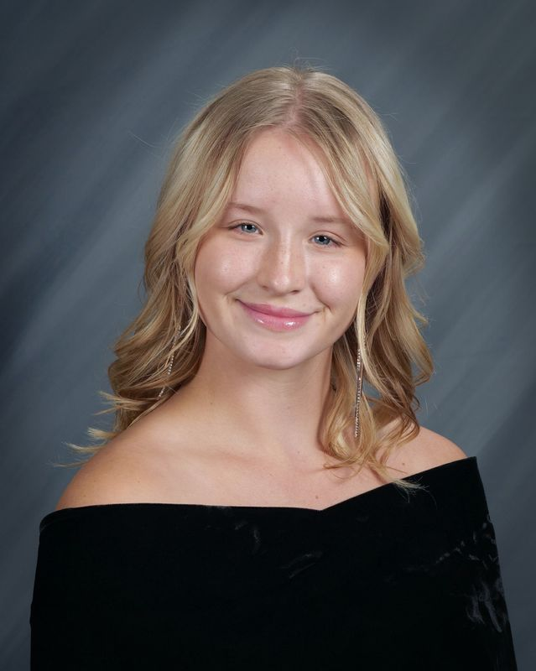

Interview with Macy Davis
by Izzie Long

Q: Where do you see yourself in 4 years?
A: Playing my senior year of basketball at Sterling College and applying for the graduate athletic training program.

Q: Tell us something interesting about yourself.”
A: I took 4 years of Taekwondo.

Q: Who is your biggest role model?
A: My mom.

Q: What is your favorite high school memory?
A: Last summer at the Red Oak Camp when we threw a party with Binger-Oney in their room.

Q: What was your dream job as a kid? What is your dream job now?
A: A professional singer as a kid and now an Athletic Trainer.

Q: Who is your favorite teacher? Why?
A: Mrs. Edington because she taught my favorite subject and she was the one I talked to the most.

Q: What is the best advice you have received from a teacher or staff member at Kremlin-Hillsdale?
A: Don’t it feel good when you think you have led someone to God?
-Mrs.Curl

Q: What would your message be to your fellow graduates?
A: Honor God in every decision you make from here on out.

Q: What would your advice be to the underclassmen here at Kremlin-Hillsdale?
A: Do you, don’t care about other people’s opinions, you’ll be at your happiest when you’re okay with being alone.

Q: If you could be granted one wish, what would that be?
A: That college debt wasn’t a thing.

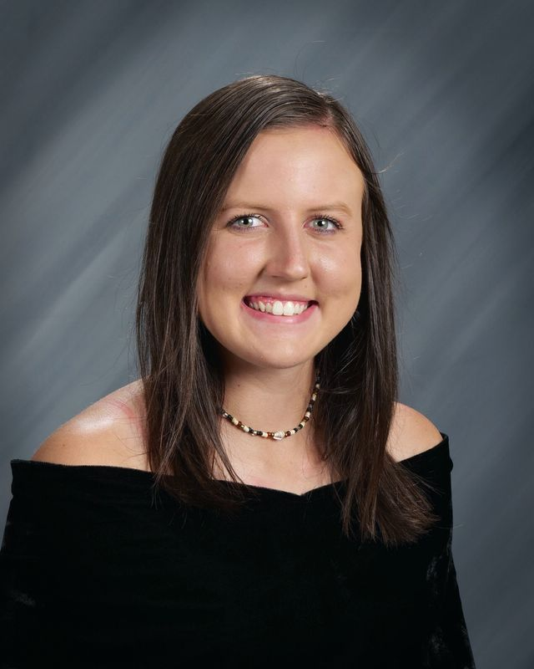

Interview with Cheyenne Moore
by Hannah Baugh

Q: Where do you see yourself in 4 years?
A: Preparing for my senior year of College at Southeastern.

Q: Tell us something interesting about yourself.
A: I will be getting my private pilot's license

Q: Who is your biggest role model?
A: Johnny Depp

Q: What is your favorite high school memory?
A: Going to a regional baseball tournament my senior year

Q: What was your dream job as a kid? What is your dream job now?
A: To be a pilot. My dream job is still to be a pilot.

Q: Who is your favorite teacher? Why?
A: Mr. Voth is my favorite teacher. He has always been an encouragement to me and pushed me to be a better version of myself.

Q. What is the best advice you have received from a teacher here at Kremlin-Hillsdale?
A: Whatever you want you can achieve as long as you give everything you have and more into your work for it. –Coach Voth

Q. What would your message be to your fellow graduates?
A: Good luck and never lose sight of what you want.

Q: What would your advice be to the underclassman here at Kremlin-Hillsdale?
A: Keep your eyes ahead on what you want but to also enjoy where you are now.

Q. If you could be granted on wish, what would it be?
A: To have 100 billion dollars.

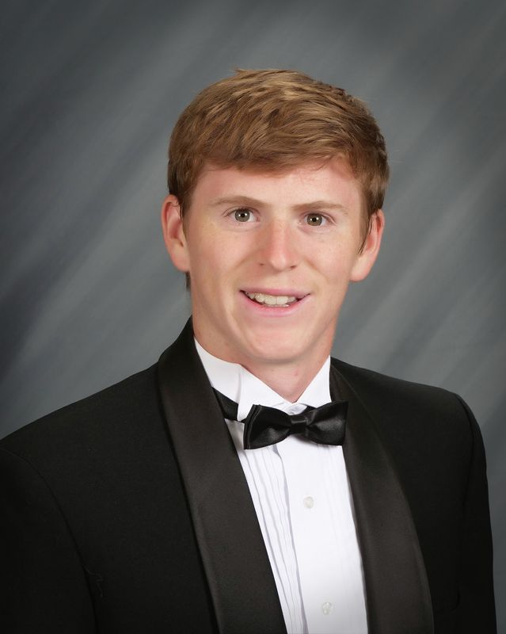

Interview with Garrett Gorman
by Izzie Long

Q: Where do you see yourself in 4 years?
A: 22.

Q: Tell us something interesting about yourself.
A: I have arthritis.

Q: Who is your biggest role model?
A: My dad.

Q: What is your favorite high school memory?
A: Going to Florida.

Q: What was your dream job as a kid? What is your dream job now?
A: My dream job as a kid was to be a Marshaller, which is the people who are on the ground at an airport controlling the planes. My dream job now is to be an HVAC journeyman.

Q: Who is your favorite teacher? Why?
A: Mrs. Lieser because she was nice and trusted everyone.

Q: What is the best advice you have received from a teacher here at Kremlin-Hillsdale?
A: That’s probably not a good idea. -Mr. Vaught

Q: What would your message be to your fellow graduates?
A: We made it!

Q: What would your advice be to the underclassmen here at Kremlin-Hillsdale?
A: Enjoy your time here and with your parents as long as possible.

Q: If you could be granted one wish, what would it be?
A: 10 more wishes.

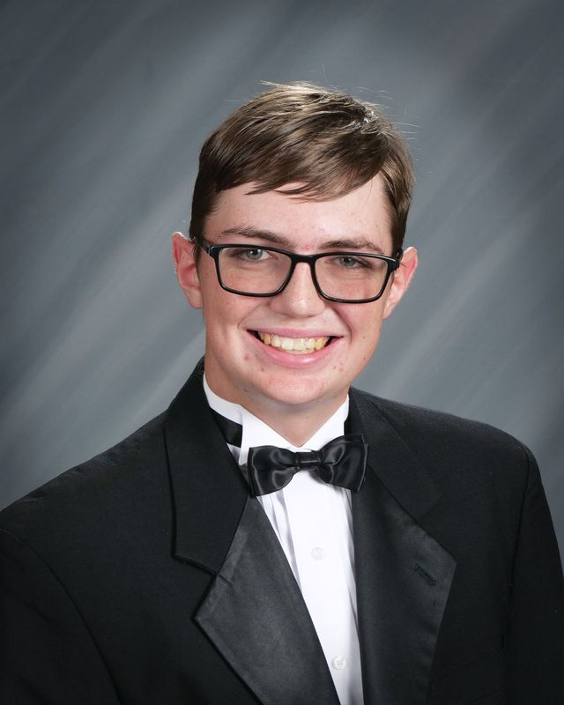

Interview with Kristin Helm
by Izzie Long

Q: Where do you see yourself in 4 years?
A: Graduating College with a degree in forensic science and psychology and having a good job.

Q: Tell us something interesting about yourself.
A: I like mystery books and movies.

Q: Who is your biggest role model?
A: Probably my dad, he has taught me how to be a good leader and between him and my mom they have taught me not to give up.

Q: What is your favorite high school memory?
A: There’s too many to choose from but probably the Disney trip.

Q: What was your dream job as a kid? What is your dream job now?
A: As a kid I wanted to be a vet, now I want to work to help people by being in forensic science.

Q: Who is your favorite teacher? Why?
A: Mrs. Toelle, she’s always there when you need her and any trip with her is always funny.

Q: What is the best advice you have received from a teacher or staff member here at Kremlin-Hillsdale?
A: To get back up when you fall and to never forget that there is always someone there to help you stand back up.

Q: What would your message be to your fellow graduates?
A: Whatever you go through in life is never as hard as you think, so push through and accomplish your best.

Q: What would your advice be to the underclassmen here at Kremlin-Hillsdale?
A: Enjoy your time in high school, make memories, and work for your future.

Q: If you could be granted one wish, what would it be?
A: To have extra money for college.

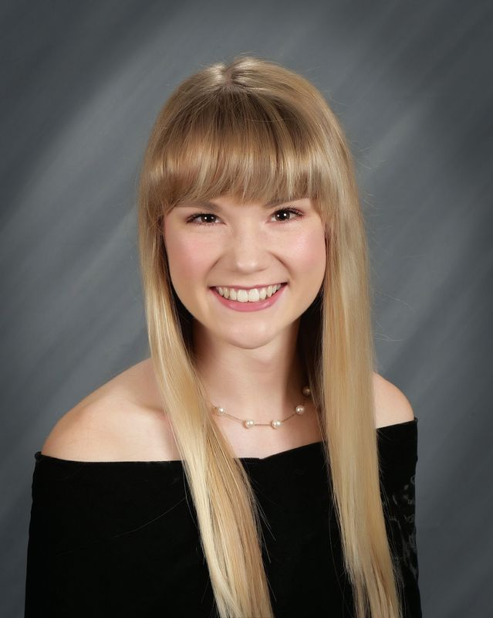

Interview with Harris Keithly
by Hannah Baugh

Q: Where do you see yourself in 4 years?
A: In graduate school or medical school.

Q: Tell us something interesting about yourself.
A: I play the piano.

Q: Who is your biggest role model?
A: Abraham Lincoln.

Q: What is your favorite high school memory?
A: State cross country meet my senior year.

Q: What was your dream job as a kid? What is your dream job now?
A: NBA player. Become a team doctor.

Q: Who is your favorite teacher? Why?
A: Coach Voth. He is very relatable to his students.

Q. What is the best advice you have received from a teacher here at Kremlin-Hillsdale?
A: Don’t be sorry, be better.

Q. What would your message be to your fellow graduates?
A: Whatever you do, do it well.

Q: What would your advice be to the underclassman here at Kremlin-Hillsdale?
A: You’re closer to graduating than you think.

Q. If you could be granted on wish, what would it be?
A: To be the wisest person in the world.

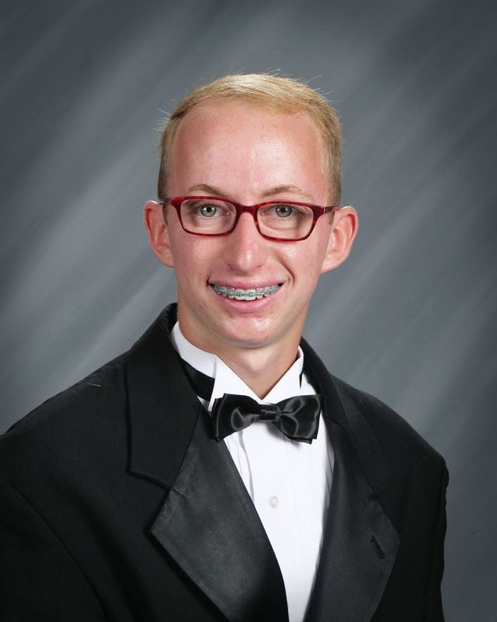

Interview with Michael Wright
by Zac Snodgrass

Q: Where do you see yourself in 4 years?
A: Probably a famous vlogger, owning a pier restaurant called FEM, driving a Porsche, and owning a Porsche dealership.

Q: Tell us something interesting about yourself.
A: I can do a cartwheel and can't dive.

Q: Who is your biggest role model?
A: Cleetus Mcfarland.

Q: What is your favorite high school memory?
A: My lunch table.

Q: What was your dream job as a kid? What is your dream job now?
A: Architect. Forensic Computer Analyst.

Q: Who is your favorite teacher? Why?
A: Goyen. Never a dull moment.

Q: What is the best advice you have received from a teacher or staff member here at Kremlin-Hillsdale?
A: Success is more attitude than aptitude.

Q: What would your message be to your fellow graduates?
A: Just do it.

Q: What would our advice be to the underclassman here at Kremlin-Hillsdale?
A: It's a long way to the top, if you want to rock and roll.

Q: If you could be granted one wish, what would that be?
A: Go on a date with Hailee Steinfield.

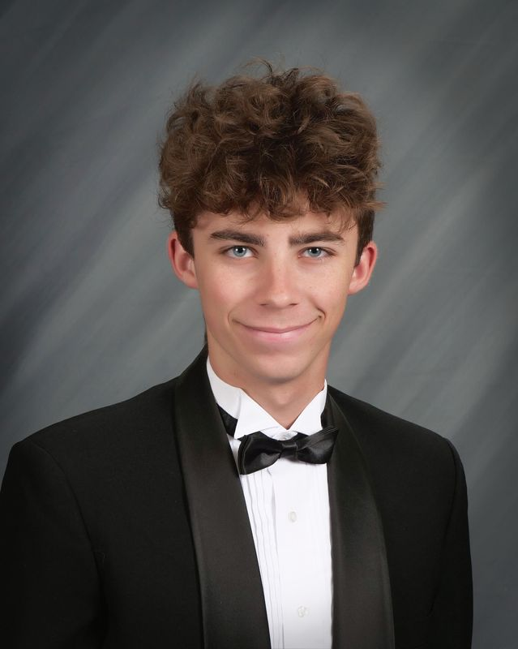

Interview with Madison Morse
by Kadence Stewart

Q: Where do you see yourself in 4 years?
A: Being an elementary teacher with a nice vehicle and in a happy and healthy relationship.

Q: Tell us something interesting about yourself.
A: I like to hunt and fish, I love older cars, and I like to watch NASCAR and Street Outlaws.

Q: Who is your biggest role model?
A: My mom. I aspire to be like her someday.

Q: What is your favorite high school memory?
A: All of the bus rides for sports and band.

Q: What was your dream job as a kid? What is your dream job now?
A: A vet. An elementary teacher.

Q: Who is your favorite teacher? Why?
A: Mrs. Conaway, she has impacted my life so much. She is so caring, sweet, and understanding.

Q: What is the best advice you have received from a teacher or staff member here at Kremlin-Hillsdale?
A: Mr. Campbell telling me about the fish scales in the sky knowing its about to rain.

Q: What would your message be to your fellow graduates?
A: I love you all; see you in the long run (grocery shopping with your families at Walmart).

Q: What would your advice be to the underclassmen here at Kremlin-Hillsdale?
A: Your grades matter! Much more than you think. Do the extra credit! Turn in homework.

Q: If you could be granted one wish, what would it be?
A: To have an endless amount of money.

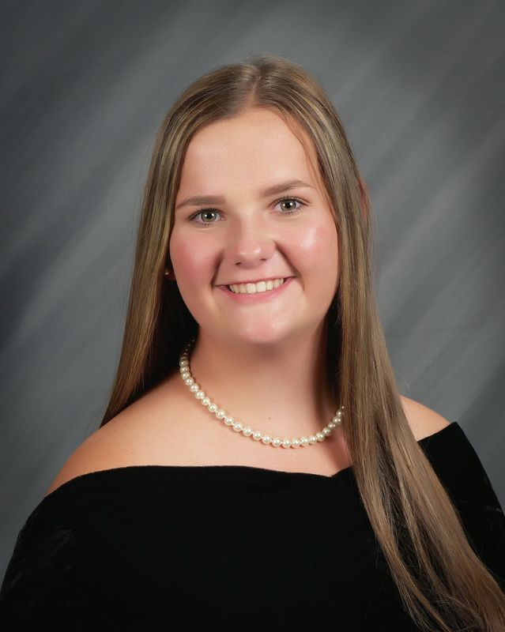

Interview with Andrew Lockhart
by Izzie Long

Q: Where do you see yourself in 4 years?
A: Starting Grad school at SWOSU for my Masters in Psychology.

Q: Tell us something interesting about yourself.
A: I can play two instruments.

Q: Who is your biggest role model?
A: My brother Tristan.

Q: What is your favorite high school memory?
A: Cross Country State (2020).

Q: What was your dream job as a kid? What is your dream job now?
A: A Lawyer. A Therapist.

Q: Who is your favorite teacher? Why?
A: Mrs. T. She has been a big supporter of my dreams.

Q: What is the best advice you have received from a teacher or staff member here at Kremlin-Hillsdale?
A: If you quit or give up, everything is for nothing.

Q: What would your message be to your fellow graduates?
A: Take your time, and don’t rush through life.

Q: What would your advice be to the underclassmen here at Kremlin-Hillsdale?
A: Stay in school, and go to Autry.

Q: If you could be granted one wish, what would it be?
A: That my sisters will have a better high school experience than I did.

