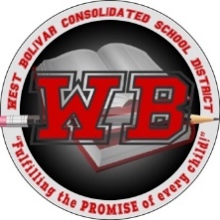
West Bolivar Consolidated School District
P.O Box 189, Rosedale, MS 38769
Phone: (662) 759-3525 Fax: (662) 769-6316

Melvin Cook, Interim Superintendent

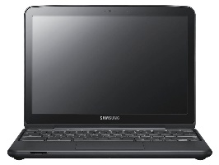

Student & Parent/Guardian Technology Agreement

Student Name: Last First

Parent Name: Last First

MSIS ID:

Address:

Parent Email Address:

Parent Phone Number:

The West Bolivar Consolidated School District’s Acceptable Use Policy allows students to use technology inside and/or outside of the classroom

Terms of Agreement
The student is responsible at all times for the care and appropriate use of technology.
I understand if my student violates the guidelines agreed to in the WBCSD Student Handbook, his/her privilege to use technology may be restricted or removed and he/she may be subject to disciplinary action.

I understand that I may be held responsible for reimbursement for loss, damage, or repair of my student’s device, which may have occurred at school, at home, or while the device was being transported. The device remains the property of the District. At the end of the school year or upon transfer from the District, parents and students agree to return the device to the District in the same condition it was issued to the student less reasonable wear.

Signature:
Parent/Guardian Signature |  | Student Signature |  |  | Date
School |  | Grade Level |  |  | Asset Number

