PJHS Lady Cats Softball
Game Schedule 2024
DATE | OPPONENT | PLACE | TIME
Fri./Sat., Feb 16th & 17th | Moody Tournament | Moody, AL | TBD
*Thursday, Feb. 22nd | Redland | Home | 4:30pm
Fri./Sat., Feb. 23rd & 24th | Smith Station Tournament | Smith Station, AL | TBD
*Tuesday, Feb. 27th | Marbury | Away | 4:30pm
*Thursday, Feb. 29th | Millbrook | Home | 4:30pm
Fri./Sat., March 1st & 2nd | Jemison Tournament | Jemison, AL | TBD
*Tuesday, March 5th | Maplesville | Home | 4:30pm
*Thursday, March 7th | Redland | Away | 4:30pm
Saturday, March 9th | Opelika Tournament | Opelika, AL | TBD
*Tuesday, March 12th | Marbury | Home | 4:30pm
*Thursday, March 14th | Millbrook | Away | 4:30pm
Fri./Sat., March 15th & 16th | Hoover Tournament | Hoover, AL | TBD
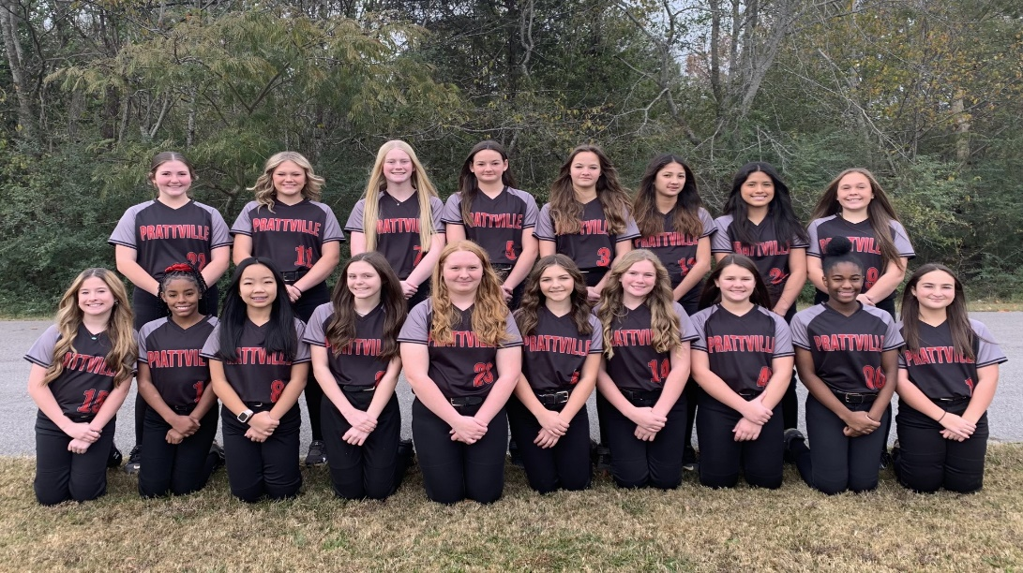

*Doubleheaders

