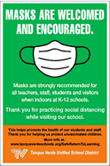

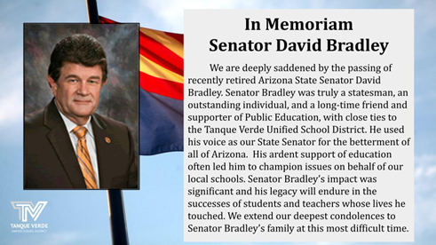

Information and discussion items included Board Goals, New Construction and School Logo Updates. Presentations were made by Mark Bollard of Swaim Architects, and Frank Williams and Anthony Fareio of Frank Williams Design. More detailed information is included in the summary below.
In Memoriiam of Ariizona State Senator Daviid Bradlley
Ariizona Aggregatte Expendiitture Liimiitt (AEL)The AZ Legislature passed legislation on the Aggregate Expenditure Limit (AEL) on Monday, February 21, 2022, so schools will remain fully funded for the remainder of this school year. A long term funding solution is still needed at the state level so schools do not have to face this crisis again next year. We appreciate the support of our community in addressing this concern with our legislative representatives.Healltth and Saffetty UpdatteBeginning Tuesday, March 1, 2022, face coverings are strongly recommended for students, staff, and visitors while indoors at K-12 schools.As a reminder, and per the COVID-19 Parental Acknowledgment and Disclosure form, we ask that you please screen your child/children dailyfor signs of illness, and do not send them to school sick.Governiing Board Meetiing Summary February 23, 2022At the February 23, 2022 Governing Board Meeting there were two action items addressed on the ELA Curriculum Adoption and the Fiscal Year 2021 Audit Report.

Curriicullum Adopttiion

After Dr. Hagerman reviewed the curriculum adoption process and implementation plan, the Board approved the recommendation of Scholastic Literacy for the ELA Curriculum Adoption for Kindergarten through 6th grade at Agua Caliente and Tanque Verde Elementary Schools.

Please see the following K-6 ELA Adoption Information:

K-6 ELA Adoption Recommendation Presentation,2-23-2022 ELA Adoption K-6 Board Memo - 2/18/2022

More curriculum information links are available through the BoardDocs agenda item details here.

Fiiscall Year 2021 Audiitt Reportt

Ms. Elaine Armienti, Director of Business Services, presented information to the Board as follows:
2021 Fiscal Year Audit and Funding Tanque Verde USD USFR CQ21

Ms. Armienti was pleased to report the success of the audit as seen in the report, and Ms. Armienti congratulated members of her team for their great work toward this major accomplishment.

New Consttructtiion Updatte

Mark Bollard from Swaim Architects AIA presented a detailed update on the new construction projects. Mr. Bollard thanked the staff and students at all sites for the patience and cooperation they have displayed during the construction process thus far. The architectural renderings are compared alongside current images of the ongoing construction projects.

The full presentation, which includes many more exciting images, may be viewed here.

New Consttructtiion Photto Gallllery

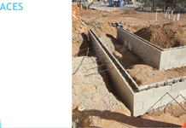
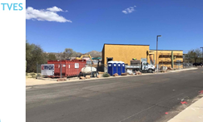
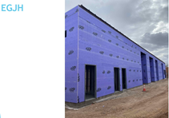
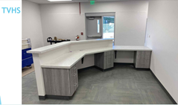
Logo Updattes

Frank Williams from Frank Williams Design (FWD) presented on developing updated logos for some of our TVUSD schools. FWD was the principal design team with the recent new TVHS and TVUSD logos, which will remain in place. The EGJH, ACES and TVES logos are being updated as part of the 2021-22 Board Goals. There may be some minor adjustments made, but we’re very pleased with the new designs and how they communicate the district brand as a ‘family’ of logos.

The FWD presentation, with old and new logo designs and their possible applications, may be viewed here. There will be an opportunity for feedback. A short survey will be included in the ACES, TVES and EGJH Constant Contact communications on March 4th.

Board Goalls Updatte

TVUSD Viisiion

"Our students will achieve academic and personal success in an ever-changing

world.”
Diisttriictt Miissiion

"TVUSD will ensure effective communication, collaboration, school partnerships and state of the art facilities that support our vision for students as well as benefit all constituents. Our balanced budget ensures continuity of programs and empowers growth."

Dr. Scott Hagerman presented an update on the 2021-22 Board Goals, stating that we will continue to be driven by the District Vision and Mission as we work to continue the high level of student achievement throughout the district.

The following are the focus of steps currently underway to continue progress on the
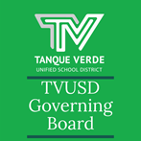
2021-22 Board Goals:
 | Goall 1:: Sttudentt Achiievementt Ongoing work implementing Professional Learning CommunitiesK-6 English Language Arts AdoptionProfessional learning opportunities and planning daysGoall 2:: Fiiscall Responsiibiilliitty Effective use of Covid Funds Operations ChangesSchool Facilities Board and BondNew ConstructionGoall 3:: Hiigh-Qualliitty Proffessiionalls RecruitmentFinancial Support for higher ed coursework |  |  | Goall 4:: Schooll Culltture Emergency Operations Plan Emergency Planning Communication Assessment of ToolsNew Website Logo UpdatesGoall 5:: Communiitty Engagementt Community Partnerships Tanque Verde Faith-Based Community Collaborative Service Organizations Advocacy
IImporttantt Dattes & IInfformattiionThu. March 3rd - Fri. March 4th K-6 RELEASEWed., March 9th - Governing Board Fri., March 11th - End of 3rd Quarter SCHOOL!Mon., March 14th - Fri. March 18th S Wed., March 23rd - Governing BoardMarch Note - TVES Site Council MeetinNextt Governiing Board Meettiing Datte::The next Regular Meeting of the TVUS Board will be held on Wednesday, Marc 6:00 p.m. at Tanque Verde Elementary S Library. The Governing Board will be ret Person Meetings in March. A Call to the held at the first meeting of each month.TVUSD Virtual Call to the Public ForBoard Meeting Agendas and MinutesTVUSD Board Meeting Livestream L |  |  | Parent Teacher Conferences K-6 EARLYMeeting 6PM/Grading Day CORRECTION - NOpring Break NO SCHOOL Meeting 6PMEventsg Date Correction - March 7, 2022D Governing h 9, 2022 at chool in the urning to In-Public will bemink

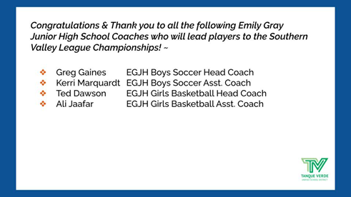
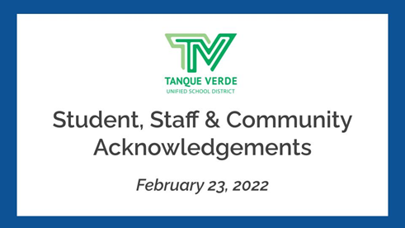
Student, Staff & Communiity Acknowlledgments
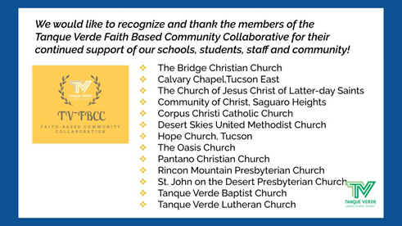
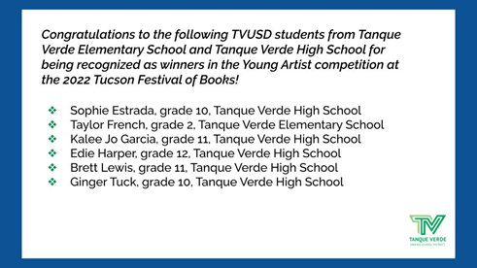
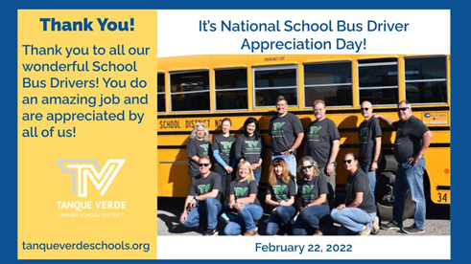
Connect wiith us
Visit our website

