Boating: Chapter 3 Review

(Unit 2: Casting off-Unit 3: Summary)

1. If the wind or current direction is toward the dock, you should cast off the ________________ first when leaving the dock.
2. The ____________________________ is required to take early and substantial action to avoid a collision by stopping, slowing down, or changing course.
3. The stand-on vessel must___________________________________________________ unless _________________________________________________________.
4. If you are driving a powerboat or PWC and meet another powerboat or PWC head on, you should keep to the ____________________.
5. If you are overtaking another vessel, you are the stand-on vessel.
   1. True
   2. False
6. If you see a red and white light ahead when boating at night, you should maintain course and speed
   1. True
   2. False
7. If you see only a green light while boating at night, you may be approaching a ____________________ and you must ______________________.
8. ____________ and ____________ are the “traffic signals” that guide boaters safely along their course.
9. The phrase “Red ______________ ______________” reminds vessels of the correct course in the lateral system of U.S. Aids and Navigation
10. This buoy marks the edge of the channel on a boater’s ________________ side when 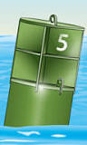

entering from the open sea or heading up stream.

1. This regulatory marker indicates ___________________________. 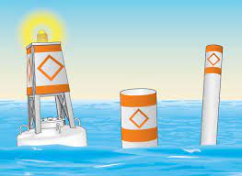
2. This regulatory marker indicates areas that are _________________________ to vessels. 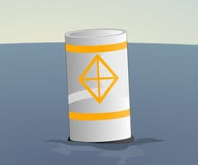
3. A good rule of thumb is that the anchor line should be at least _______________ times the depth of the water.
4. You should never anchor from the _____________ of the vessel as that can make the vessel unstable.
5. To maintain steering control of a PWC, you must never allow the engine to _________________ or ________________
6. The most common complaint boaters have against PWC operators are ______________________ and ______________________
7. As a courtesy to other boaters and people on shore, PWC operators should __________________ their operating areas
8. Name a safety device that shuts the engine off if the operator is thrown from the proper operating position. ______________________________
9. To avoid propeller strike accidents, make sure the ______________________________ when passengers are boarding and disembarking a boat.