Unofficial Until Approved Meeting Minutes 2/27/2018
The Governing Board of the Tanque Verde Unified School District #13, Pima County, Tucson, Arizona held a regular Board meeting on February 27, 2018 in the Board Room, at Tanque Verde School District Administrative Office, 2300 N. Tanque Verde Loop Rd, Tucson, Arizona 85749. The meeting was called to order at 6:58 p.m.
- ROLLCALL
Board Members present:

Ms. Susan Fry, President
Mr. Jeremy Schalk, Board Clerk
Mr. Steven Auslander, Board Member

Administrative Staff:
Dr. Scott Hagerman, Superintendent Mr. Adam Hamm, Business Manager
- APPROVAL OF AGENDA
Mr. Jeffrey Neff, Board Member (absent) Mr. Carlos Ruiz, Board Member
Kaitlyn McWilliams, Student Board Member

MOTION: Mr. Auslander made a motion to approve the agenda. Mr. Schalk seconded; the motion carried unanimously.
- CONSENT AGENDA (see attached personnel report)
Dr. Hagerman introduced the following new teachers: Ms. Haley Wilson, Ms. Anne Marie Karel, and Mr. Jerald Frey to Governing Board Members.
MOTION: Mr. Auslander made a motion to approve the Consent Agenda as presented. Mr. Ruiz seconded; the motion carried unanimously.
- INFORMATION AND DISCUSSION ITEMS
  - ACES - Student Presentation: Reading Fair - Ms. Jessica Feldman
ACES Librarian, Ms. Jessica Feldman spoke about a new program introduced this year, Reading Fair, during Love of Reading week. Students were encouraged to develop poster boards, similar to Science Fair project boards. The poster boards students created were about books they've read. The Reading Fair poster boards were judged and the winners received gift cards from Bookmans. Ms. Feldman hopes to continue the Reading Fair program next year.
The following students presented their Reading Fair poster boards to Board Members: Noemi Celani- 2nd grader- received a $25 gift card from Bookmans
John Sullivan - 2nd grader - received a $25 gift card from Bookmans
Lyla Taylor - 5th grader - shared the $25 gift card with Sierra from Bookmans Sierra Kanoza - 5th grader - shared the $25 gift card with Lyla from Bookmans Hunter Scott- 5th grader - shared the $25 gift card with Daniel from Bookmans
Daniel Provenzano - 5th grader- shared the $25 gift card with Hunter from Bookmans

  - Special Education Audit - Dr. Scott Hagerman

Dr. Hagerman spoke about looking for areas of opportunity to improve our Special Education programs and services. He presented the following Special Education PowerPoint:

Special Education Process: Eligibility
Does the student have a disability?
Specific definition based on Department of Education (DOE) and Arizona Department of Education (ADE)
Does the student need specialized instruction? Based on evaluation and team determination
Other Health Impaired (OHI), Specific Learning Disability (SLD), Developmental Delay (DD) and Speech language Impaired (SLI)
Definitions -
Universal issues with identification. (DD, OHi, SLD and Speech)
( these are areas of concern in every district across the country)

Least Restrictive Environment (LRE)
The goal is for the Special Education population to remain in the classroom with general population whenever possible. Obviously a student's Individualized Education Programs (IEP) provides specific guidelines.
Special Ed Determination Process
- What does the process look like?
- Who decides?
- What role does the district have in the process?

Student Data
ACES -19% w/o preschool TVES- 13%
EGJH-16% TVHS-11%
12% has been the state average. 10% has been the state goal.
Elementary Caseloads ACES:
Program | FTE | Average caseload
CBI | 1.0 | 14
Resource | 2.8 | 22.8
Speech | 1.55 | 47
TVES:  Program | FTE | Average caseload
CBI | 1.0 | 7
Resource | 3.0 | 15.6
Speech | 1.0 | 37
EGJH:  Program | FTE | Average caseload
CBI | 1.0 | 10
Resource | 2.0 | 24
Speech |  | 13
TVHS:
Program | FTE | Average caseload
CBI | 1.0 | 7
Resource | 3.0 | 17
Speech |  | 6

Recommendations:
Procedural Clarity - Parapro consideration process, Eligibility criteria, Pre referral intervention Service Location - In the general education setting or in resource room?
Service Models - What types of specialized instruction are we providing?
Shared Materials and PD -
Are our intervention efforts effective, and systematic?
Does our staff have the support and materials to be successful? What else should we be doing?
Legal Considerations
    - What are the legal questions we should ask?
    - Do we ensure access to general ed curriculum?
    - Are we providing specialized instruction designed to have students make academic progress?
    - Do we make team determinations based on data?
    - Do we make adjustments as we go to ensure ongoing progress?
###

Special Education Director, Ms. Sally Glennon addressed the Board by saying she has participated in hundreds of IEP meetings throughout the District with staff, students and parents. There is an overwhelming sense of thanks and gratitude for everything the District is doing to help students.
Dr. Hagerman concluded his presentation by saying a handbook (15-20 pages) will be developed to provide strategic guidelines for staff, which will promote consistency among the sites.
Board Members asked clarifying questions throughout the presentation.
Dr. Hagerman responded by saying we can utilize student intervention more effectively before and after Special Education services. This will promote student success and reduce the identification numbers district wide.
  - Writing program feedback - Dr. Scott Hagerman
Dr. Hagerman shared the Writing program feedback with Board Members. He met with K-6th grade teachers and administrators from both of the elementary campuses. He presented the following PowerPoint:
Agenda History
Feedback Session Themes Suggestions
History
PD needs assessment Pilot Year
Initial Training Yearl

Feedback Session
Mix of teachers from both sites
Talk in small groups and then as a large group The basic questions were:
    - What's working?
    - Where are the challenges?

    - How can we help the process?

Themes Time Pacing
How tightly do we follow? Curriculum conflicts

Suggestions
Teachers need longer blocks of time (Master schedule adjustments) Guidance on what writer's workshop means in TVUSD
Pacing
Non-negotiables K-2 Issues Variety of PD
Time to learn from each other

Takeaways for Writing
- Have a broader group make the decision.
- Pilot group tends to get better support than the rest of the team, make sure not to leave people berund.
- Make sure to think about how to get new staff training.

- Give guidance on viable ways to implement.
###
Board members asked clarifying questions about the process throughout the presentation. All expressed their thanks and appreciation that we are looking at alignment in our schools and grade levels.

STEM Update - Dr. Scott Hagerman
Dr. Hagerman and Ms. Svea Anderson presented the following PowerPoint: The Initial Model
Three components:
- STE(A)M content.
- Critical and creative thinking.
- A culture that nurtures growth mindsets for students and adults.

STEAM Experiences/Content STE(A)M experiences include:
- Coding/Programing
- Problem Solving/Critical thinking
- Keyboarding
- Project Based Learning
- 3-D printers
- Industry exposure (Raytheon and Texas Instruments)
- CTE
- Citizen Science

Thinkin Skills
STE(A)M thinking skill approaches are outcome-focused and aim to solve real world challenges.
STE(A)M education and training establishes relationships between the four disciplines of
Science, Technology, Engineering, and Mathematics, with a strong emphasis on critical and creative thinking skills.
STE(A)M learning is an interdisciplinary approach to learning, connecting school with
community, work, and business.
Cognitive STE(A)M thinking skill competencies for learners include knowledge, skills and abilities.
Mindset and why is it important in STE(A)M education? Characteristics of a Growth Mindset
  - Everyone can change through applicat;ion and experience
  - Passion for learning

  - Overcome weaknesses
  - Step outside their comfort zones, take risks
  - Confront challenges
  - Persistence. Sticking with something even when it is not going well
  - Failure is a learning opportunity
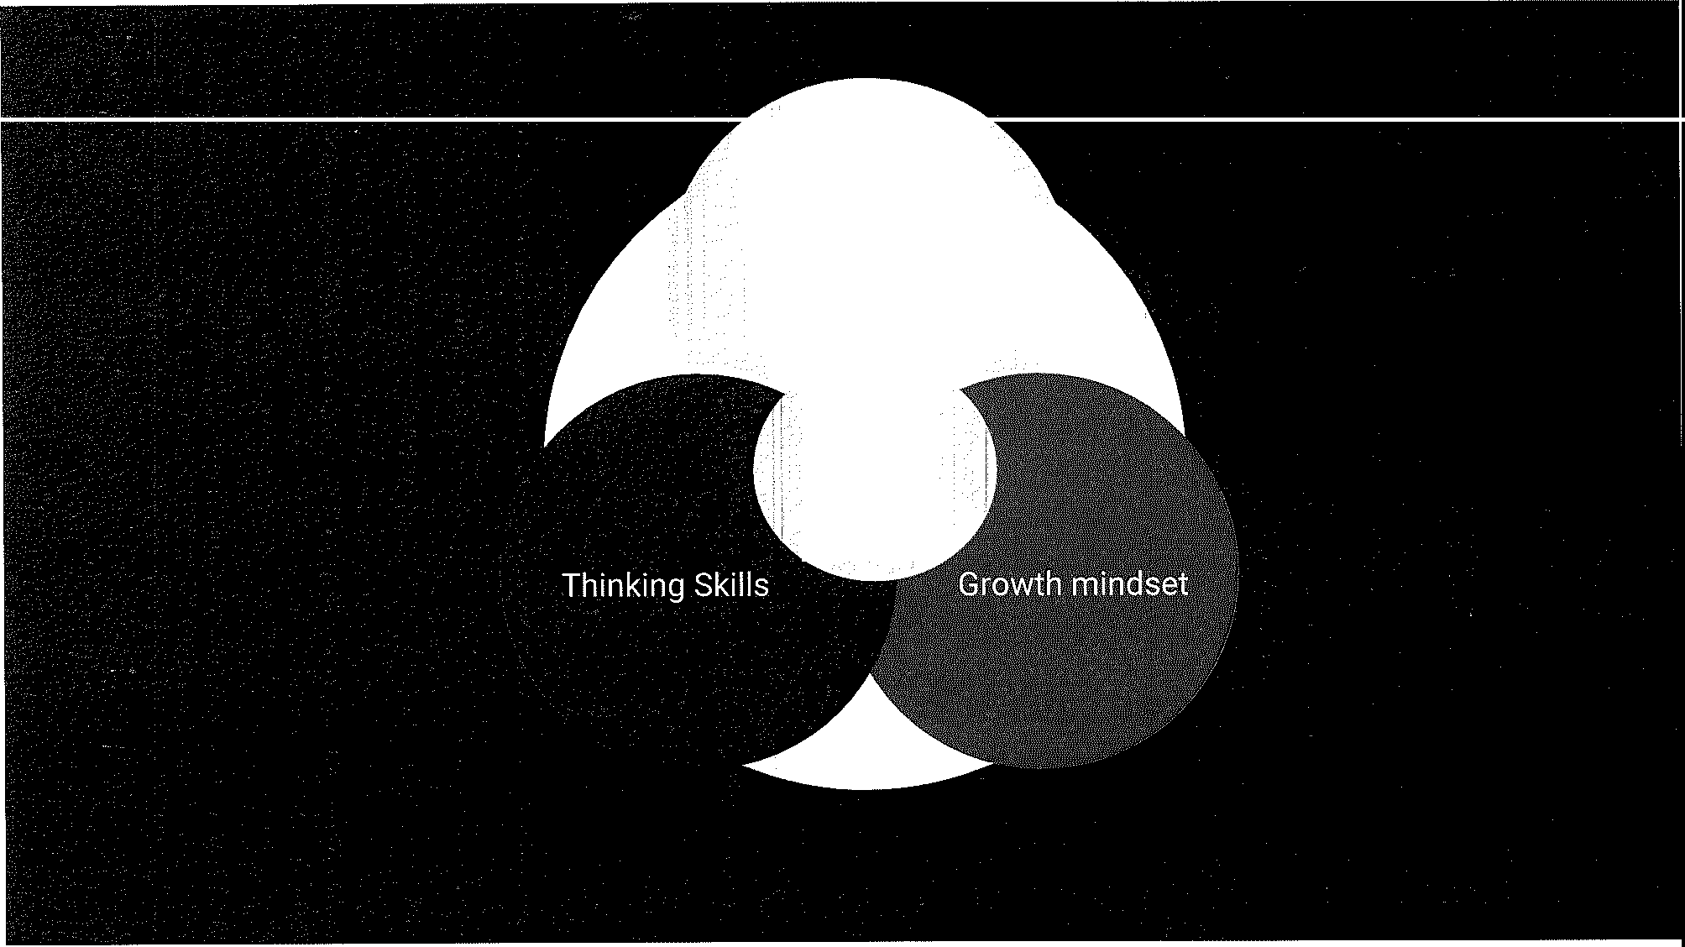

.Experiences/· content

STE(A)M
Summer Workshop
1st annual conference to explore and learn about the three elements of STEM May 31,
2018
- How do we develop critical and creative thinking skills for all students?
- How do we nurture a culture that supports a growth mindset for students and staff?
- Provide teachers with interactive immersive STEM experiences.

Math Alignment
  - An effective shared approach to math is critical.
  - Develop plans for math curriculum K-12
    - K-5 process
- 6-8
    - High School

Chief Science Officers
4 Students (2 TVHS and 2 EGJH) elected by peers who will:
Attend a Leadership Training Institute, Cabinet Meetings with business leaders through the Chief Science Officer Program.
Provide student leadership for STEM on their campuses.

Advanced Math Pathway and Staffing Ensure access to an advanced math pathway.
- Reduce barriers to participation.
- Use assessment process to increase participation.
- Continue to look for ways to challenge students.··
###
Ms. Fry expressed her desire for Math alignment in our schools and at grade levels. She asked if we have the infrastructure in place to support expanded programs such as Coding. Dr. Hagerman indicated we would start with a test case, we will inventory our devices and ensure, moving forward, that we have the necessary infrastructure
in place to support this program.

  - 301 Plan 2018-19 SY - Dr. Scott Hagerman
Dr. Hagerman presented the following PowerPoint:
PURPOSE
The purpose of the TVUSD Performance Based Pay Plan is to promote student achievement through the successful completion of site goals which are aligned with Tanque Verde Unified School District goals. The plan will foster collaboration between the certified staff and the administration as they endeavor to accomplish unique site goals.

History
Classroom Site Fund 15-977: Subsection A, History; Proposition 301 was approved by Arizona voters in the fall of 2000 and provides for an increase in the state sales tax that began on May 31,

2001 to provide funding for a variety of programs including education. An increase in teacher salaries was a major focus. Funds from the increase in sales tax go into what is called the Classroom Site Fund. The Statute called for funds in the Classroom Site Fund to go into three (3) buckets of funding.
    - Bucket 1 consists of 20% of the funds a district receives and must be applied directly to the
teacher's salary schedule (A.RS. § 15-977 A). This portion is part of TVUSD teachers salaries.
    - Bucket 2 is comprised of 40% of the funds a district receives and is used for performance based compensation: This fund is paid out based on performance on site goals. Returning teachers receive a $500 retention incentive paid in December, the remaining amount is paid out in June.
    - Bucket 3 is the final 40% of funds a district receives. These funds are paid out as follows: a portion is blended into TVUSD teacher salaries.

Participation
All eligible teachers at each site will participate in the achievement of the Site Goals. If the Principal determines that a participant is not fulfilling the responsibilities of achieving the site
. goals, the Principal will recommend to the Superintendent that performance pay be withheld from that individual.
Teachers who work an equal amount of time at different school sites will earn a prorated amount from each site.
Teachers who work unequal amounts at different school sites will choose one site. Their choice of site will be made in consultation with the site Principals.
Teachers on special assignment will choose one school site. Their choice of site will be made in consultation with the site Principals.

Site Goals
      - Eligible teachers will earn performance-based pay through the achievement of site goals.
      - Site goals will be aligned with District goals.

      - Participants will agree on three site goals. One goal will address student achievement. Two out of these three goals must be achieved to earn performance based pay.

Each site goal will include:
- A statement of the site goal, including measurable performance.
- A statement of how the site goal relates to the District goal.
- The steps the participants will take to achieve the goal.
- The steps the principal will take to assist participants in achieving the goal.
- How the goals will be measured/assessed.
- What documentation will be submitted to support achievement of goal.
- A timeline for achievement of the goal. ·

Approval of site goals:
The site Principal and participant representative(s) will present the site goals to the Superintendent for final approval.

Evaluation of site goal achievement:
Each site will present documentation to support the achievement of each site goal. Documentation will be presented to the Superintendent by the site Principal and participant representative(s). The Superintendent will verify the achievement of the site goals.
If the Superintendent is unable to verify the achievement of two out of the three site goals, the Appeals Process may be undertaken. (seep. 3)

Appeals Process
If the Superintendent does not verify the achievement of two out of three site goals, the site may follow the Appeals Process.
The Appeals Committee will consist of the Superintendent, one teacher from each school* not involved in with the appeal, and a principal from one school not involved with the appeal.
The site principal and participant representatives from the appealing site will present
evidence to the Appeals Committee in support of goal achievement. The Committee will consider the evidence and make the final decision.

*Schools:
Agua Caliente Elementary Tanque Verde Elementary Emily Gray Junior High Tanque Verde High

Distribution of Funds
Money from Bucket #1 (salary fund) and a portion of Bucket #3 9 Menu funds) is distributed evenly throughout the year.
$500 is paid to returning teachers as a retention incentive in December.
The remaining funds are paid in June. Distribution of funds is dependent upon successful completion of site goals by eligible participants.
The Superintendent provides the Business Office with a list of eligible participants. Performance pay is prorated to FTE.
Principals may recommend that performance pay be withheld to individuals not meeting site goals. This does not affect other site participants. The share of unpaid money remains in the Prop 301 fund and becomes part of the performance pay for the following year.
**********

Summer
Start of School Year Before Labor Day
Before Fall Break October31 December31 April30

MaylO May20 June 1
. June 30

District Timeline
Governing Board finalizes and adopts District Goals Superintendent Site goals for 2018-2019 presented to by site principal and participant representative(s)
Superintendent approves site OR Site goals returned for revision Goals if needed
Site goals re-submitted for approval, if needed
Resubmitted goals approved
Retention compensation in paychecks to eligible employees. Documentation for achievement of site goals presented to Superintendent by site principal and participant epresentative(s) Process if site goal achievement not verified, appeals may begin Appeals Process completed
List of eligible participants submitted to Business Office
Compensation in paychecks no later than June 30

This plan will be reviewed annually by the District 301 Committee.

###

Board Goals: Professional Learning Community training update-Dr. Scott Hagerman
Dr. Hagerman updated Board Members that he and several administrators attended a training
last week in Phoenix. He provided the following PowerPoint:

District Background:
    - PLC began as part of new teacher evaluation.
    - District need for better alignment and coherence.
    - Last year's superintendent Hiring Process.

What is a Professional Learning Community:
It's a school and school district culture where the adults work closely together to ensure high levels of learning for all students.
Is there any evidence it would work?
Dr. Hagerman provided the following grafts -

...0.2---......
--o. ₁
I
o·· .·
·O

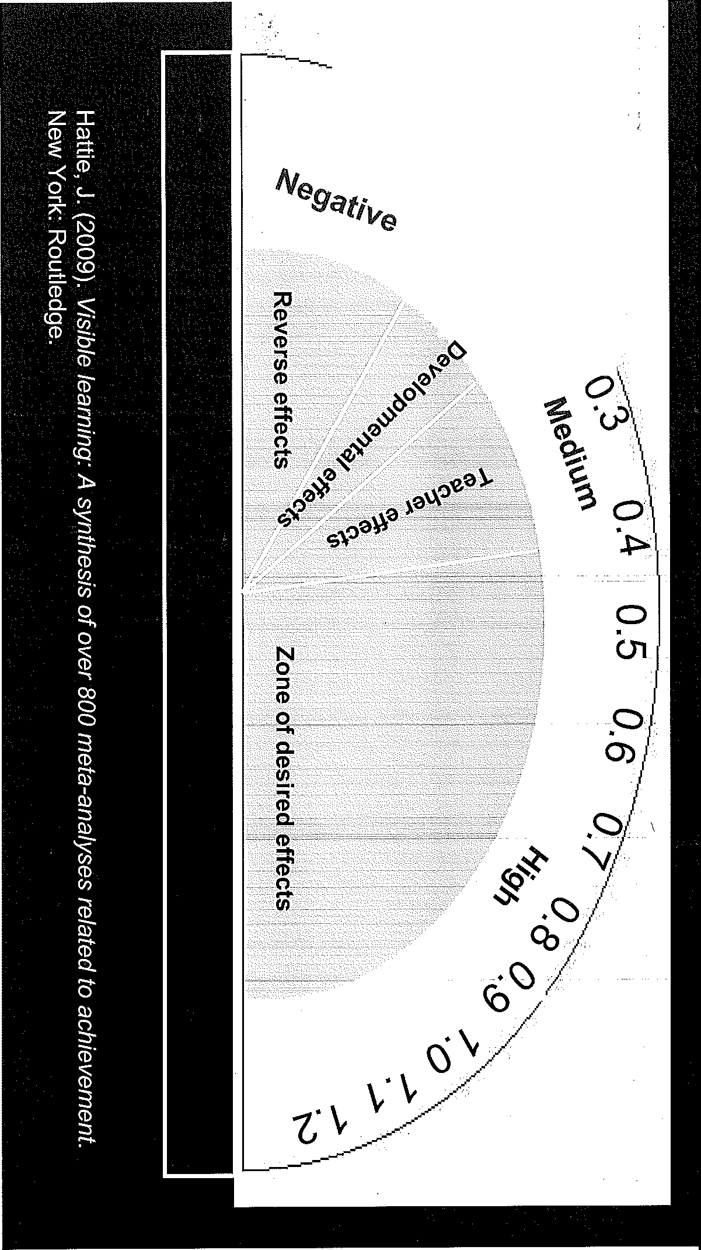
0·7

<o'l,g,. 0·:

··"·

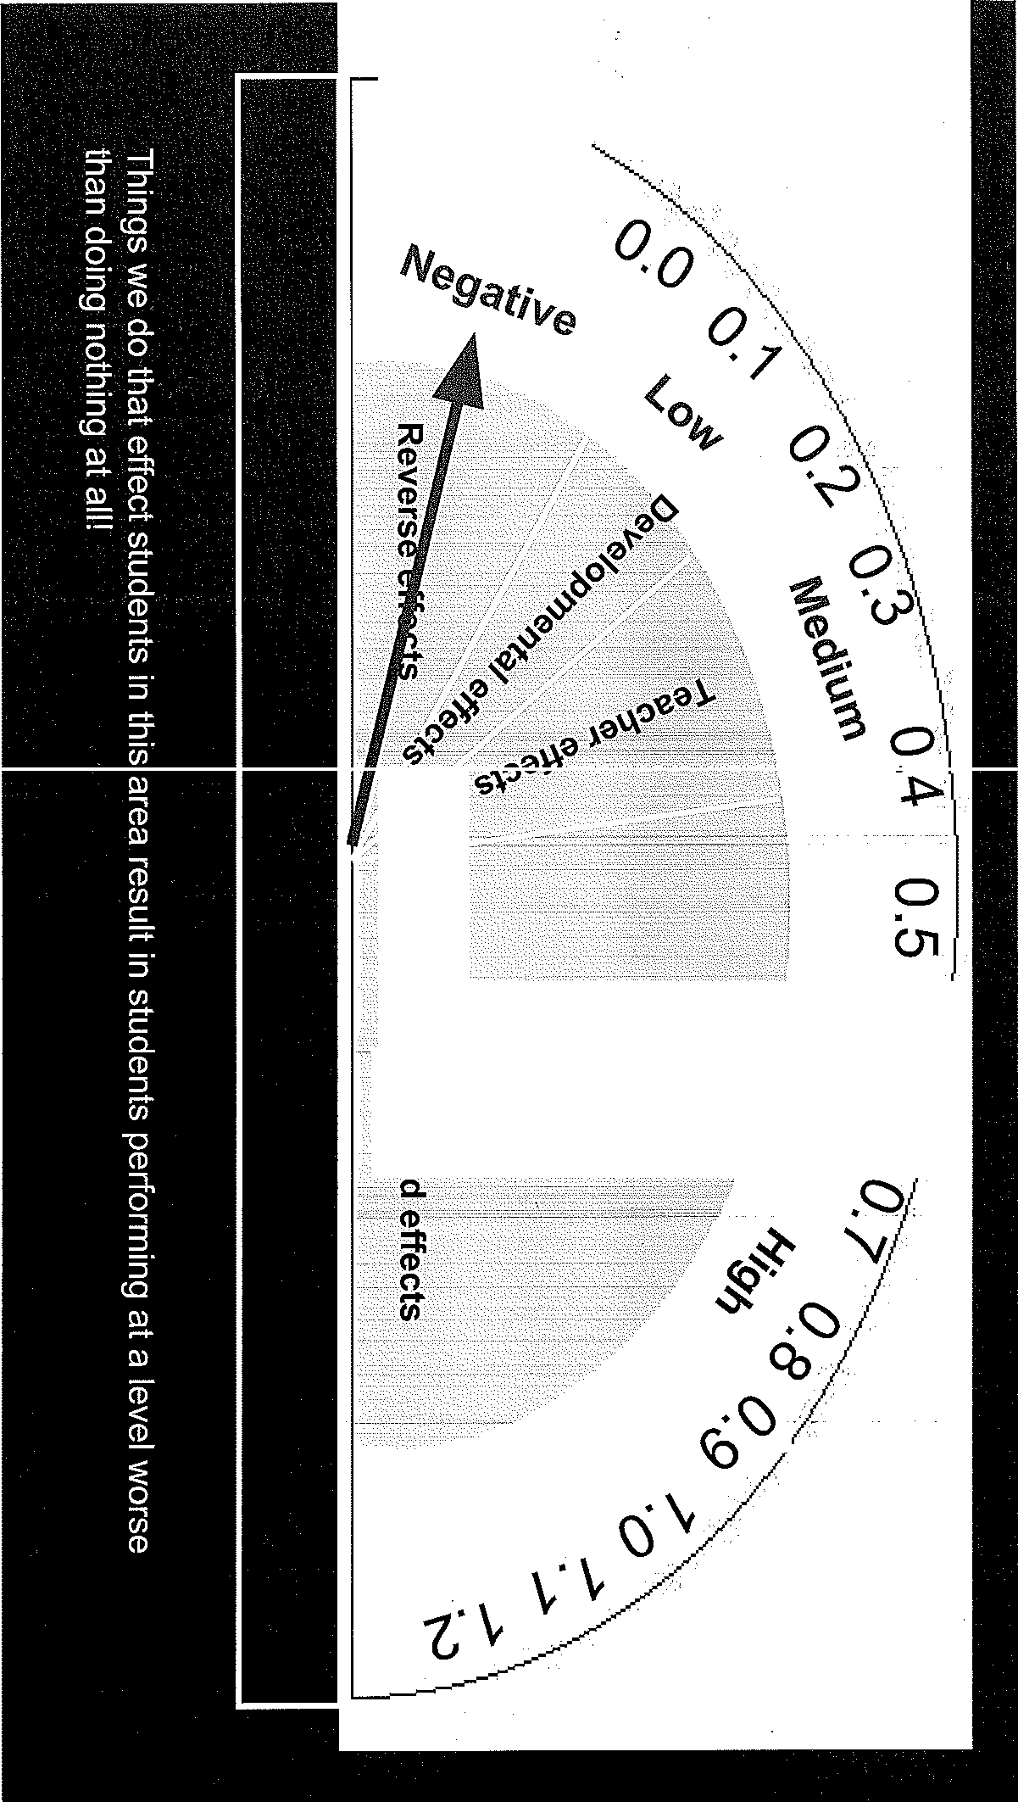

0.,2 --0.1

N
0
::,
(1)
--S, C)
•
C.
0)
(1)
(-/)·
@
C.
i
- 0....
(/)
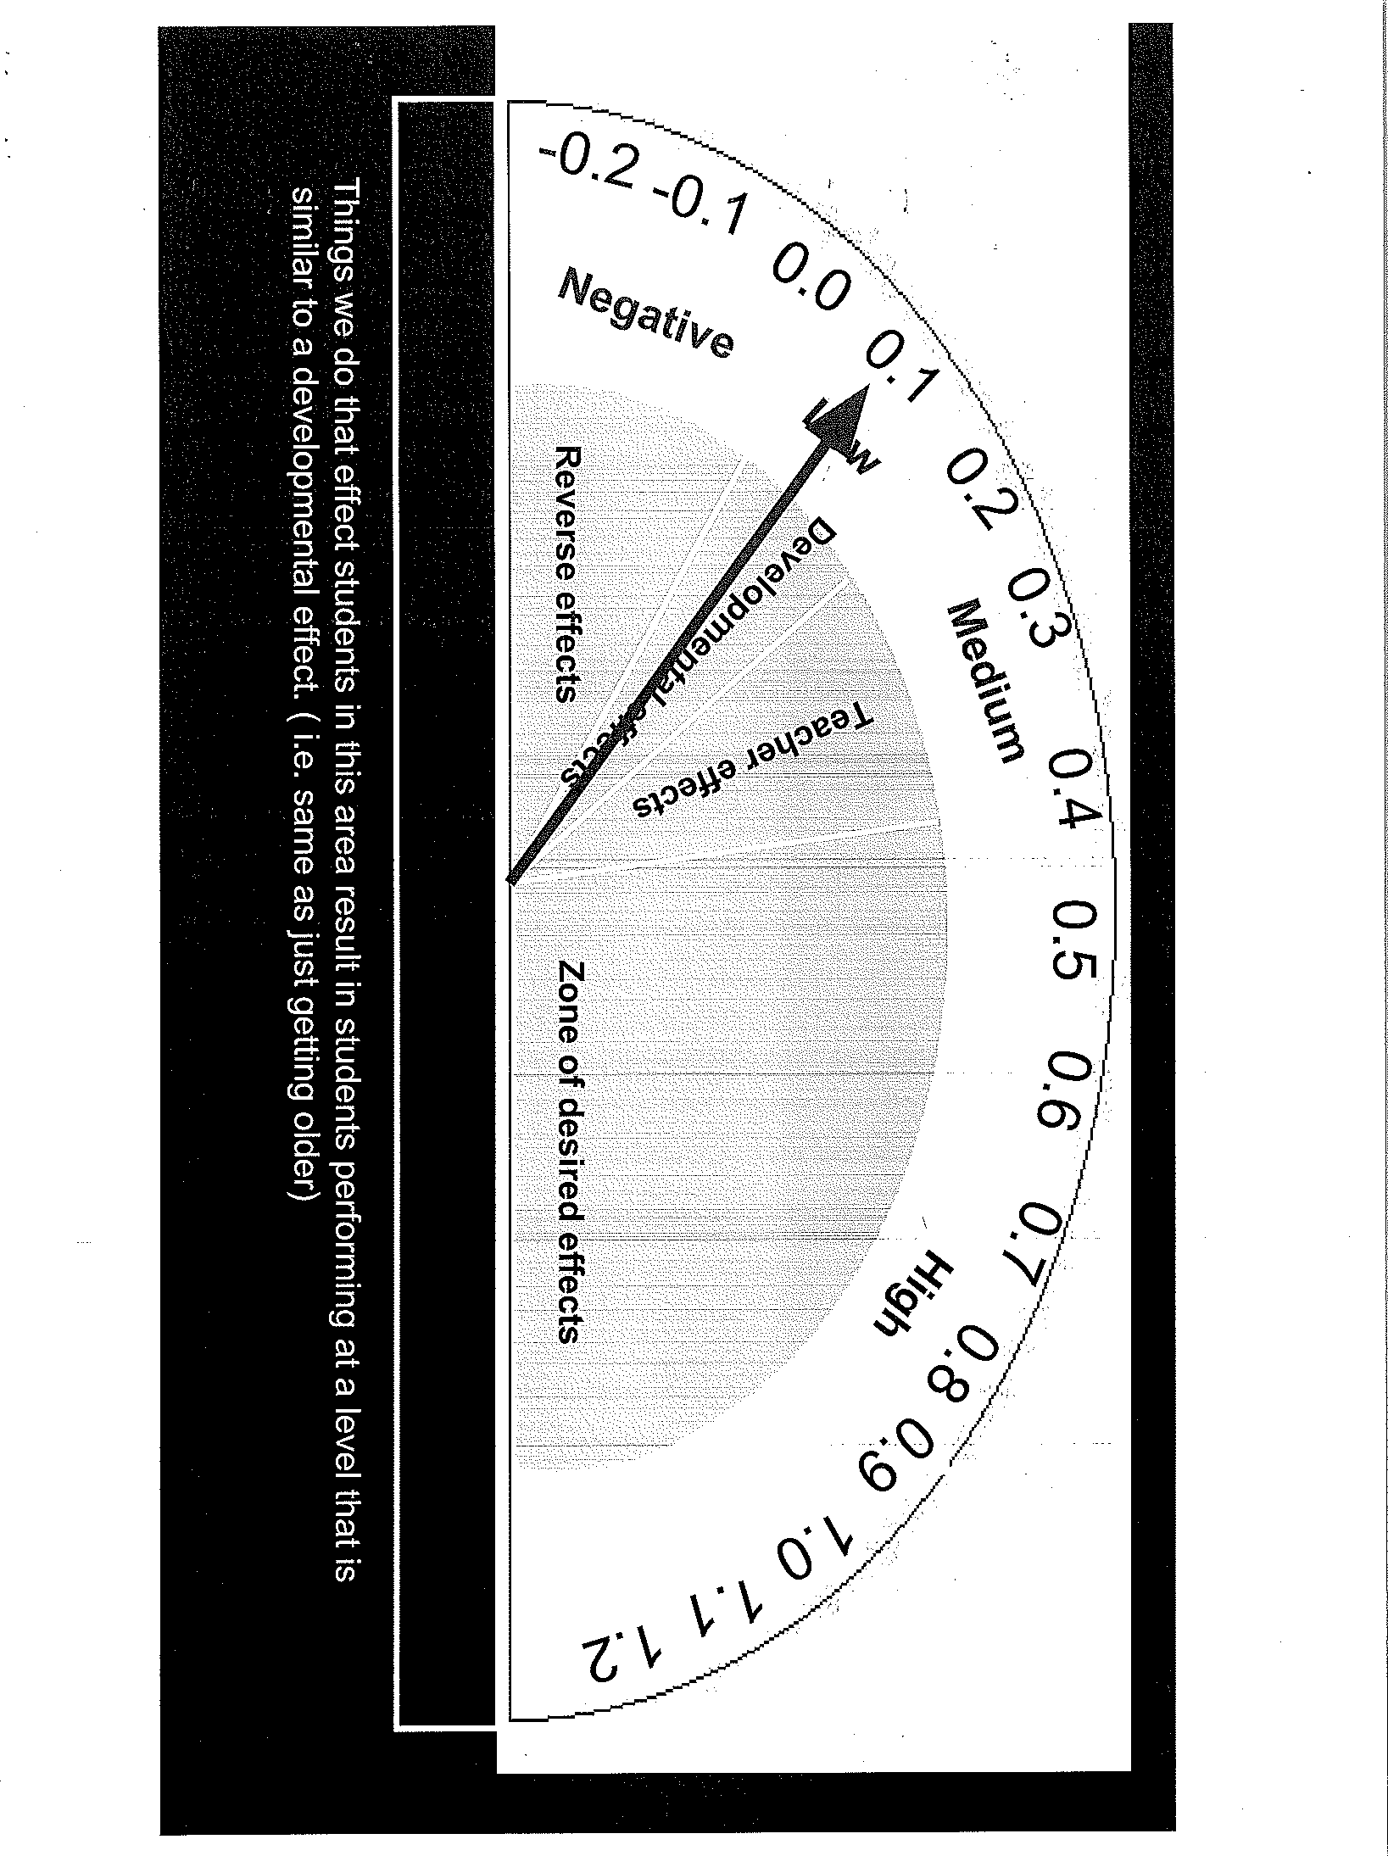

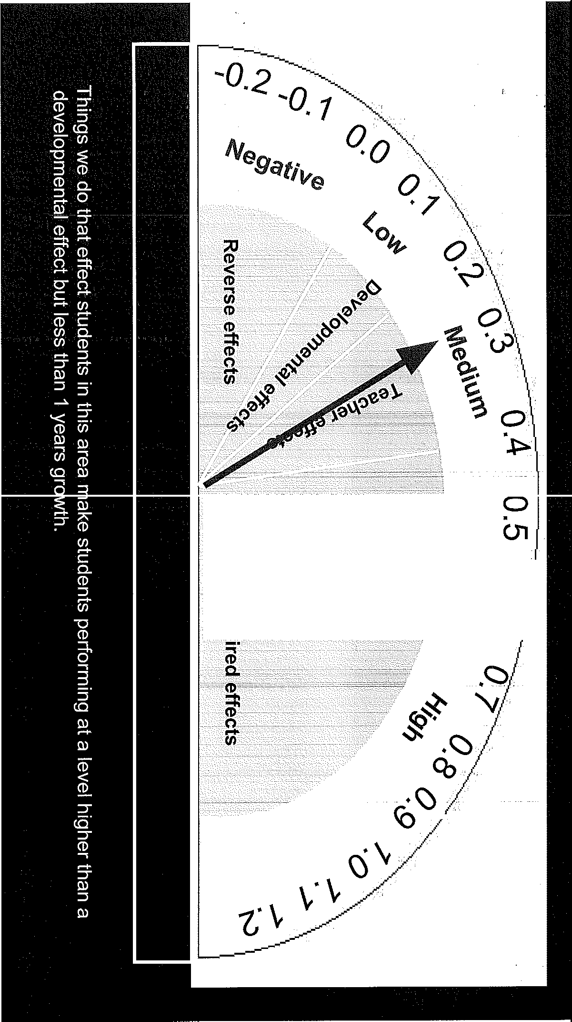
··si
:::s
CD
e,......
Q.

m

.o.

0)

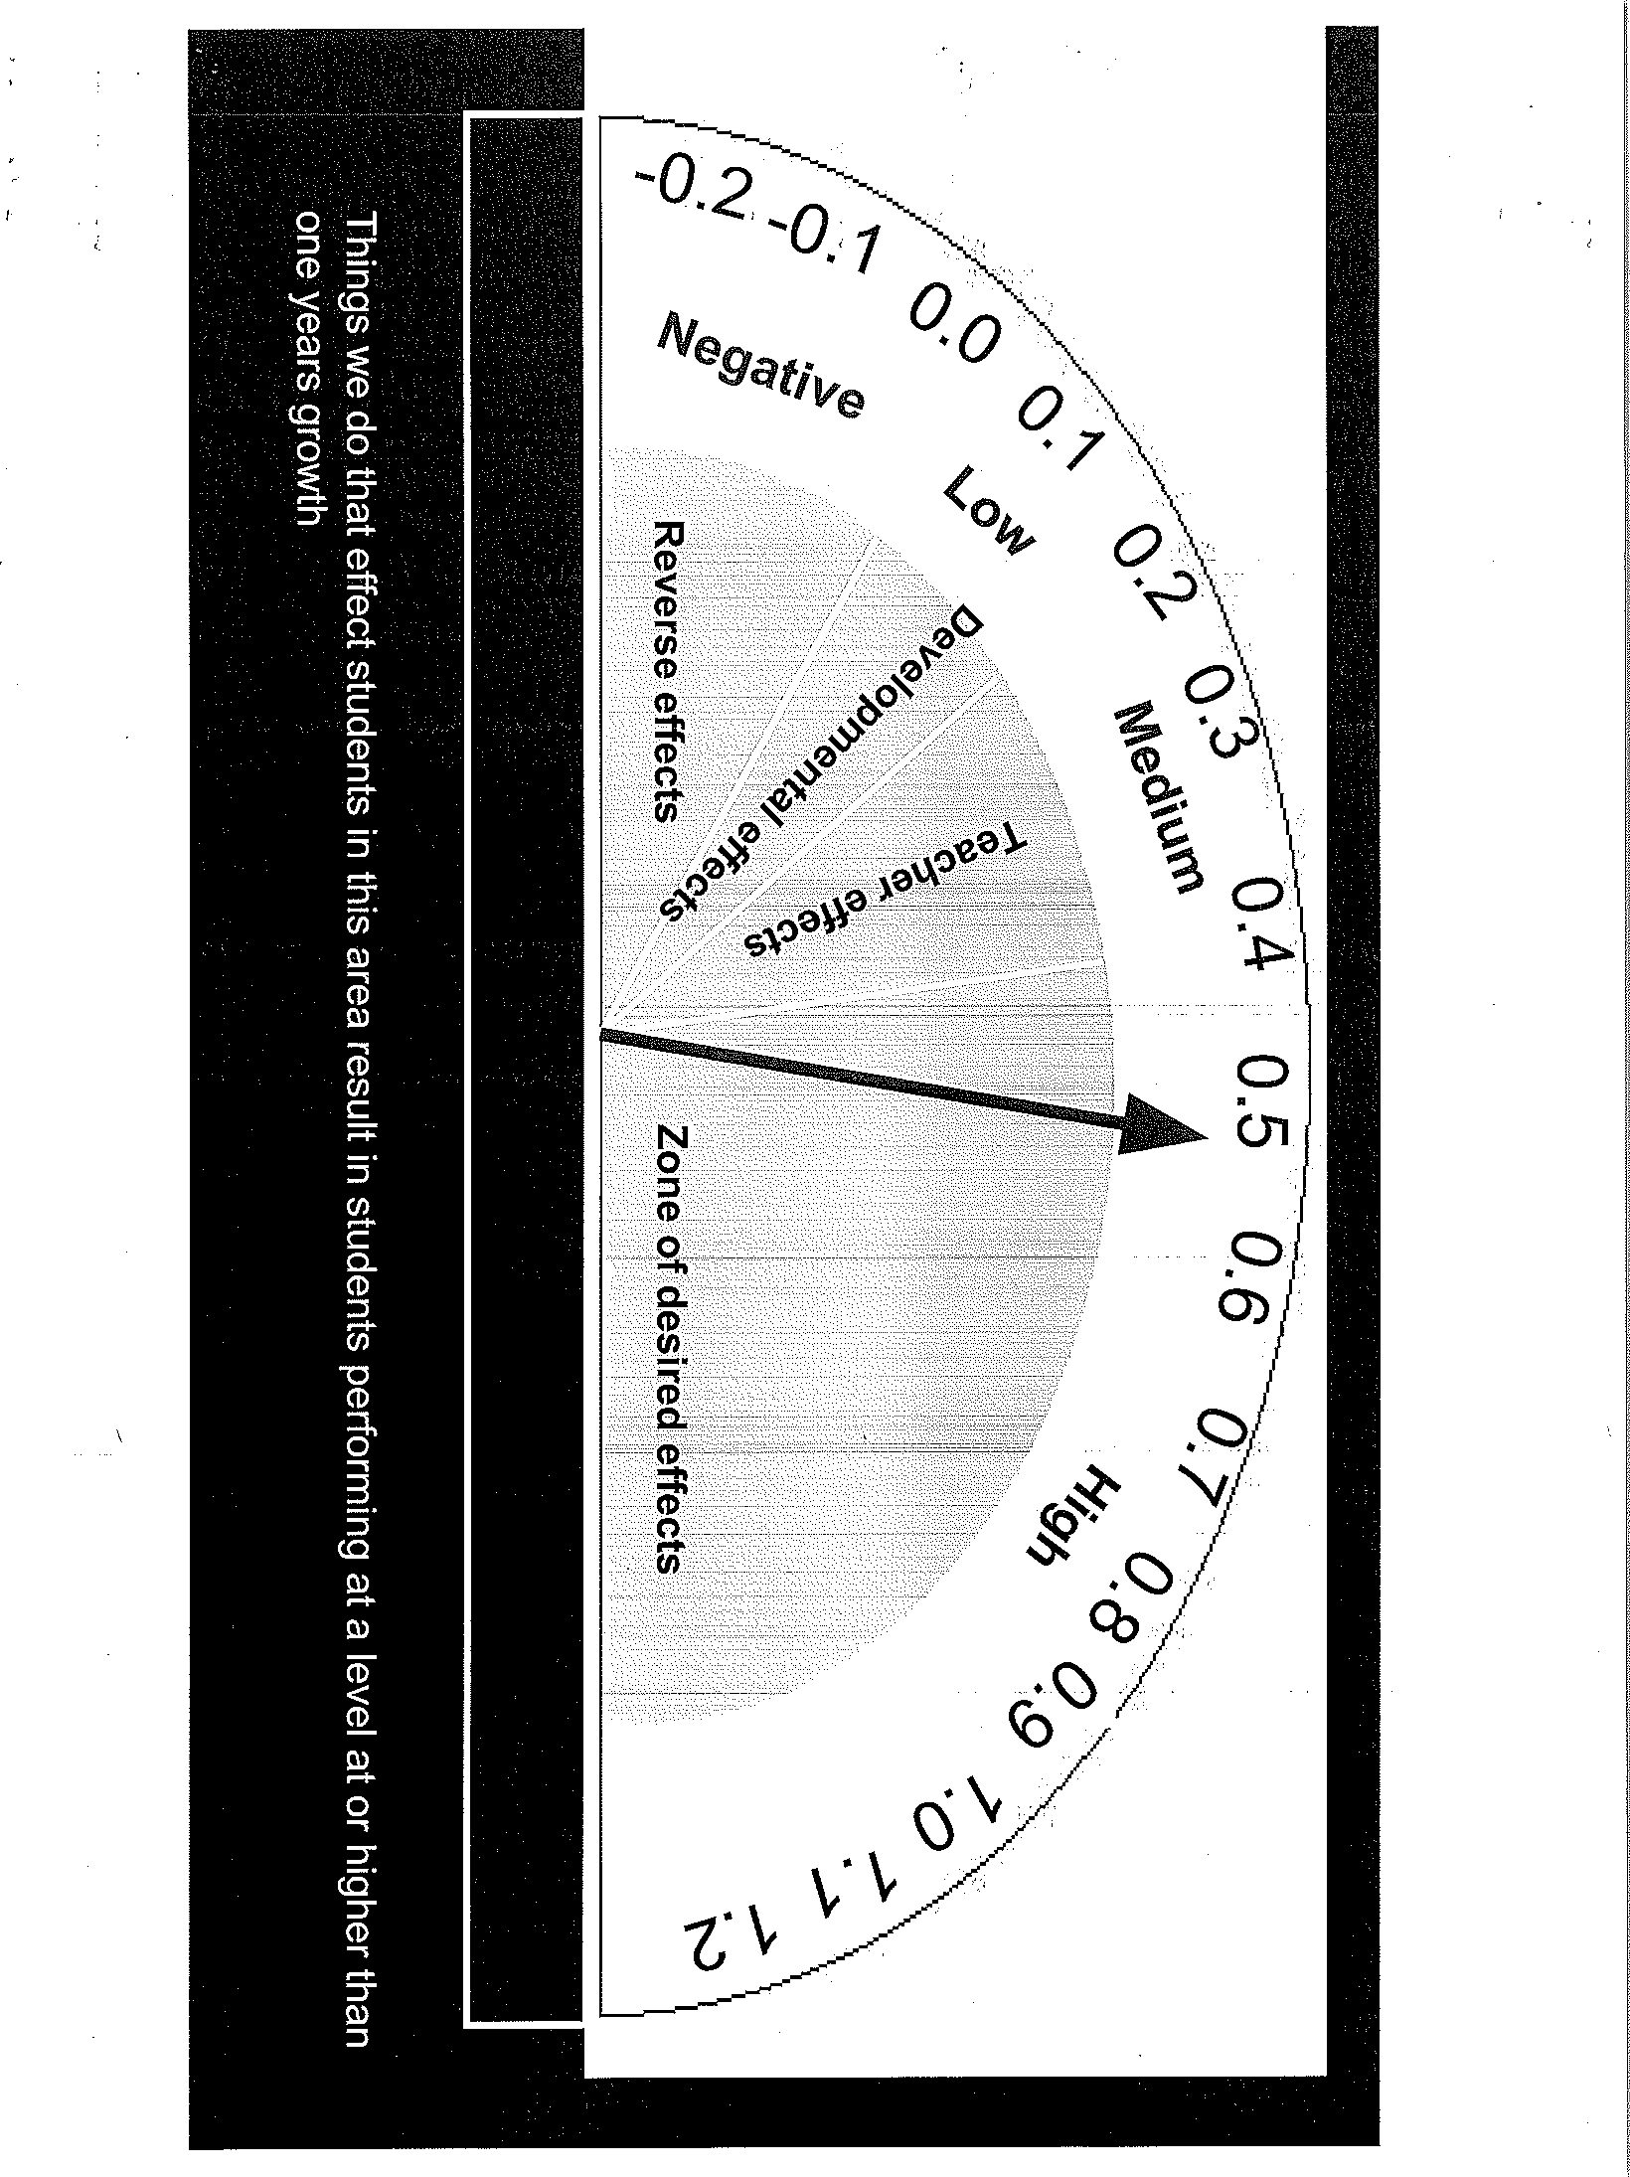
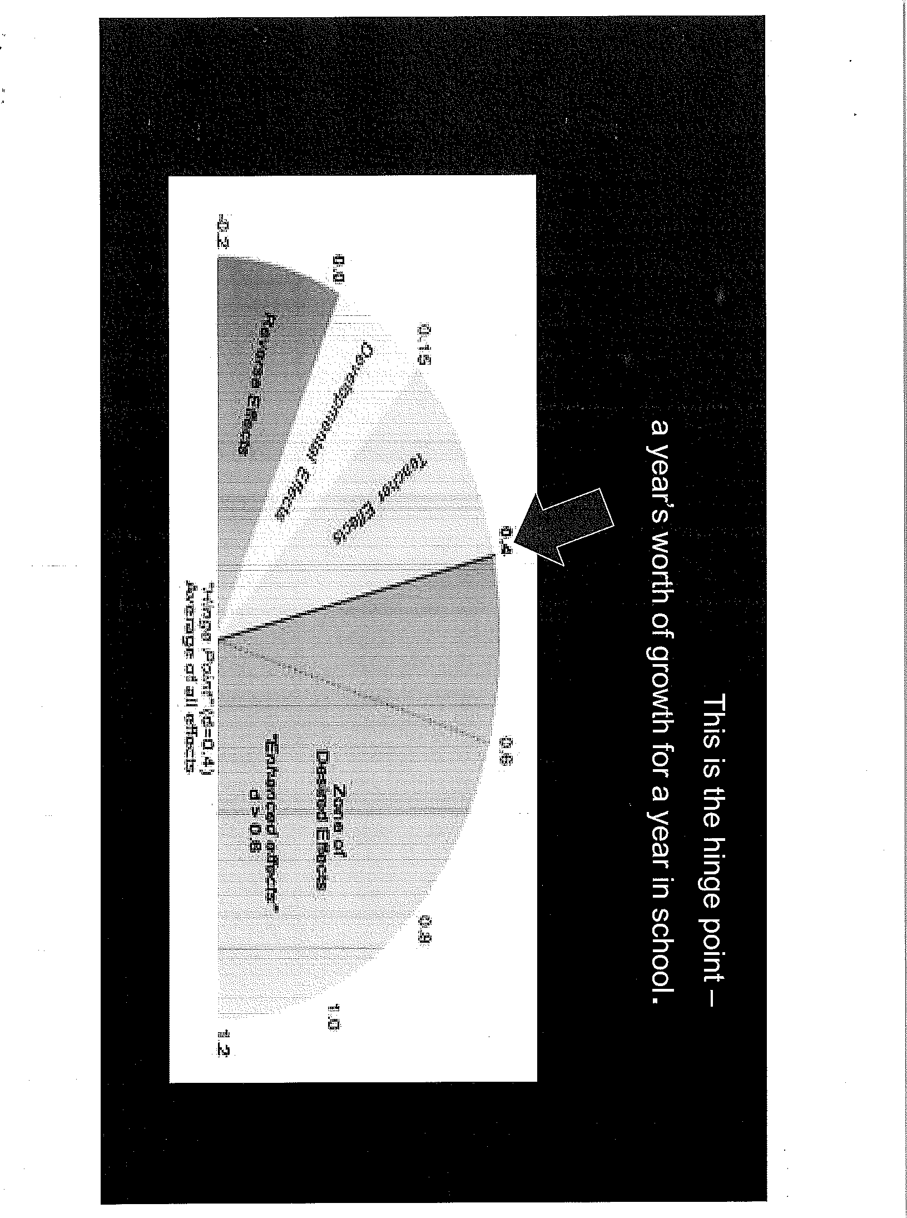
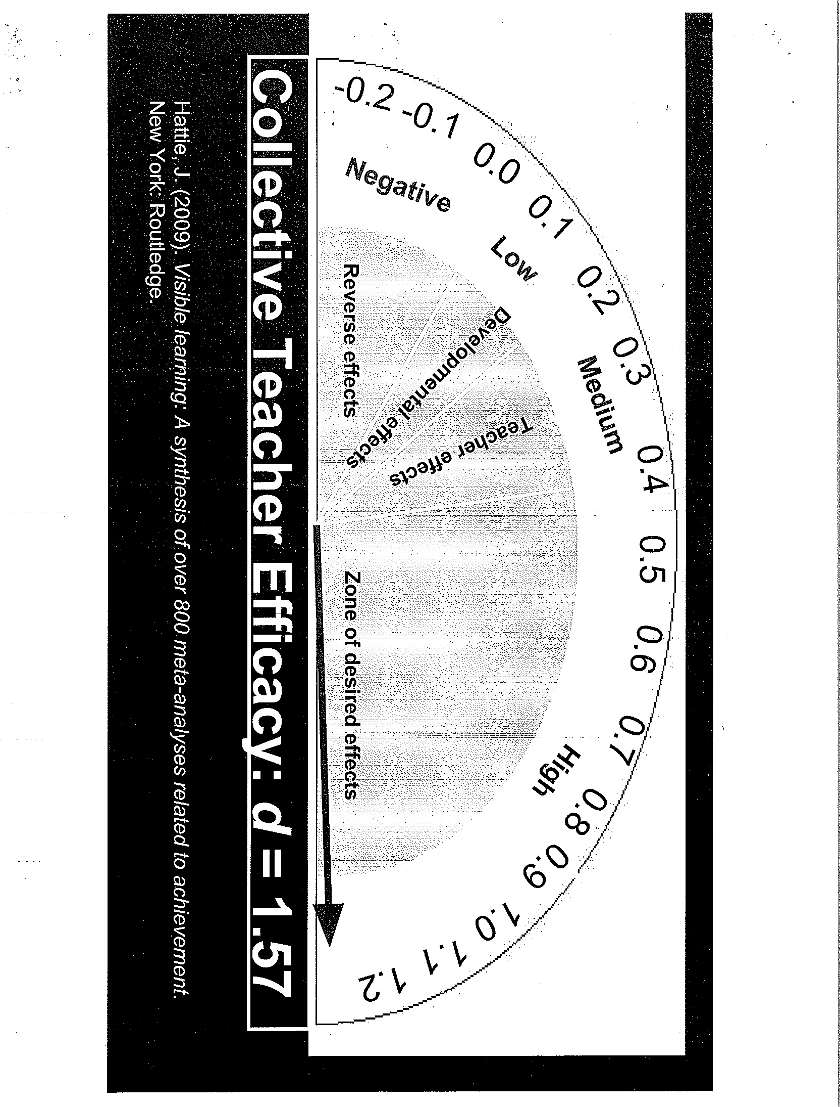

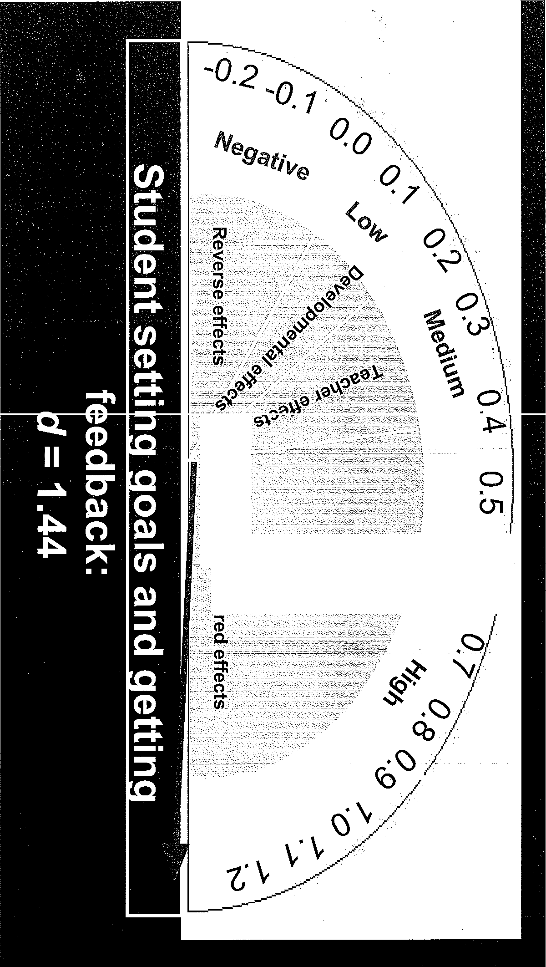
N
0
::I
.CD
···S.
0.
CD
(-(I·

0

0).
•

6 essential characteristics of PLC:
- Shared Goals and Values
- Collaborative Teams focused on learning
- Collective Inquiry
- Action orientation
- Continuous improvement
- Results orientation

First Steps
  - Develop Shared knowledge
  - Find things to stop doing
  - Ensure teams have time and understand why
  - Work in collaborative teams and take collective responsibility
###

  - Behavior Matrix - Dr. Scott Hagerman
Dr. Hagerman provided Board Members with the Code of Conduct/ Behavior Matrix that was created through collaborative efforts with the all of the administrators. He reminded Board Members they had previously reviewed the matrix, and this version reflects only minor changes made. This Matrix provides possible consequences and allows for consistency across the District with student discipline issues.
Each disciplinary infraction carries a point value. An accumulation of more than 6 points in the duration of a school year may result in an administrative recommendation for long-term suspension. An administrative recommendation may include a 10-day suspension pending a long-term suspension hearing.
- ACTION ITEMS
  - May 10, 2018 Board Meeting conflict - Preschedule to May 8, 2018 - Dr. Scott Hagerman Dr. Hagerman indicated there is conflict on May 10th; TVHS has their Spring Band concert. MOTION: Mr. Ruiz made a motion to change the May 10, 2018 board meeting to May 8, 2018. Mr. Auslander seconded; the motion carried unanimously.
- BOARD AND SCHOOL EVENTS
See attached School Events Calendar
District Office - Preschool Screening - February 28, 2018 8:30 -11:30 Taste of Tanque Verde -April 21
MEC - Advocacy Award CARLOS RUIZ - April 27

- FUTURE BOARD AGENDA ITEMS
Board Goals: Vision and Mission at the sites and Board - March Board Goals: Community Involvement - April
Board Goals: Evaluation 2017-18 SY I 2018-19 SY - May
Behavior Matrix - January or February

- ADJOURNMENT
Ms. Fry adjourned the meeting at 8:46 p.m.

Respectfully submitted by,
Judy Bower, Governing Board Secretary

ABSENT
Susan Fry, Board President Jeffrey Neff, Board Member

Jeremy Schalk, Board Clerk Carlos Ruiz, Board Member

Steven Auslander, Board Member
Personnel Items - Board Meeting - February 27, 2018

AdininistfatorContracts··.··.i· ,. Position . • ' .' .>·>.;···<.···· ···Rea.son· - t·· ..,,·/Site. ·.FTF· \Date
Admi.nistrator Resignations l..;D; .••.,. P 1•,>•·:,x, Reason (Replace!New) • •'····•·... Site .I FTE ' Date ·,
 | Names did not make last board report
Elementary - TBD | Vacancv created by internal transfer at TVES | TVES | 1.0 | 7/3012018
Music Teacher | Replace Amv Brauer | ACES | 1,0 | 7130/2018
Elementarv - TBD | Vacancy created by internal transfer at TVES | TVES | 1.0 | 7130/2018
Science Teacher | Replace Michael Stock | EGJH | 1,0 | 7130/2018
5th Grade Teacher | Obtained full certification - no lonaer a TOSA | ACES | 1.0 | 2122/2018

C rtified·.Confracl$ ;;••·••• >
See attached list
Haley Wilson Lisa Brown
Anne Marie Karel
Jerald Frev Ronald Scrima
.•.•.·· ...,,,,fl6sition ,·./\.\ .. '. R 1:1so11 {Replace /.New)>
·' '. '
srie·..·. FTE . <·D. , a...t.e •.· ,,

Certified Resignations .··' , <, ·. ·• ,Position . · ·. ' ·., ·.·•.·..·..·,·..· Reason (Replaceil\lew) ,· ··· ··. . Site FTE --- -,,,Date._:-

Classified Contracts < ·•···•. , > Position , ' · ..
'
. .
,..·.·.··•..•·'. i. <Reason (Replace I New)•··· . ·.·• · , ... Site ,.fTE .., ·. Date,

Classified Agreements ·.;
.'-"· .. ,,P.OS·-·IIrOn·-->,..-- -
.,,_ 1 • • > Reason (Replace /New)-- ··.
- •• 1 Site FTE ·•Date.

Paula Tellez Bus Monitor Replace Mary Gallagher TRANS 0.50 211912018

Classified Resignations ·.··· I _,_·..·,, -.,---.-_--.,_. p0s1_'f1on,.-_,,._·-..,., ---. . ji • . Reason (Replace/ New)· . '
=' -- . " .Date.··.
Zachary Taylor | School Security Monitor |  | Other Employment | TVHS 1.0 | 212212018

Kim Elias | IT Supnort Specialist |  | Other Employment
Cynthia Kieft | Food Services Assistant |  | Personal
Paula Tellez | Bus Monitor

"'''Family obliaations
·-:·,.-'
Other ,,,,,. ··•· ·,·., •·... .. ·< .· . _----:' ---:::;-. ·-::-.,--i>.\·..-._-,/_-:,_,,_:,_.
:--''..-- •.........,,'.,
,
....
' ...·.. '. ·., ;;-- '
 | TVHS | 0.50 | 211912018
.. ···.. | TRANS  ; :,·· _.' - 1  '.·.. | 0,50  , < .. | 211912018  _.,:,., ._ ·, ,' .  . ' : ·_-;- --_.
 | TVES | 0.50 | 21112018
 | TVES | 0.60 | 21112018
.. ·  '.• | Site. | FTE | - Date·:

... Site FTE.

TVHS 1.0 212312018
.

Lindsey Kowalski Motor Lab Aide Personal LOA
Cindy Hodaeson Teacher Personal LOA
' .

Other Continuations . ··.,· . .
',7 ' '_ -_
,' ,· ·.' _-.,'
·_. ·._

•••
> ,, .·· Reason. (Replace / New) '

Qttfef.!xoiseontinuations 's.,1···· · :·,:. ·.,, •., .., .. ,$it ili[ 'Fi'l'l;ii "·cn;;;,·<·"·
Assistant Baseball Coach | Personal | EGJH | Varies | 2112/2018
Varsi Head Coach | Personal |  |  | 212112018

"--·--"
.,... ,_,,.,. -·-· ' · .,,... ,.,.-... ,.. , ,,,,,,,,
Jeremiah Johnson
Mark Gaxiola Varsity Boys Basketball Coach Personal TVHS Varies 212012018

Art Arnold
Ptti \fi!".l wl'fllr:Eii;'iii/t ,z,;,.,.,,,.,.•... ITlfn
TVHSIVariesI

Aaron Gruber Assistant Baseball Coach Replace Jeremiah Johnson EGJH Varies 2/1212018 Joseph Elizalda Classified Substitute New Vaires Varies 2/1912018
Jamie Rietz Substitute Nurse New Vaires Varies 2/19/2018

/K. Wick 3/2/2018

Certified Contract Names
SY 2018 / 2019
Last Name | First Name | Primary Job Title | Site
YAW | WILLIAM | TEACHER | TANQUE VERDE HIGH SCHOOL
SCRIMA | RONALD | TEACHER | AGUA CALIENTE ELEMENTARY SCHOOL
 |  |  | .
 |  | -

Page 1 of 1

