

Oatmeal

Toast or English Muffin

Fresh Fruit

100% Fruit Juice

1% Lowfat Chocolate/White Milk

Biscuit with Sausage Gravy

Fresh Fruit

100% Fruit Juice

1% Lowfat Chocolate/White Milk

Boiled Egg

Hash brown Potatoes

Fruit Cup

100% Fruit Juice

1% Lowfat Chocolate/White Milk

Blueberry Pancakes

Sausage Link

Fruit Cup

100% Fruit Juice

1% Lowfat Chocolate/White Milk

Hot Ham & Cheese Wrap

Whole Wheat Tortilla

Fruit Cup

100% Fruit Juice

1% Lowfat Chocolate/White Milk

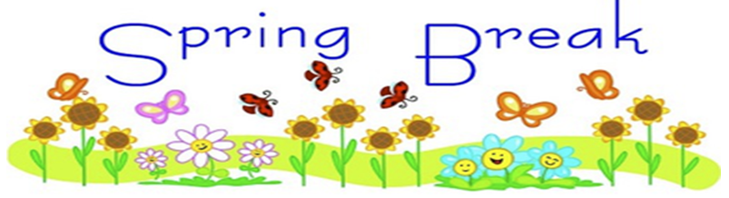



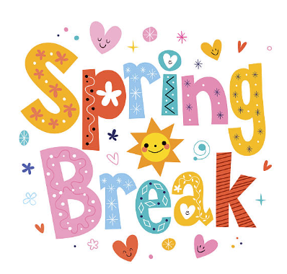

**NO SCHOOL - SPRING BREAK**

Lowfat vanilla yogurt

Oatmeal Topper:

Orange/Blueberry Mix

100% Fruit Juice

1% Lowfat Chocolate/White Milk

Scrambled egg

Shredded Cheese

Wheat Toast

100% Fruit Juice

1% Lowfat Chocolate/White Milk

Cereal Bowl

Fresh Fruit

100% Fruit Juice

1% Lowfat Chocolate/White Milk

Oatmeal with oatmeal topper

Topper-dried cranberries, raisins,

Granola

String Cheese

100% Fruit Juice

1% Lowfat Chocolate/White Milk

Egg and cheese omelet

Wheat Tortilla 6”

Salsa

100% Fruit Juice

1% Lowfat Chocolate/White Milk

Cream of Wheat

String Cheese

Fruit Cup

100% Fruit Juice

1% Lowfat Chocolate/White Milk

Bagel and cream cheese

Fresh Fruit

100% Fruit Juice

1% Lowfat Chocolate/White Milk

Ham & Cheese

Muffin Sandwich

Fruit Cup

100% Fruit Juice

1% Lowfat Chocolate/White Milk

Turkey Sausage Pancake Wrap

Syrup

Fresh Fruit

100% Fruit Juice

1% Lowfat Chocolate/White Milk

Cinnamon Pop Tart

Yogurt Cup

Fresh Fruit

100% Fruit Juice

1% Lowfat Chocolate/White Milk

Cereal Bowl

Gogurt

Fruit cup

100% Fruit Juice

1% Lowfat Chocolate/White Milk

Scrambled Egg

Sausage Crumble

Wheat Toast

Fresh Fruit

100% Fruit Juice

1% Lowfat Chocolate/White Milk

Banana Bread Square

String Cheese

Cinnamon Applesauce

100% Fruit Juice

1% Lowfat Chocolate/White Milk

**\*\*This institution is an equal opportunity**

**provider\*\***

**\*\*Menu subject to change upon product availability**

**MARCH 2023**

Haak’u Community Academy