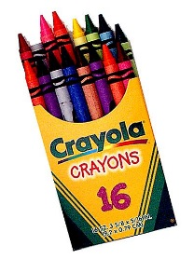
Kindergarten Supply List
2022-2023

- Crayola Watercolor Paints (8 colors)
- 4 expo dry erase markers
- 1 large pink eraser
- Colored pencils (1 set of 12)
- 1-1.25 oz bottle Elmers school glue
- 1 box of crayons (24 count)
- 3 large glue sticks
- 1 box quart size ziplock bags
- A shelf stable classroom snack (crackers, fruit snacks, granola bars, ect.)

1 pair of head phones to be used with computer devises in the classroom

1 pair of tennis shoes for P.E. (these shoes will remain at school throughout the year)
-if your child is still learning how to tie their shoes, please do not send shoes that need to be tied!!!

2 pocket notebooks with child’s name (plastic folders work best)
- these folders will be used as a form of daily communication.

