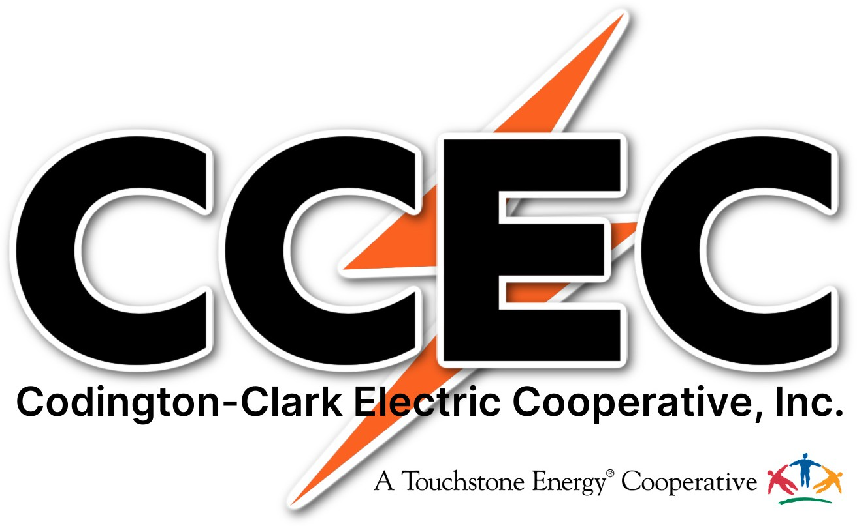
Scholarship Application
$1,000 Codington Clark Electric/CoBank Scholarship
$500 Codington-Clark Electric Scholarship
(One application covers both scholarships)

Please complete the form below. Information provided in #5-7 may be used for publicity purposes.

1. Name: |  |  | Home Phone
2. Last 4 digits of Social Security Number: |  |  | Are you a  U.S. Citizen? Yes No
(street)  3. Permanent Address: | (city) |  |  | (state) | (zip)
4. Mother’s Name: | Father’s Name:
5. High School name and address from which you will graduate this spring:
6. Accredited School name and address you will be attending in the fall of the year:
7. Major Course of Study: |  | Minors:
Student Signature: |  |  | Date:
Parent Signature: |  |  | Date:

Scholarship Submittal Requirements

- Complete this form by typing or printing (attach additional sheets if necessary).

- Enclose your most recent academic transcript from high school.

- Enclose a copy of your college entrance examination (ACT) scores.

- Enclose a short essay (100 words or less) written by you explaining your educational and career goals.

- Enclose two letters of reference from third parties. (i.e. teacher, counselor)

- Mail your complete application packet to the address below by February 14, 2025:

Codington-Clark Electric Cooperative, Inc.
P.O. Box 880
Watertown, SD 57201-0880

