JMJ
Saint Patrick Catholic Church
301 Shamrock Trail
Adamsville, Alabama 35005
205-798-5326
Rev. Anthony Weis, Pastor

Volume 38 August 15, 2021 Number 33
Solemnity of the Assumption of the Blessed Virgin Mary

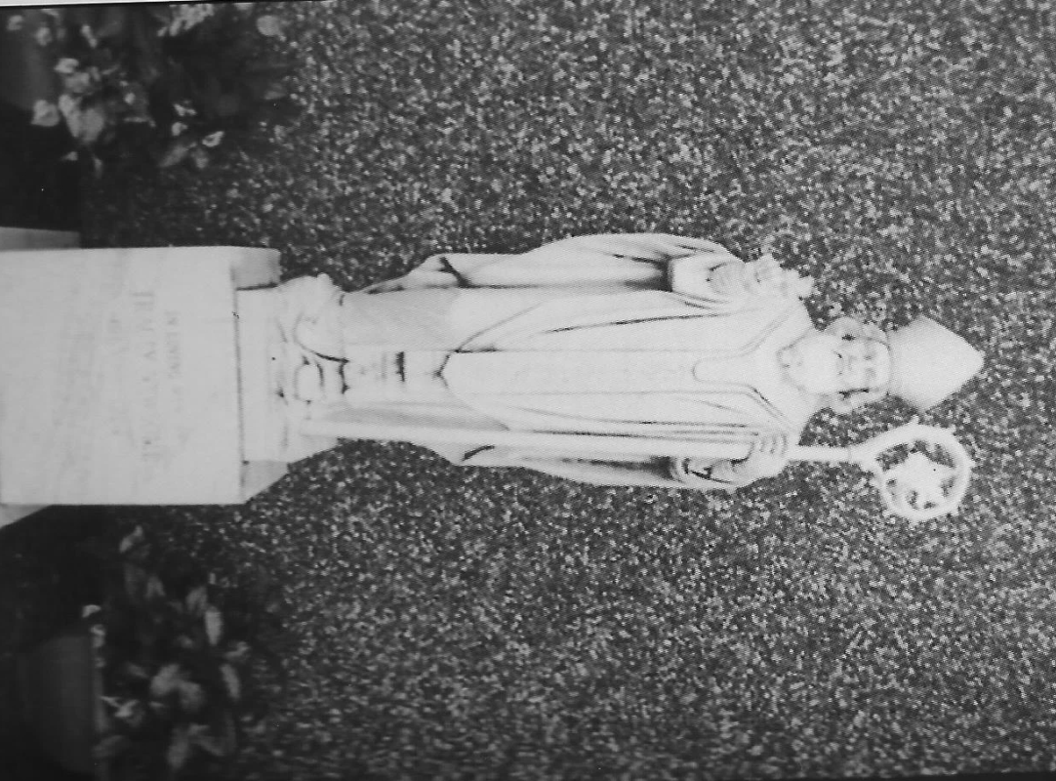

Celebration of the Holy Sacrifice of the Mass

Saturday, 4:00 pm Sunday, 10:00 am

Wednesday and Thursday, 9:00 am
First Friday, 10:00am
Holy Days of Obligation, 6:30 pm

The Sacrament of Reconciliation

One hour before each Mass until Fifteen minutes before Mass or by appointment
Twenty-First Sunday in Ordinary Time
1st Reading: (Joshua 24:1-2a,15-17,18b) 2nd Reading (Ephesians 5:21-32) Gospel (John 6:60-69)

PRAY FOR OUR PARISHIONERS IN THE HOSPITAL OR ON HOSPICE: Please keep all the sick and their caregivers in your prayers.

PRAYER BOOK: The prayer book in the narthex is available for all prayer requests. Please pray daily for these requests.

PRAY FOR OUR TROOPS: Especially our families, friends and loved ones who are currently in active military service: Joseph Byrd (Poland) Brett King (Guam) Delia King (Stateside), Jason King (Stateside) Please keep all of our brave men and women in your prayers. Please call the office to add to or remove names from this list,

PLEASE JOIN OUR PARISH! We would love to have you as a registered member of St. Patrick. If you would like to join our parish, please pick up a Census Card in the narthex, fill it out and put it in the collection basket.

PRAY FOR OUR PARISHIONERS WHO ARE
UNABLE TO LEAVE THEIR HOMES Mickey Davidson, Pat Rogato and Kevin Whitaker. Please keep these, all the homebound, and their caregivers in your prayers. If you know of any parishioner who should be added to or removed from this list, please contact the office.
Assumption – 20th Sunday Our cummunion with Jesus unites us with all belivers. As you participate in the Eucharist pray that the Church may be strengthened as the Body of Christ. (John 6:51-58) Let us pray that the Church may be strengthened as the Body of Christ. (Vocation View is sponsored by Serra Club)
PARISH PICNIC: Plans are being made for our fundraising grand prize drawing and parish picnic to be held on Sunday, September 12, immediately following our 10:00 Mass.

SIGN-UP SHEET! There is a sign-up sheet in the Narthex for anyone who can help with the Parish Picnic on September 12th. Many hands make light work.

$100 GRAND PRIZE- Interested? Ready to compete? We are looking for St. Patrick’s grand champion in cake baking. Stop by the Shamrock Booth to sign up and enter a cake in our contest to be held at the parish picnic on September 12. Entries include pound cakes, cheese cakes or layer cakes with blind judging based on taste and appearance. All entries will be served at the picnic and winner to be announced at the conclusion of the days activities. Deadline to enter is Sunday, September 5.

OVERSTOCK SALE: The Gaeton Gotcha’ Board Committee has taken stock of our available shamrocks and have decided to run a limited-time special. For every $75 and/or $150 shamrock you adopt, you will receive 2-for-1 entries for the cash grand prize drawing to be held at the parish picnic on Sunday, September 12th. Stop by the table in St. Joseph Hall, purchase your shamrock (cash, check or card), and receive double the entries! Remember, this is a limited time offer so get your shamrock(s) now!

MEETING: Members of the Gaeton Gotcha board planning committee will have a meeting this Sunday, August 15, after Mass in the hall.

PART TIME MUSIC MINISTRY LEADER POSITION: St. Patrick needs someone who can read music, play piano and/or organ, and lead the choir at Mass on weekends and Holy days. Call Father Weis for more details.

PLEASE WELCOME our newest member of St. Patrick, Lacie DeAnne (St. Monica) Sullivan as she receives Baptism, Confirmation and First Holy Communion on Sun. August 15, 2021. The Sullivan Family has deep roots at St. Patrick and we are blessed Lacie has chosen to deepen her faith and walk with Jesus here with us.

Weekly Finance Report
Account Income Expense Diff.
Operations 3.738.00 4,648.42 (910.42)
Capital Imp 605.00 499.98 105.02

RCIA Considering joining the Catholic Church? Catholic but never confirmed? Need to make your First Communion? Want to be baptized? Let us help you! Check out our RCIA classes for adults considering joining the Catholic Church. Come and Learn. For more information, please call the church office. Weekly classes are each Tuesday, at 6:00 pm September – April.

FAITH FORMATION: K-12 registration for the 2021-2022 school year is now open. Updates and calendar will be coming soon! If you are interested in teaching or being a teacher’s aide, please contact Lisa Dougherty or Tara Blanchard.

FAITH FORMATION BEGINS Wed. September, 15, 2021. Please register your school age children K-12 ASAP. Teachers and rosters are being planned and we want to include all our youth in this New, Amazing Year!!

SPIRIT: Calling all youth from grades 6th - 12th. It's time for SPIRIT sign-up. Join us in the Spirit youth room on Sunday August 22nd after Mass. Bring your parents with you to fill out the paperwork. Lunch will be provided. We will also recognize our Senior Class of 2022 by putting their hand prints on the Senior wall.

LABOR DAY BOSTON BUTT SALE! The Knights of Columbus will are taking orders for our Labor Day Boston Butt Sale. They are once again $35 each. Orders must be turned in by August 29th. Boston Butts will be available for pick up on Saturday September 4th from 3-5pm and on Sunday September 5th after Mass. Call or text Dale Blanchard @ 205-541-6597 or see any Knight to place your order.

THE FOOTBALL SEASON is just weeks away and the Knights of Columbus is sponsoring two football "squares" boards to kick off the season. A square on either board is available for a $5 donation to the Knights. Payoff will be $50 per quarter and $50 for the final score. The two games are - Alabama vs. Miami on September 4 and Auburn vs Penn St. on September 18. To purchase a square, see Mike Muro or any member of the Knights of Columbus. All proceeds benefit Knights of Columbus 10567 charitable ventures.

SHAWL MINISTRY: Prayer shawl ministry has changed meeting times. We will meet the third Monday of every month. For more information contact Mary Evans at 205-491-2291.

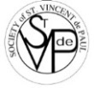
SVDP MEETING: Our next meeting will be announced at a later time.

PANTRY NEEDS

SHOP AT AMAZONSMILE: Amazon will donate a portion of any online purchase to SVdP. Simply click the icon on the SVdP page on St. Patrick website to place your order. Donations will be computed by AMAZON and automatically transferred to our account.

Saltines
The Assumption of the Blessed Virgin Mary: In today’s Gospel, even the child in Elizabeth’s womb leaps with joy at the approach of Mary, the “lowly servant,” who by accepting God’s plan for her became blessed for all generations. With love for your neighbors who have nothing, look around your house to see what furniture, household items, and clothing you no longer use…and give it to the Society of St. Vincent de Paul.
Grits

Oatmeal
Dry soup

2nd Collection Weekly Mass Schedule

^{Saturday} ^{08/14} ^{4:00 pm} ^{Louis Muro -} ^{Sunday} 08/15 10:00 am ^{For the People}
^{Monday} ^{08/16} ^{No Mass}
^{Tuesday} ^{08/17} ^{9:00 am @ St. Stanislaus}
^{Wednesday} ^{08/18} ^{9:00 am} ^{Deidre Collins - H} ^{Thursday} ^{08/19} ^{9:00 am} ^{Joe Maniscalco -}
^{Friday} ^{08/20} ^{9:00 am @ St. Stanislaus}
^{Saturday} ^{08/21} ^{4:00 pm} ^{Charles Perricotti -}
^{Sunday} ^{08/22} ^{10:00 am} ^{For the People}
CLEAN OUT FOR CHRIST- We’re back and ready to take donations for our sale scheduled for first weekend in October. We are looking for clean, gently used items such as linens, kitchen items or small appliances, home decor, tools, children’s clothing and toys, baby items, shoes, ladies handbags, jewelry and furniture. No books, tv’s , adult clothing or mattresses please! If you have furniture to donate it must be unloaded inside the back of the gym. Arrangements for furniture must be coordinated with the church office during regular hours and you will be responsible for unloading. We will have areas in the back of St. Joseph hall for all other donations. Questions? Contact Margaret Pender 205-903-8993. Donations will be accepted until September 12, 2021. All proceeds from this sale will go to St. Patrick’s church and Saint Vincent DePaul Society.
THE CATHOLIC BUSINESS AND PROFESSIONAL NETWORK (CBPN) will be kicking off a series of quarterly luncheons on Wednesday, August 18th, from 11:30 AM - 1:00 PM at The Club in Birmingham. The first speaker for the series will be Bishop Steven Raica. Anyone who holds a job, or has ever held a job (that includes those who work inside the home), is invited to join us for this opportunity to hear Bishop Raica speak and to network and fellowship with other Catholics. Tickets for the event are $35/person. To make your reservation for the August 18th luncheon, simply go to: www.catholicnetwork.net, click on “Event Calendar.”
WORLDWIDE MARRIAGE ENCOUNTER is now having LIVE Weekend Experiences! Unlock the power of your relationship with new ways to do the “I do.” Renew the romance and live your best life in love. Learn to become the best version of yourselves together! Alabama’s next IN PERSON WEEKEND IS OCTOBER 15-17, 2021. St. Bernard Abbey in Cullman. You can get more information or register online at www.wwme.org or by calling Frank and Kathryn Wessling at 205-530-3607.

THE PADRE PIO PRAYER GROUP will meet on Saturday, August 21st, at 10am at Our Lady of Sorrows Catholic Church in Homewood, AL. All are welcome to join us for an hour of prayer/rosary/adoration and Holy Mass led by Fr. Mugagga Epah. For more information, contact Angela Kolar at angkolar@att.net or 205-991-9554. "Pray, Hope, and Don't Worry!" Padre Pio... pray for us!

CATHOLIC YOUTH VOLUNTEERS NEEDED: High School Students interested in working with children and youth having intellectual and developmental disabilities, are invited to a training workshop on Saturday, August 21st from 10:00 am – 12:00 Noon at St. Francis Xavier School Annex Building. Those who participate in the Nazareth House Saturday Program are eligible for service hours that meet the requirements for graduation and college scholarship applications. For more information email Sr. Mary Vernon Gentle, RSM at Mygentle@aol.com or Fr. Patrick Cullen at Rathmines.Cullen@gmail.com or call 205-907-0287.

