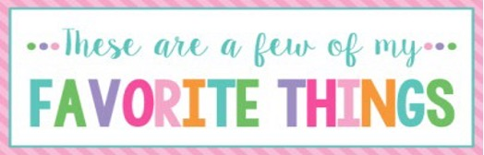

Name: | Rebecca Baker | T-Shirt Size: | Medium
Birthday: | 09/05 | Monogram: | rBI
Favorite Color: | pink | Favorite Flower: | Yellow rose
Favorite Scent: | vanilla | Favorite Candy: | Milk duds
Favorite Drink: | Diet Dr. Pepper | Favorite Food: | pasta
Favorite Snack: | Skinny pop | Favorite Fruit: | strawberry
Favorite Restaurant: | Olive Garden | Favorite Fast Food: | Chick-fil-a
Favorite Places to Shop: |  | Target or Marshalls
Favorite Bath & Body Works Scent: |  | Strawberry pound cake
Things I Collect:
Favorite Author/Book Series for Personal Reading:
Wish List for Classroom:

