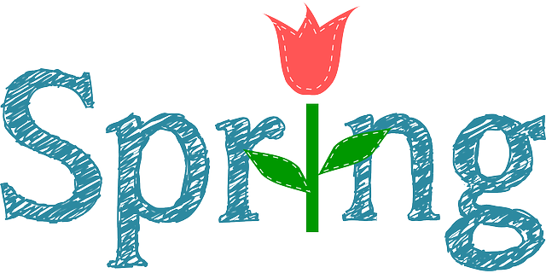
Mrs. Way’s Class News
Week of 3-27-23
HOMEWORK: Read for 15 min. and study spelling words (on back) every night.

Reading - Story: “Anthony Reynoso: Born to Rope”
- Skill: summarize; words with ph,gh

Language/Writing – Write an opinion paragraph
- Prefixes & Suffixes

Math – Fractions

Science – Habitats

PLEASE STUDY THESE WORDS FOR FRIDAY’S TEST (3-31):
1. paragraph
2. elephant
3. photo
4. graph
5. telephone
6. tough
7. laugh
8. cough
9. rough
10. enough
11. why
12. would

