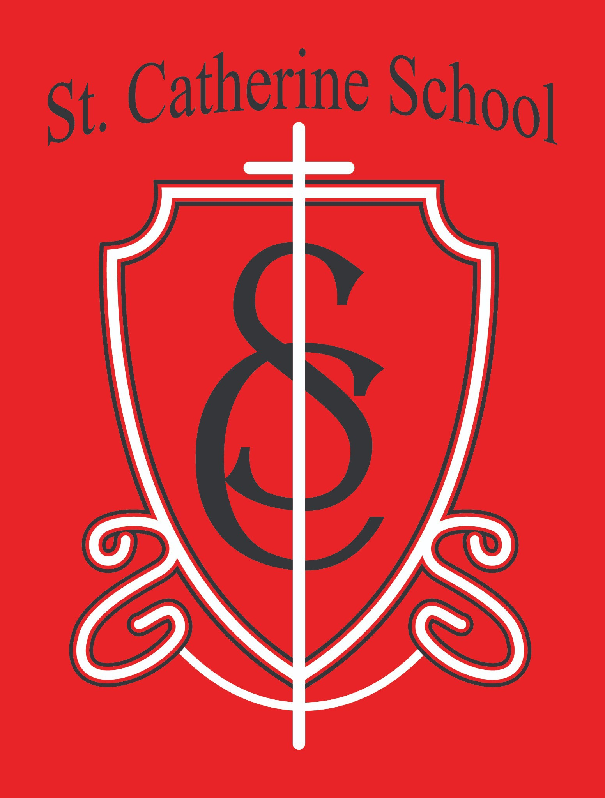

St. Catherine School Weekly Newsletter (March 10-14)
https://www.stcatherine.k12.nd.us/parents

Principal's Message
Dear St. Catherine Families,
My apologies for not sending last week’s email. I thought I would start this week off with a quick update and a few important reminders for the weeks ahead.
Thank you for the many ways you continue to support our school and the mission of Catholic education.

Reminders

School in Session – Friday, March 20

St. Catherine School will be in session on Friday, March 20, even though Valley City Public Schools will not be in session that day.
Because VCPS will not be in school, there will be no bus transportation available that day. Families will need to arrange student transportation to and from school.

Kids Heart Challenge – Final Week

This is the last week of the Kids Heart Challenge, and we are currently at about 30% of our fundraising goal.

If you are able, please help us reach our goal by sending in donations. Donation envelopes with money are due Friday, March 20.
Thank you to everyone who has already supported this effort.

Winter Gear Reminder

Please continue sending all winter gear to school each day until the school communicates otherwise. Even though the calendar says spring is approaching, the weather still requires winter gear.

Big Ticket Raffle

Our annual Big Ticket Raffle is beginning soon.

Tickets will be $100 each, and only 300 tickets will be sold. Because of a generous benefactor who has already provided the prize money, every ticket sold goes directly to support St. Catherine School.
Prizes include:

- $5,000 Grand Prize

- Five $1,000 cash prizes

If all 300 tickets are sold, the school will raise $30,000 to support St. Catherine School's mission.
Tickets will be available after Mass this coming weekend and the following weekend. They will also be available in the church office or the school office.
We will also be sharing social media posts this week and encourage families to help spread the word.

Holy Week / Easter Break

There will be no school beginning Friday, April 3 for Easter Break. School will resume on Monday, April 13.

School in Session – April 17

Please note that St. Catherine School will have school on Friday, April 17, even though Valley City Public Schools will not be in session that day.
Families should also plan for student transportation that day.

St. Catherine Spotlight

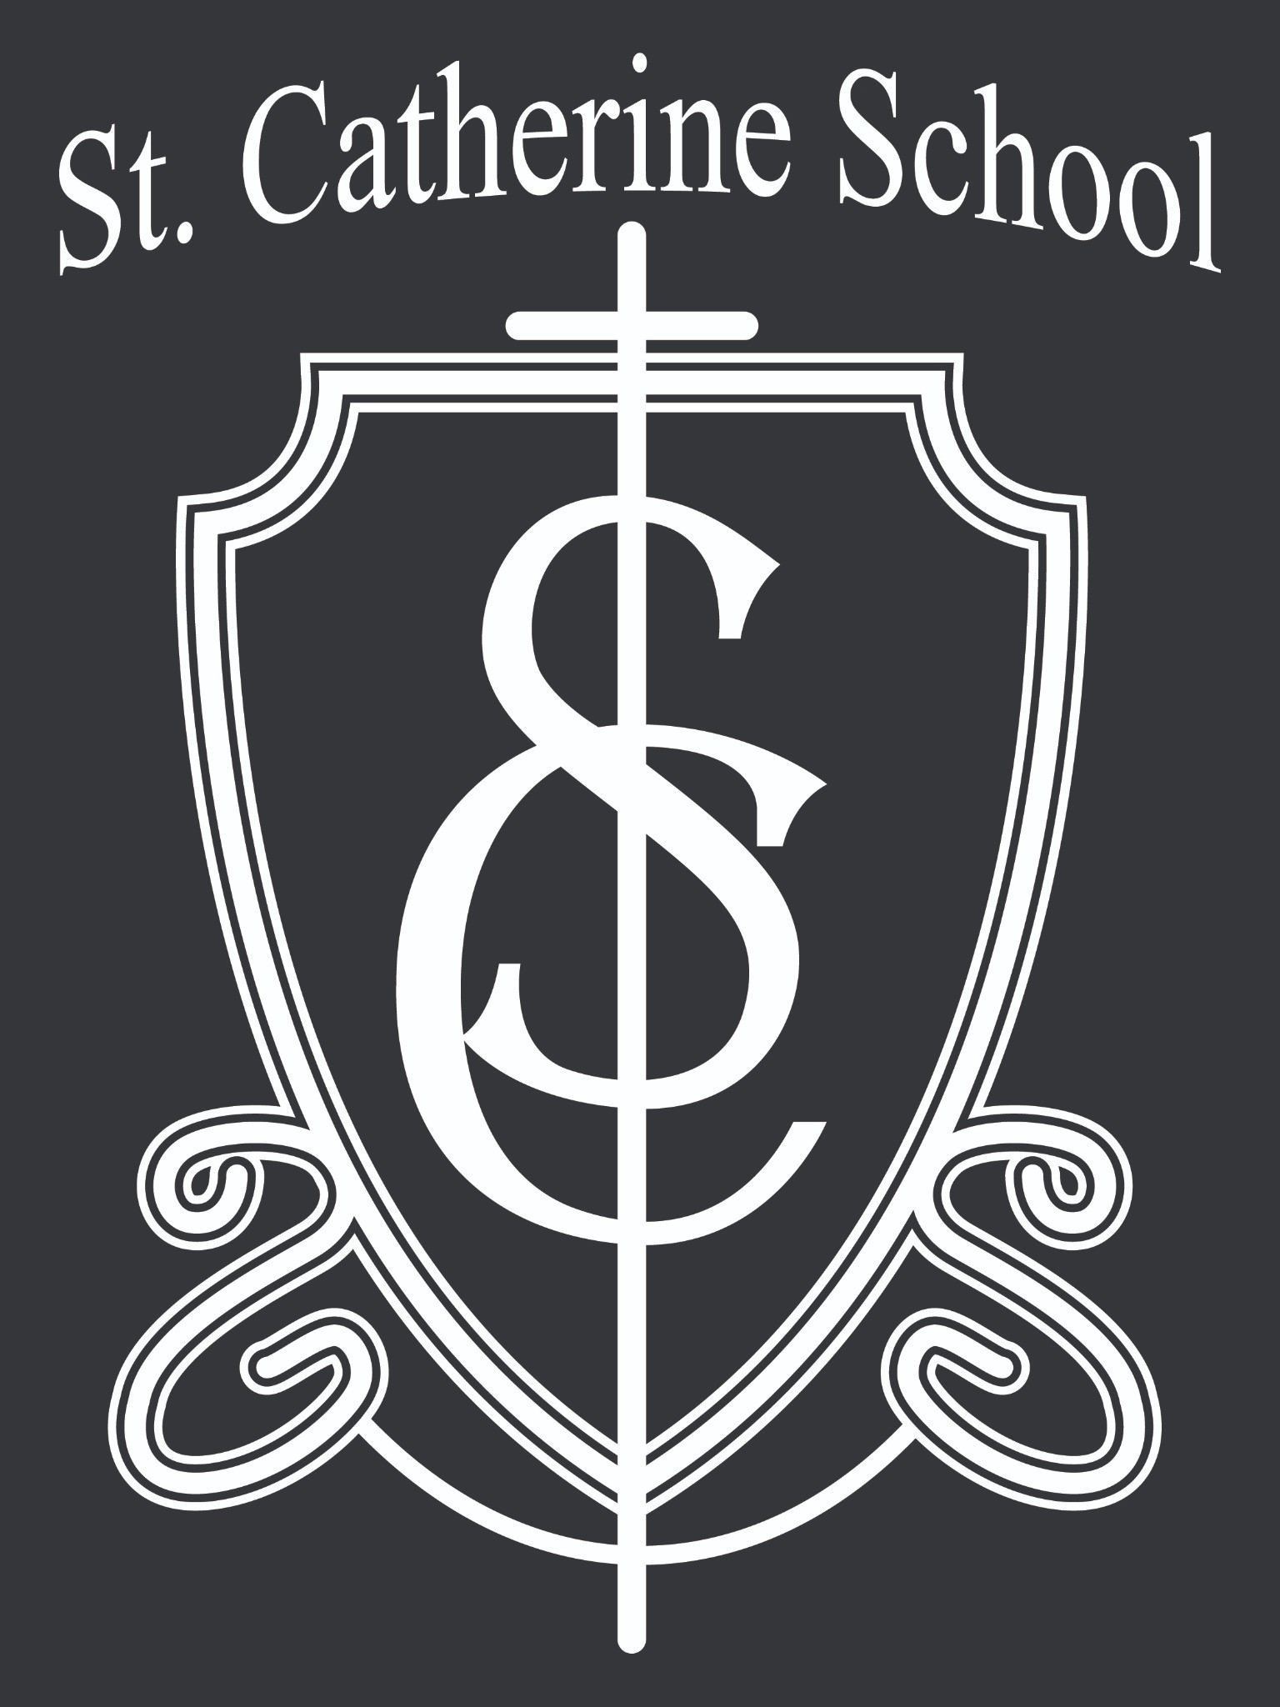The 1st and 2nd grade class did a wonderful job leading the Stations of the Cross in chapel on Wednesday. These are not easy readings for young students, and they handled them with reverence and confidence.
Thank you to Mrs. Burchill and the parents who helped the students practice and prepare. Opportunities like this allow our students to actively participate in our faith traditions and help make Lent meaningful for the entire school community.

Stay Connected with St. Catherine School
📍 Address: 540 3rd Ave. NE, Valley City, ND 58072
Email: nicholas.lee1@k12.nd.us
📧
Phone: 1-701-845-1453
📞
Website: www.stcatherine.k12.nd.us
🌐
📘 Follow Us on Facebook: St. Catherine School on Facebook

“Inspiring excellence through faith, learning, and service.”

