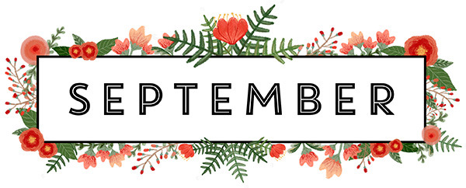
Mrs. Way’s Class News
Week of 9-19-22
*PLEASE STUDY SPELLING WORDS ON THE BACK.
*PLEASE SIGN AND RETURN INTERIM REPORT SENT ON FRI., SEPT. 9TH.

HOMEWORK: Read for 15 min. and study spelling words every night.
Reading – Story: “The Enormous Turnip”
Skill: Identify sequence/use words with ack, ock

Language/Writing – Identify, use, and write plural nouns

Math – Identify ordinal numbers/Identify and extend patterns

Social Studies – Locate the following in the U.S. – James River, Rio Grande River, Mississippi River, Appalachian Mountains, Rocky Mountains, Great Lakes
PLEASE STUDY THESE WORDS FOR FRIDAY’S TEST (9-23):
1. black
2. pack
3. back
4. crack
5. snack
6. lock
7. rocket
8. flock
9. shock
10. clock
11. said
12. play

