How to Get into Parent Accounts
1. Go to schoology.com and click login.
****This is different from where to students go***
2. 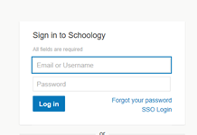Say forgot password.
3. Enter your email address. This must be the same email address that is in powerschools. This is the email address that you put in during registration. If you are not sure of the email address, you can call the office and we can check.
4. Check your email (if you do not see it, you may want to check your spam folder).
5. Go back to schoology.com and login with your email address and password.

