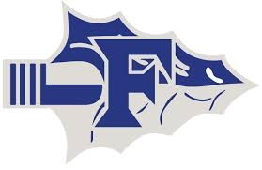

FRANKSTON HIGH SCHOOL
2026 TRACK SCHEDULE

Sabine Relay only(JV/Varsity) Thursday, Feb. 19th

Frankston Relays (JV/Varsity) Thursday, Feb. 26th

Union Grove (JV/Varsity) Friday, March 6th

Alto Relays (JV/Varsity) Thursday, March 12th

Spring Break Spring Break

Cushing Relays (JV/Varsity) Thursday, March 26th

Elkhart Relays (JV/Varsity) Thursday, April 2nd

District Meet @ Alba-Golden (JV/Varsity) Wednesday, April 8th
Thursday, April 9th

Area Meet @ Madisonville Thursday, April 16th
Regionals @ Palestine Friday, May 1st
Saturday, May 2nd

State Meet @ Austin May 14th – 16th
Frankston Middle School
2025 Track Schedule

Frankston Relays(7th/8th) Monday, March 2nd
Alto Relays(7th/8th) Monday, March 9th
Cushing Relays(7th/8th) Monday, March 23rd
District Meet @ Alba Golden (7th/8th) Monday, March 30th

