
Mr. Mattox Course Syllabus
2025-2026 (Semester 2)

Motivation + Hard Work = Success

Instructor Information
Course: Geometry with Data Analysis
Room #: A24
Contact: Message through ParentSquare or email to “jason.mattox@acboe.net” or call school at 334-387-1910
Visit www.marburyhighschool.org and click on “Faculty & Staff” to view teacher bio, schedule, lesson plans.

Student Class Supplies
- Mechanical or #2 pencils (hand held sharpener might also be beneficial)
- Extra erasers just in case they are needed
- 3-ring binder with college ruled loose-leaf paper and tab dividers to stay organized or notebook and folder to stay organized
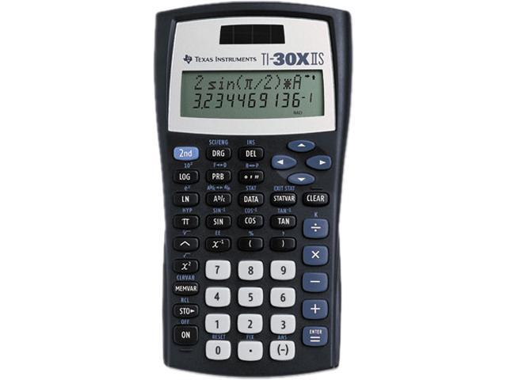
- 12” ruler for creating data tables and graphs
- Pack of colored pencils for creating foldables and graphic organizers
- Recommended personal calculator: “Texas Instruments TI-30X IIS”
at Walmart or Office Depot for around $15. This calculator comes in
multiple colors and operates easily and will enable students a smoother
transition for future math classes.

Teacher Wish List (optional donations that would be greatly appreciated)
White copy paper, color copy paper, graph paper, tissues, 13 gallon trash bags with drawstring, AA and AAA batteries, disinfecting wipes, college ruled loose leaf paper, paper towels, pre-sharpened #2 pencils, black expo dry-erase markers

Textbooks
There will be a classroom set of textbooks that will be used throughout the course, but will be kept in the classroom. Students may check out a book if desired and are responsible for the condition of the textbook while in their possession.

Grading Policy
Student grades will be updated on a regular basis through “PowerSchool”. Averages are weighted following Autauga County Board of Education policy and all assessments are based on a 100 point system. The grading scale used is as follows: A=90-100, B=80-89, C=70-79, D=60-69, F=0-59. Grades of 0.5 or higher will round up.

- Major Grades – 65%
Could be standard specific test, mid-unit test, or end of unit test.
- Minor Grades – 35%
Could be a quiz, homework assignment, or classwork participation grade.

I will be glad to inform a student of their current average at anytime if they want to know.
A midterm exam counting 20% will be taken ending the 1st nine weeks with no exemptions possible.
A final exam counting 20% will be taken ending the 2nd nine weeks with exemptions possible based on the
Board of Education policy for semester averages and absences (A – at most 5 absences, B – at most 3 absences). Final course average is determined by 50% from 1st nine weeks and 50% from 2nd nine weeks.

Make-Up Work
If a student has an absence from class, they are responsible to stay caught up in the curriculum by asking for missed assignments and will have three days to turn in an excuse. Assessments with excused absences are allowed to be madeup but will result in half credit if submitted late. Makeup assessments not submitted will result in a zero recorded in the gradebook. Unexcused absences will result in a zero for any assessments missed.

Daily Schedule
Our normal routine will begin with a “Before” activity like a bellringer and turning in any homework. This time is used to refine yesterday’s material or to spiral review a specific concept to activate background knowledge. New material will then be presented using a “During” activity through instructional examples and strategies followed by guided practice. Some days will consist of partner work, interactive activities, games, or other instructional strategies to reinforce learning. On most days there will be some kind of summarizing activity or “After” assessment at the end of class to check for understanding and help drive instruction for the next day. Multiple strategies and activities will be used for application during the learning process.

Classroom Behavioral Expectations ----------3 R’s: Respectful, Responsible, Resourceful
- Demonstrate respect for others
“A good attitude is a little thing that makes a big difference in your life”

- No inappropriate items: electronic devices, food, drink
(Unless otherwise stated by the teacher)
- Be on time, prepared, and responsible for your work
- Be honest and have integrity in your work
- Keep area clean and use trash can
*Always be mindful of and adhere to the school policies in the student handbook.

Four-Step Discipline & Tardy Policy (Some actions may cause steps to be skipped)
When behavior issues arise, the following system will be followed with documentation in order to address the issue:
- Student-Teacher Conference
- Parent Notification
- Parent-Teacher-Admin Conference
- Office Referral
*Also be mindful of the Autauga County Schools Policy regarding the FOCUS Act and electronic devices:
1st offense - 3 days in ISS , 2nd 0ffense – 5 days in ISS , 3rd offense – 5 days at Second Chance

Tutoring Available
I am willing to spend more time with a student before school or during Bulldog Period in order to help him or her become more confident in their work and get closer to mastery of material they may be struggling with. Please ask if interested in receiving this additional help outside of the designated class time.

Geometry Data Analysis Course Description
This course is designed to emphasize the study of multiple algebraic representations.
In Geometry with Data Analysis, students build on and deepen prior understanding of
transformations, congruence, similarity, and coordinate geometry concepts. Informal
explorations of transformations provide a foundation for more formal considerations
of congruence and similarity, including development of criteria for triangle congruence
and similarity. An emphasis on reasoning and proof throughout the content area promotes
exploration, conjecture testing, and informal and formal justification. Each standard will be
addressed at a greater depth with various embedded concepts that build upon prior
knowledge. Multiple strategies and activities will be used for application during the learning
process. Students who complete Geometry with Data Analysis will be equipped with the
foundational knowledge in preparation for more advanced math and the ACT test.

