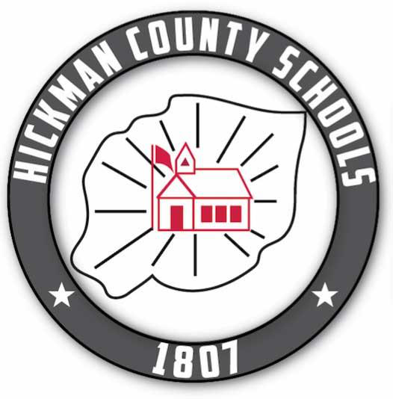
Hickman County School District School - Family Compact
2023-2024 School Year
Our Mission: The Hickman County School System exists to engage and develop the mind, body and character of every student so that each is prepared for success in education, work and life.
Our Vision: We engage and inspire our students from start to finish by setting high expectations for both students and adults. Every student is valued by teachers, leaders and support staff who provide each one access to quality instruction and support.
Our Core Values:
- Our schools must be safe, welcoming and positive for students, parents and teachers.
- Each student can learn, can be successful and deserves our high expectations. We encourage and support growth without limitations for all.
- We engage and inspire our students from start to finish.
- We expect to develop our students into well-rounded citizens who continue to learn throughout life.
- We strive to develop citizens who can apply knowledge ethically and with integrity in our community and world.
Goals
- Caring educators will create a positive environment and culture of high expectations and empower students to establish and pursue their future aspirations and goals.
- High quality instruction and a rigorous and engaging curriculum will positively impact student learning and improve achievement.
- Identify, grow, and support future teachers and leaders to sustain an educational system of excellence.
- Nurture partnerships between schools and stakeholders to serve the community and its citizens by sharing resources to create learning opportunities.

School Responsibilities –
1. Provide high-quality curriculum and instruction in a supportive and effective learning environment that enables the participating children to meet the state’s student academic achievement standards as follows:
2. Hold parent-teacher conferences (at least annually in elementary schools) during which this compact will be discussed as it relates to the individual child’s achievement.
3. Provide parents with frequent reports on their children’s progress.
4. Provide parents reasonable access to staff.
5. Provide parents opportunities to volunteer, participate in their child’s class, and observe classroom activities

Parent and Family Responsibilities - We will support our children’s learning in the following ways:
• Monitoring attendance.
• Making sure that homework is completed.
• Monitoring the amount of my child’s screen time.
• Volunteering in my child’s classroom.
• Participating, as appropriate, in decisions relating to my child’s education.
• Promoting positive use of my child’s extracurricular time.
Staying informed about my child’s education and communicating with the school by promptly reading all notices from the school or the school district received either by my child or by mail and responding, as appropriate.

